

**Documentation**

**Deep Neural Network Hardware Accelerator**

**TEAM:**

**Stefan Sredojevic, Marko Kozomora, Milan Popovic**

**ADVISOR:**

**dr Vuk Vranjkovic**

**Submitted for the 2018 Digilent Design Contest Europe**

[**Faculty of Technical Sciences**](http://www.ftn.uns.ac.rs/n1386094394/faculty-of-technical-sciences)

**Novi Sad, Serbia**

**07/5/2018**

**Team member’s information**

Stefan Sredojevic [stefan.sredojevic95@gmail.com](mailto:stefan.sredojevic95@gmail.com)

Marko Kozomora [markokozomora95@gmail.com](mailto:markokozomora95@gmail.com)

Milan Popovic [popovicm.e1@gmail.com](mailto:popovicm.e1@gmail.com)



Contents

**CHAPTER-0 Introduction** 6

0.1 LEARNING 6

0.1.1 Machine Learning 6

0.2 TYPES OF MACHINE LEARNING 7

0.3 SUPERVISED LEARNING 8

0.3.1 Regression 8

0.3.2 Classification 10

0.4 SUPERVISED LEARNING 12

**CHAPTER-1 Preliminaries** 13

1.1 SOME TERMINOLOGY 13

**CHAPTER-2 Preliminaries** 14

2.1 KNOWING WHAT YOU KNOW: TESTING ML ALGORITHMS 14

2.1.1 Overfitting 14

2.1.2 Training, Testing and Validation Sets 15

2.1.3 The Confusion Matrix 16

**CHAPTER-3 Neurons, Neural Networks and Linear Discriminants** 17

3.1 THE BRAIN AND THE NEURON 17

3.1.1 Hebb's Rule 17

3.1.2 McCulloch and Pitts Neuron 17

3.1.3 Limitations of The McCulloch and Pitts Neuronal Model 19

3.2 NEURAL NETWORKS 19

3.3 THE PERCEPTRON 20

3.3.1 The Learning Rate η 22

3.3.2 The Bias Input 22

3.3.3 The Perceptron Learning Algorithm 23

3.3.4 An Example of Perceptron Learning: Logic Functions 24

3.4 LINEAR SEPARABILITY 25

3.4.1 The Exclusive OR (XOR) Function 27

3.4.2 A Useful Insight 27

3.4.3 Preprocessing: Data Preparation 28

**CHAPTER-4 Multi-Layer Perceptron** 30

4.1 GOING FORWARDS 31

4.1.1 Biases 32

4.2 GOING BACKWARDS: BACK-PROPAGATION OF ERROR 32

4.2.1 Multi-Layer Perceptron Algorithm 35

4.2.2 Initialising the Weights 37

4.2.3 Different Output Activation Functions 37

4.2.4 Sequential and Batch Training 38

4.2.5 Local Minima 39

4.2.6 Picking Up Momentum 40

4.2.7 Minibatches and Stochastic Gradient Descent 41

4.2.8 Other Improvements 41

4.3 THE MULTI-LAYER PERCEPTRON IN PRACTICE 41

4.3.1 Amount of Training Data 42

4.3.2 Number of Hidden Layers 42

4.3.3 When to Stop Learning 43

4.4 A RECIPE FOR USING THE MLP 44

**CHAPTER-5 Using Neural Network To Recognize Handwritten Digits** 46

5.1 Usage of perceptron in digital systems 47

5.2 Implementing logic gates by perceptron 49

5.3 The architecture of neural network 51

5.3.1 Recurrent neural network 52

5.4 A simple network to classify handwritten digits 52

5.5 GETTING COEFFICIENTS USING PYTHON SCRIPT 55

5.5.1 How well does the program recognize handwritten digits? 58

**CHAPTER-6 Hardware (FPGA) Implementation** 60

6.1 AXI INTERFACE 67

6.1.1 What is AXI? 67

6.1.2 Summary of AXI4 benefits 67

6.1.3 How AXI Works 67

6.1.4 Combining AXI4-Stream and Memory-Mapped Protocols 70

6.1.5 Using Vivado AXI IP in RTL projects 70

6.1.6 Adding AXI IP to the IP Catalog using Vivado IP Packager 74

6.1.7 AXI4 Interface signals 76

6.1.8 AXI4 Protocol Waveforms 77

6.2 DATAMOVER 80

6.2.1 Overview 80

6.2.2 Feature Summary 81

6.2.3 Command Interface 82

6.2.4 Command FIFO 84

6.2.5 Status Interface 85

6.2.6 Status FIFO 85

6.3 uCAM III – UART2AXI INTERFACE 86

6.3.1 Why UART and why uCAM III 86

6.3.2 General about UART protocol 87

6.3.3 Hardware implementation 88

6.3.4 Camera commands 91

6.4 SOFTWARE IMAGE COMPRESSION 97

6.5 DEEP NEURAL NETWORK (MLP) 100

6.4 8x8 MATRIX 111

6.4.1 Working principles of LED matrix 111

**CHAPTER-7 REFERENCES** 113

# **CHAPTER-0 Introduction**

## LEARNING

Before we delve too much further into the topic, let’s step back and think about what learning actually is. The key concept that we will need to think about for our machines is learning from data, since data is what we have; terabytes of it, in some cases. However, it isn’t too large a step to put that into human behavioural terms, and talk about learning from experience. Hopefully, we all agree that humans and other animals can display behaviours that we label as intelligent by learning from experience. Learning is what gives us flexibility in our life; the fact that we can adjust and adapt to new circumstances, and learn new tricks, no matter how old a dog we are! The important parts of animal learning for this book are remembering, adapting, and generalising: recognising that last time we were in this situation (saw this data) we tried out some particular action (gave this output) and it worked (was correct), so we’ll try it again, or it didn’t work, so we’ll try something different. The last word, generalising, is about recognising similarity between different situations, so that things that applied in one place can be used in another. This is what makes learning useful, because we can use our knowledge in lots of different places.

Of course, there are plenty of other bits to intelligence, such as reasoning, and logical deduction, but we won’t worry too much about those. We are interested in the most fundamental parts of intelligence—learning and adapting—and how we can model them in a computer. There has also been a lot of interest in making computers reason and deduce facts. This was the basis of earliest Artificial Intelligence, and is sometimes known as symbolic processing because the computer manipulates symbols that reflect the environment. In contrast, machine learning methods are sometimes called subsymbolic because no symbols or symbolic manipulation are involved.

### Machine Learning

Machine learning, then, is about making computers modify or adapt their actions (whether these actions are making predictions, or controlling a robot) so that these actions get more accurate, where accuracy is measured by how well the chosen actions reflect the correct ones. Imagine that you are playing Scrabble (or some other game) against a computer. You might beat it every time in the beginning, but after lots of games it starts beating you, until finally you never win. Either you are getting worse, or the computer is learning how to win at Scrabble. Having learnt to beat you, it can go on and use the same strategies against other players, so that it doesn’t start from scratch with each new player; this is a form of generalisation.

It is only over the past decade or so that the inherent multi-disciplinarity of machine learning has been recognised. It merges ideas from neuroscience and biology, statistics, mathematics, and physics, to make computers learn. There is a fantastic existence proof that learning is possible, which is the bag of water and electricity (together with a few trace chemicals) sitting between your ears. In Section 3.1 we will have a brief peek inside and see if there is anything we can borrow/steal in order to make machine learning algorithms. It turns out that there is, and neural networks have grown from exactly this, although even their own father wouldn’t recognise them now, after the developments that have seen them reinterpreted as statistical learners. Another thing that has driven the change in direction of machine learning research is data mining, which looks at the extraction of useful information from massive datasets (by men with computers and pocket protectors rather than pickaxes and hard hats), and which requires efficient algorithms, putting more of the emphasis back onto computer science.

The computational complexity of the machine learning methods will also be of interest to us since what we are producing is algorithms. It is particularly important because we might want to use some of the methods on very large datasets, so algorithms that have highdegree polynomial complexity in the size of the dataset (or worse) will be a problem. The complexity is often broken into two parts: the complexity of training, and the complexity of applying the trained algorithm. Training does not happen very often, and is not usually time critical, so it can take longer. However, we often want a decision about a test point quickly, and there are potentially lots of test points when an algorithm is in use, so this needs to have low computational cost.

## TYPES OF MACHINE LEARNING

In the example that started the chapter, your webpage, the aim was to predict what software a visitor to the website might buy based on information that you can collect. There are a couple of interesting things in there. The first is the data. It might be useful to know what software visitors have bought before, and how old they are. However, it is not possible to get that information from their web browser (even cookies can’t tell you how old somebody is), so you can’t use that information. Picking the variables that you want to use (which are called features in the jargon) is a very important part of finding good solutions to problems, and something that we will talk about in several places in the book. Equally, choosing how to process the data can be important. This can be seen in the example in the time of access. Your computer can store this down to the nearest millisecond, but that isn’t very useful, since you would like to spot similar patterns between users. For this reason, in the example above I chose to quantise it down to one of the set morning, afternoon, evening, night; obviously I need to ensure that these times are correct for their time zones, too.

We are going to loosely define learning as meaning getting better at some task through practice. This leads to a couple of vital questions: how does the computer know whether it is getting better or not, and how does it know how to improve? There are several different possible answers to these questions, and they produce different types of machine learning. For now, we will consider the question of knowing whether or not the machine is learning. We can tell the algorithm the correct answer for a problem so that it gets it right next time (which is what would happen in the webpage example, since we know what software the person bought). We hope that we only have to tell it a few right answers and then it can ‘work out’ how to get the correct answers for other problems (generalise). Alternatively, we can tell it whether or not the answer was correct, but not how to find the correct answer, so that it has to search for the right answer. A variant of this is that we give a score for the answer, according to how correct it is, rather than just a ‘right or wrong’ response. Finally, we might not have any correct answers; we just want the algorithm to find inputs that have something in common.

These different answers to the question provide a useful way to classify the different algorithms that we will be talking about:

**Supervised learning** A training set of examples with the correct responses (targets) is provided and, based on this training set, the algorithm generalises to respond correctly to all possible inputs. This is also called learning from exemplars.

**Unsupervised learning** Correct responses are not provided, but instead the algorithm tries to identify similarities between the inputs so that inputs that have something in common are categorised together. The statistical approach to unsupervised learning is known as density estimation.

**Reinforcement learning** This is somewhere between supervised and unsupervised learning. The algorithm gets told when the answer is wrong, but does not get told how to correct it. It has to explore and try out different possibilities until it works out how to get the answer right. Reinforcement learning is sometime called learning with a critic because of this monitor that scores the answer, but does not suggest improvements.

**Evolutionary learning** Biological evolution can be seen as a learning process: biological organisms adapt to improve their survival rates and chance of having offspring in their environment. We’ll look at how we can model this in a computer, using an idea of fitness, which corresponds to a score for how good the current solution is.

The most common type of learning is supervised learning, and it is going to be the focus of the next few chapters. So, before we get started, we’ll have a look at what it is, and the kinds of problems that can be solved using it.

## SUPERVISED LEARNING

As has already been suggested, the webpage example is a typical problem for supervised learning. There is a set of data (the training data) that consists of a set of input data that has target data, which is the answer that the algorithm should produce, attached. This is usually written as a set of data (**x**i, **t**i), where the inputs are xi, the targets are ti, and the i index suggests that we have lots of pieces of data, indexed by i running from 1 to some upper limit N. Note that the inputs and targets are written in boldface font to signify vectors, since each piece of data has values for several different features; the notation used in the book is described in more detail in Section 1.1. If we had examples of every possible piece of input data, then we could put them together into a big look-up table, and there would be no need for machine learning at all. The thing that makes machine learning better than that is generalisation: the algorithm should produce sensible outputs for inputs that weren’t encountered during learning. This also has the result that the algorithm can deal with noise, which is small inaccuracies in the data that are inherent in measuring any real world process. It is hard to specify rigorously what generalisation means, but let’s see if an example helps.

### Regression

Suppose that I gave you the following datapoints and asked you to tell me the value of the output (which we will call y since it is not a target datapoint) when x = 0.44 (here, x, t, and y are not written in boldface font since they are scalars, as opposed to vectors).



**FIGURE 1.3 Top left: A few datapoints from a sample problem. Bottom left: Two possible ways to predict the values between the known datapoints: connecting the points with straight lines, or using a cubic approximation (which in this case misses all of the points). Top and bottom right: Two more complex approximators (see the text for details) that pass through the points, although the lower one is rather better than the top.**

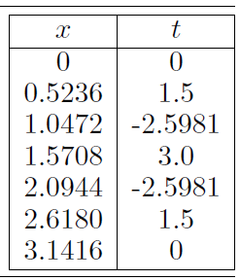

Since the value x = 0.44 isn’t in the examples given, you need to find some way to predict what value it has. You assume that the values come from some sort of function, and try to find out what the function is. Then you’ll be able to give the output value y for any given value of x. This is known as a regression problem in statistics: fit a mathematical function describing a curve, so that the curve passes as close as possible to all of the datapoints. It is generally a problem of function approximation or interpolation, working out the value between values that we know.

The problem is how to work out what function to choose. Have a look at Figure 1.3. The top-left plot shows a plot of the 7 values of x and y in the table, while the other plots show different attempts to fit a curve through the datapoints. The bottom-left plot shows two possible answers found by using straight lines to connect up the points, and also what happens if we try to use a cubic function (something that can be written as ax3 +bx2 +cx+d = 0). The top-right plot shows what happens when we try to match the function using a different polynomial, this time of the form ax10 + bx9 + . . . + jx + k = 0, and finally the bottom-right plot shows the function y = 3 sin(5x). Which of these functions would you choose?

The straight-line approximation probably isn’t what we want, since it doesn’t tell us much about the data. However, the cubic plot on the same set of axes is terrible: it doesn’t get anywhere near the datapoints. What about the plot on the top-right? It looks like it goes through all of the datapoints exactly, but it is very wiggly (look at the value on the y-axis, which goes up to 100 instead of around three, as in the other figures). In fact, the data were made with the sine function plotted on the bottom-right, so that is the correct answer in this case, but the algorithm doesn’t know that, and to it the two solutions on the right both look equally good. The only way we can tell which solution is better is to test how well they generalise. We pick a value that is between our datapoints, use our curves to predict its value, and see which is better. This will tell us that the bottom-right curve is better in the example.

So one thing that our machine learning algorithms can do is interpolate between datapoints. This might not seem to be intelligent behaviour, or even very difficult in two dimensions, but it is rather harder in higher dimensional spaces. The same thing is true of the other thing that our algorithms will do, which is classification—grouping examples into different classes—which is discussed next. However, the algorithms are learning by our definition if they adapt so that their performance improves, and it is surprising how often real problems that we want to solve can be reduced to classification or regression problems.

### Classification

The classification problem consists of taking input vectors and deciding which of N classes they belong to, based on training from exemplars of each class. The most important point about the classification problem is that it is discrete—each example belongs to precisely one class, and the set of classes covers the whole possible output space. These two constraints are not necessarily realistic; sometimes examples might belong partially to two different classes. There are fuzzy classifiers that try to solve this problem, but we won’t be talking about them in this book. In addition, there are many places where we might not be able to categorise every possible input. For example, consider a vending machine, where we use a neural network to learn to recognise all the different coins. We train the classifier to recognise all New Zealand coins, but what if a British coin is put into the machine? In that case, the classifier will identify it as the New Zealand coin that is closest to it in appearance, but this is not really what is wanted: rather, the classifier should identify that it is not one of the coins it was trained on. This is called novelty detection. For now, we’ll assume that we will not receive inputs that we cannot classify accurately.

Let’s consider how to set up a coin classifier. When the coin is pushed into the slot, the machine takes a few measurements of it. These could include the diameter, the weight, and possibly the shape, and are the features that will generate our input vector. In this case, our input vector will have three elements, each of which will be a number showing the measurement of that feature (choosing a number to represent the shape would involve an encoding, for example that 1=circle, 2=hexagon, etc.). Of course, there are many other features that we could measure. If our vending machine included an atomic absorption spectroscope, then we could estimate the density of the material and its composition, or if it had a camera, we could take a photograph of the coin and feed that image into the classifier. The question of which features to choose is not always an easy one. We don’t want to use too many inputs, because that will make the training of the classifier take longer (and also, as the number of input dimensions grows, the number of datapoints required increases faster; this is known as the curse of dimensionality), but we need to make sure that we can reliably separate the classes based on those features. For example, if we tried to separate coins based only on colour, we wouldn’t get very far, because the 20 $ and 50 $ coins are both silver and the $1 and $2 coins both bronze. However, if we use colour and diameter, we can do a pretty good job of the coin classification problem for NZ coins. There are some features that are entirely useless. For example, knowing that the coin is circular doesn’t tell us anything about NZ coins, which are all circular (see Figure 1.4). In other countries, though, it could be very useful.

The methods of performing classification that we will see during this book are very different in the ways that they learn about the solution; in essence they aim to do the same thing: find decision boundaries that can be used to separate out the different classes. Given the features that are used as inputs to the classifier, we need to identify some values of those features that will enable us to decide which class the current input is in. Figure 1.5 shows a set of 2D inputs with three different classes shown, and two different decision boundaries; on the left they are straight lines, and are therefore simple, but don’t categorise as well as the non-linear curve on the right.

Now that we have seen these two types of problem, let’s take a look at the whole process of machine learning from the practitioner’s viewpoint



**FIGURE 1.4 The New Zealand coins.**



**FIGURE 1.5 Left: A set of straight line decision boundaries for a classification problem. Right: An alternative set of decision boundaries that separate the plusses from the lightening strikes better, but requires a line that isn’t straight.**

## SUPERVISED LEARNING

This section assumes that you have some problem that you are interested in using machine learning on, such as the coin classification that was described previously. It briefly examines the process by which machine learning algorithms can be selected, applied, and evaluated for the problem.

**Data Collection and Preparation** Throughout this book we will be in the fortunate position of having datasets readily available for downloading and using to test the algorithms. This is, of course, less commonly the case when the desire is to learn about some new problem, when either the data has to be collected from scratch, or at the very least, assembled and prepared. In fact, if the problem is completely new, so that appropriate data can be chosen, then this process should be merged with the next step of feature selection, so that only the required data is collected. This can typically be done by assembling a reasonably small dataset with all of the features that you believe might be useful, and experimenting with it before choosing the best features and collecting and analysing the full dataset.

Often the difficulty is that there is a large amount of data that might be relevant, but it is hard to collect, either because it requires many measurements to be taken, or because they are in a variety of places and formats, and merging it appropriately is difficult, as is ensuring that it is clean; that is, it does not have significant errors, missing data, etc.

For supervised learning, target data is also needed, which can require the involvement of experts in the relevant field and significant investments of time. Finally, the quantity of data needs to be considered. Machine learning algorithms need significant amounts of data, preferably without too much noise, but with increased dataset size comes increased computational costs, and the sweet spot at which thereis enough data without excessive computational overhead is generally impossible to predict.

**Feature Selection** an example of this part of the process was given in Section 0.3.2 when we looked at possible features that might be useful for coin recognition. It consists of identifying the features that are most useful for the problem under examination. This invariably requires prior knowledge of the problem and the data; our common sense was used in the coin’s example above to identify some potentially useful features and to exclude others.

As well as the identification of features that are useful for the learner, it is also necessary that the features can be collected without significant expense or time, and that they are robust to noise and other corruption of the data that may arise in the collection process.

**Algorithm Choice** Given the dataset, the choice of an appropriate algorithm (or algorithms) is what this book should be able to prepare you for, in that the knowledge of the underlying principles of each algorithm and examples of their use is precisely what is required for this.

**Parameter and Model Selection** for many of the algorithms there are parameters that have to be set manually, or that require experimentation to identify appropriate values. These requirements are discussed at the appropriate points of the book.

**Training** Given the dataset, algorithm, and parameters, training should be simply the use of computational resources in order to build a model of the data in order to predict the outputs on new data.

**Evaluation** Before a system can be deployed it needs to be tested and evaluated for accuracy on data that it was not trained on. This can often include a comparison with human experts in the field, and the selection of appropriate metrics for this comparison.

# **CHAPTER-1 Preliminaries**

## SOME TERMINOLOGY

We start by considering some of the terminology that we will use throughout the documentation. We will talk about inputs and input vectors for our learning algorithms. Likewise, we will talk about the outputs of the algorithm. The inputs are the data that is fed into the algorithm. In general, machine learning algorithms all work by taking a set of input values, producing an output (answer) for that input vector, and then moving on to the next input. The input vector will typically be several real numbers, which is why it is described as a vector: it is written down as a series of numbers, e.g., (0.2, 0.45, 0.75, −0.3). The size of this vector, i.e., the number of elements in the vector, is called the dimensionality of the input. This is because if we were to plot the vector as a point, we would need one dimension of space for each of the different elements of the vector, so that the example above has 4 dimensions.

We will often write equations in vector and matrix notation, with lowercase boldface letters being used for vectors and uppercase boldface letters for matrices. A vector *x* has elements (*x1, x2, . . ., xm*). We will use the following notation in the documentation:

* **Inputs** an input vector is the data given as one input to the algorithm. Written as *x*, with elements *xi*, where *i* runs from 1 to the number of input dimensions, *m*.
* **Weights** *wij*, are the weighted connections between nodes *i* and *j*. For neural networks these weights are analogous to the synapses in the brain. They are arranged into a matrix *W*.
* **Outputs** The output vector is *y*, with elements *yj* , where *j* runs from 1 to the number of output dimensions, *n*. We can write *y(x,W)* to remind ourselves that the output depends on the inputs to the algorithm and the current set of weights of the network.
* **Targets** The target vector *t*, with elements *tj*, where *j* runs from 1 to the number of output dimensions, *n*, are the extra data that we need for supervised learning, since they provide the ‘correct’ answers that the algorithm is learning about.
* **Activation Function** for neural networks, *g (·)* is a mathematical function that describes the firing of the neuron as a response to the weighted inputs, such as the threshold function described in Section 3.1.2.
* **Error E**, a function that computes the inaccuracies of the network as a function of the outputs *y* and targets *t*.

# **CHAPTER-2 Preliminaries**

## 2.1 KNOWING WHAT YOU KNOW: TESTING ML ALGORITHMS

The purpose of learning is to get better at predicting the outputs, be they class labels or continuous regression values. The only real way to know how successfully the algorithm has learnt is to compare the predictions with known target labels, which is how the training is done for supervised learning. This suggests that one thing you can do is just to look at the error that the algorithm makes on the training set.

However, we want the algorithms to generalize to examples that were not seen in the training set, and we obviously can’t test this by using the training set. So, we need some different data, a test set, to test it on as well. We use this test set of (input, target) pairs by feeding them into the network and comparing the predicted output with the target, but we don’t modify the weights or other parameters for them: we use them to decide how well the algorithm has learnt. The only problem with this is that it reduces the amount of data that we have available for training, but that is something that we will just have to live with.

### 2.1.1 Overfitting

Unfortunately, things are a little bit more complicated than that, since we might also want to know how well the algorithm is generalizing as it learns: we need to make sure that we do enough training that the algorithm generalizes well. In fact, there is at least as much danger in over-training as there is in under-training. The number of degrees of variability in most machine learning algorithms is huge — for a neural network there are lots of weights, and each of them can vary. This is undoubtedly more variation than there is in the function we are learning, so we need to be careful: if we train for too long, then we will overfit the data, which means that we have learnt about the noise and inaccuracies in the data as well as the actual function. Therefore, the model that we learn will be much too complicated, and won’t be able to generalize. Figure 2.1 shows this by plotting the predictions of some algorithm (as the curve) at

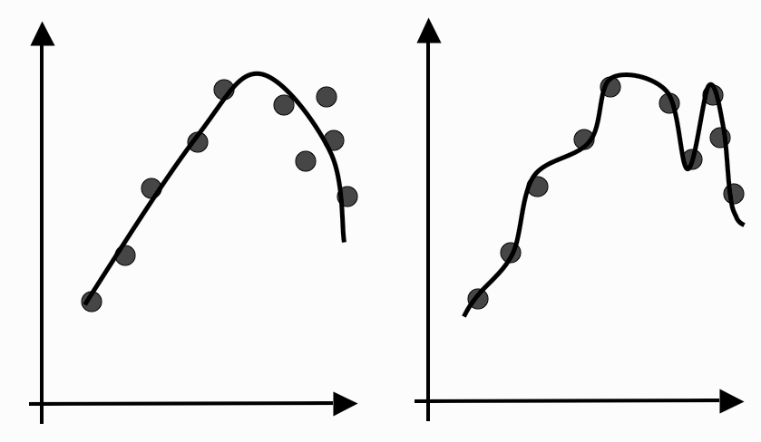

**FIGURE 2.1 The effect of overfitting is that rather than finding the generating function (as shown on the left), the neural network matches the inputs perfectly, including the noise in them (on the right). This reduces the generalization capabilities of the network.**

two different points in the learning process. On the left of the figure the curve fits the overall trend of the data well (it has generalized to the underlying general function), but the training error would still not be that close to zero since it passes near, but not through, the training data. As the network continues to learn, it will eventually produce a much more complex model that has a lower training error (close to zero), meaning that it has memorized the training examples, including any noise component of them, so that is has overfitted the training data.

We want to stop the learning process before the algorithm overfits, which means that we need to know how well it is generalizing at each timestep. We can’t use the training data for this, because we wouldn’t detect overfitting, but we can’t use the testing data either, because we’re saving that for the final tests. So, we need a third set of data to use for this purpose, which is called the validation set because we’re using it to validate the learning so far. This is known as cross-validation in statistics. It is part of model selection: choosing the right parameters for the model so that it generalizes as well as possible.

### 2.1.2 Training, Testing and Validation Sets

We now need three sets of data: the training set to actually train the algorithm, the validation set to keep track of how well it is doing as it learns, and the test set to produce the final results. This is becoming expensive in data, especially since for supervised learning it all has to have target values attached (and even for unsupervised learning, the validation and test sets need targets so that you have something to compare to), and it is not always easy to get accurate labels (which may well be why you want to learn about the data). The area of semi-supervised learning attempts to deal with this need for large amounts of labelled data; see the Further Reading section for some references.

Clearly, each algorithm is going to need some reasonable amount of data to learn from (precise needs vary, but the more data the algorithm sees, the more likely it is to have seen examples of each possible type of input, although more data also increases the computational time to learn). However, the same argument can be used to argue that the validation and

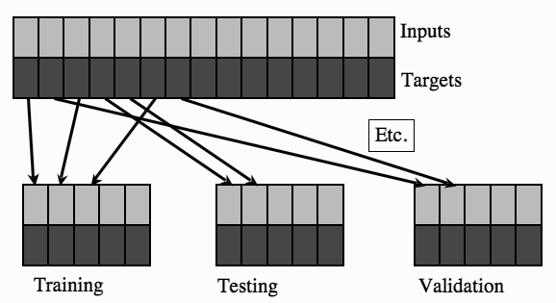

**FIGURE 2.2 The dataset is split into different sets, some for training, some for validation, and some for testing.**

test sets should also be reasonably large. Generally, the exact proportion of training to testing to validation data is up to you, but it is typical to do something like 50:25:25 if you have plenty of data, and 60:20:20 if you don’t. How you do the splitting can also matter. Many datasets are presented with the first set of datapoints being in class 1, the next in class 2, and so on. If you pick the first few points to be the training set, the next the test set, etc., then the results are going to be pretty bad, since the training did not see all the classes. This can be dealt with by randomly reordering the data first, or by assigning each datapoint randomly to one of the sets, as is shown in Figure 2.2. If you are really short of training data, so that if you have a separate validation set there is a worry that the algorithm won’t be sufficiently trained; then it is possible to perform leave-some-out, multi-fold cross validation. The idea is shown in Figure 2.3. The dataset is randomly partitioned into K subsets, and one subset is used as a validation set, while the algorithm is trained on all of the others. A different subset is then left out and a new model is trained on that subset, repeating the same process for all of the different subsets. Finally, the model that produced the lowest validation error is tested and used. We’ve traded off data for computation time, since we’ve had to train K different models instead of just one. In the most extreme case of this there is leave-one-out cross-validation, where the algorithm is validated on just one piece of data, training on all of the rest.

### 2.1.3 The Confusion Matrix

Regardless of how much data we use to test the trained algorithm, we still need to work out whether or not the result is good. We will look here at a method that is suitable for classification problems that is known as the confusion matrix. For regression problems things are more complicated because the results are continuous, and so the most common thing to use is the sum-of-squares error that we will use to drive the training in the following chapters. We will see these methods being used as we look at examples.

The confusion matrix is a nice simple idea: make a square matrix that contains all the possible classes in both the horizontal and vertical directions and list the classes along the top of a table as the predicted outputs, and then down the left-hand side as the targets. So for example, the element of the matrix at (*i, j*) tells us how many input patterns were put

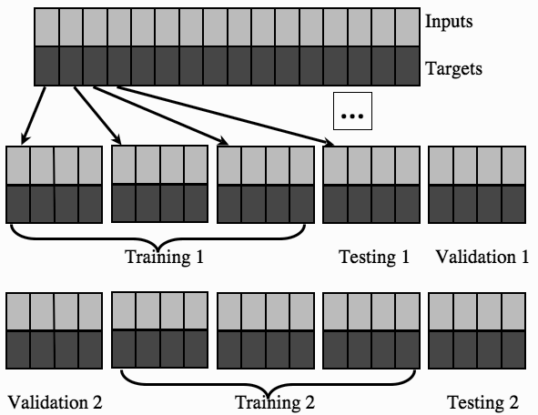

**FIGURE 2.3 Leave-some-out, multi-fold cross-validation gets around the problem of data shortage by training many models. It works by splitting the data into sets, training a model on most sets and holding one out for validation (and another for testing). Different models are trained with different sets being held out.**

into class i in the targets, but class j by the algorithm. Anything on the leading diagonal (the diagonal that starts at the top left of the matrix and runs down to the bottom right) is a correct answer. Suppose that we have three classes: C1, C2, and C3. Now we count the number of times that the output was class C1 when the target was C1, then when the target was C2, and so on until we’ve filled in the table:

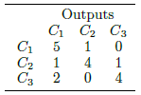

This table tells us that, for the three classes, most examples were classified correctly, but two examples of class C3 were misclassified as C1, and so on. For a small number of classes this is a nice way to look at the outputs. If you just want one number, then it is possible to divide the sum of the elements on the leading diagonal by the sum of all of the elements in the matrix, which gives the fraction of correct responses. This is known as the accuracy, and we are about to see that it is not the last word in evaluating the results of a machine learning algorithm.

# **CHAPTER-3 Neurons, Neural Networks and Linear Discriminants**

## 3.1 THE BRAIN AND THE NEURON

In animals, learning occurs within the brain. If we can understand how the brain works, then there might be things in there for us to copy and use for our machine learning systems. While the brain is an impressively powerful and complicated system, the basic building blocks that it is made up of are fairly simple and easy to understand. We’ll look at them shortly, but it’s worth noting that in computational terms the brain does exactly what we want. It deals with noisy and even inconsistent data, and produces answers that are usually correct from very high dimensional data (such as images) very quickly. All amazing for something that weighs about 1.5 kg and is losing parts of itself all the time (neurons die as you age at impressive/depressing rates), but its performance does not degrade appreciably (in the jargon, this means it is robust).

So how does it actually work? We aren’t actually that sure on most levels, but in this documentation, we are only going to worry about the most basic level, which is the processing units of the brain. These are nerve cells called neurons. There are lots of them (100 billion = 1011 is the figure that is often given) and they come in lots of different types, depending upon their particular task. However, their general operation is similar in all cases: transmitter chemicals within the fluid of the brain raise or lower the electrical potential inside the body of the neuron. If this membrane potential reaches some threshold, the neuron spikes or fires, and a pulse of fixed strength and duration is sent down the axon. The axons divide (arborize) into connections to many other neurons, connecting to each of these neurons in a synapse.

Each neuron is typically connected to thousands of other neurons, so that it is estimated that there are about 100 trillion (= 1014) synapses within the brain. After firing, the neuron must wait for some time to recover its energy (the refractory period) before it can fire again. Each neuron can be viewed as a separate processor, performing a very simple computation: deciding whether or not to fire. This makes the brain a massively parallel computer made up of 1011 processing elements. If that is all there is to the brain, then we should be able to model it inside a computer and end up with animal or human intelligence inside a computer. This is the view of strong AI. We aren’t aiming at anything that grand in this documentation, but we do want to make programs that learn. So how does learning occur in the brain? The principal concept is plasticity: modifying the strength of synaptic connections between neurons, and creating new connections. We don’t know all of the mechanisms by which the strength of these synapses gets adapted, but one method that does seem to be used was first postulated by Donald Hebb in 1949, and that is what is discussed now.

### 3.1.1 Hebb's Rule

Hebb’s rule says that the changes in the strength of synaptic connections are proportional to the correlation in the firing of the two connecting neurons. So if two neurons consistently fire simultaneously, then any connection between them will change in strength, becoming stronger. However, if the two neurons never fire simultaneously, the connection between them will die away. The idea is that if two neurons both respond to something, then they should be connected.

### 3.1.2 McCulloch and Pitts Neuron

We’re going to look at a mathematical model of a neuron that was introduced in 1943. The purpose of a mathematical model is that it extracts only the bare essentials required to accurately represent the entity being studied, removing all of the extraneous details. McCulloch and Pitts produced a perfect example of this when they modelled a neuron as:

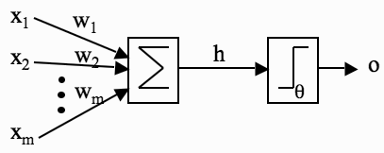

**FIGURE 3.1 A picture of McCulloch and Pitts’ mathematical model of a neuron. The inputs *xi* are multiplied by the weights *wi*, and the neurons sum their values. If this sum is greater than the threshold θ then the neuron fires; otherwise it does not.**

1. **A set of weighted inputs** *wi*that correspond to the synapses
2. **An adder** that sums the input signals (equivalent to the membrane of the cell that collects electrical charge)
3. **An activation function** (initially a threshold function) that decides whether the neuron fires (‘spikes’) for the current inputs

A picture of their model is given in Figure 3.1, and we’ll use the picture to write down a mathematical description. On the left of the picture are a set of input nodes (labelled *x1, x2, . . . xm*). These are given some values, and as an example we’ll assume that there are three inputs, with *x1* = 1, *x2* = 0, *x3* = 0.5. In real neurons those inputs come from the outputs of other neurons. So the 0 means that a neuron didn’t fire, the 1 means it did, and the 0.5 has no biological meaning, but never mind. (Actually, this isn’t quite fair, but it’s a long story and not very relevant.) Each of these other neuronal firings flowed along a synapse to arrive at our neuron, and those synapses have strengths, called weights. The strength of the synapse affects the strength of the signal, so we multiply the input by the weight of the synapse (so we get *x1 × w1 and x2 × w2*, etc.). Now when all of these signals arrive into our neuron, it adds them up to see if there is enough strength to make it fire. We’ll write that as

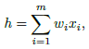.....(3.1)

which just means sum (add up) all the inputs multiplied by their synaptic weights. I’ve assumed that there are *m* of them, where *m* = 3 in the example. If the synaptic weights are *w1* = 1, *w2* = −0.5, *w3* = −1, then the inputs to our model neuron are *h* = 1 × 1 + 0 × (−0.5) + 0.5 × (−1) = 1 + 0 + (−0.5) = 0.5. Now the neuron needs to decide if it is going to fire. For a real neuron, this is a question of whether the membrane potential is above some threshold. We’ll pick a threshold value (labelled θ), say θ = 0 as an example. Now, does our neuron fire? Well, *h* = 0.5 in the example, and 0.5 > 0, so the neuron does fire, and produces output 1. If the neuron did not fire, it would produce output 0.

The McCulloch and Pitts neuron is a binary threshold device. It sums up the inputs (multiplied by the synaptic strengths or weights) and either fires (produces output 1) or does not fire (produces output 0) depending on whether the input is above some threshold. We can write the second half of the work of the neuron, the decision about whether or not to fire (which is known as an activation function), as:

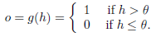…..(3.2)

This is a very simple model, but we are going to use these neurons, or very simple variations on them using slightly different activation functions (that is, we’ll replace the threshold function with something else) for most of our study of neural networks. In fact, these neurons might look simple, but as we shall see, a network of such neurons can perform any computation that a normal computer can, provided that the weights *wi* are chosen correctly. So one of the main things we are going to talk about for the next few chapters is methods of setting these weights.

### 3.1.3 Limitations of The McCulloch and Pitts Neuronal Model

One question that is worth considering is how realistic is this model of a neuron? The answer is: not very. Real neurons are much more complicated. The inputs to a real neuron are not necessarily summed linearly: there may be non-linear summations. However, the most noticeable difference is that real neurons do not output a single output response, but a spike train, that is, a sequence of pulses, and it is this spike train that encodes information. This means that neurons don’t actually respond as threshold devices, but produce a graded output in a continuous way. They do still have the transition between firing and not firing, though, but the threshold at which they fire changes over time. Because neurons are biochemical devices, the amount of neurotransmitter (which affects how much charge they required to spike, amongst other things) can vary according to the current state of the organism. Furthermore, the neurons are not updated sequentially according to a computer clock, but update themselves randomly (asynchronously), whereas in many of our models we will update the neurons according to the clock. There are neural network models that are asynchronous, but for our purposes we will stick to algorithms that are updated by the clock.

Note that the weights wi can be positive or negative. This corresponds to excitatory and inhibitory connections that make neurons more likely to fire and less likely to fire, respectively.

Both of these types of synapses do exist within the brain, but with the McCulloch and Pitts neurons, the weights can change from positive to negative or vice versa, which has not been seen biologically—synaptic connections are either excitatory or inhibitory, and never change from one to the other. Additionally, real neurons can have synapses that link back to themselves in a feedback loop, but we do not usually allow that possibility when we make networks of neurons. Again, there are exceptions, but we won’t get into them.

It is possible to improve the model to include many of these features, but the picture is complicated enough already, and McCulloch and Pitts neurons already provide a great deal of interesting behavior that resembles the action of the brain, such as the fact that networks of McCulloch and Pitts neurons can memories pictures and learn to represent functions and classify data, as we shall see in the next couple of chapters. In the last chapter we saw a simple model of a neuron that simulated what seems to be the most important function of a neuron—deciding whether or not to fire—and ignored the nasty biological things like chemical concentrations, refractory periods, etc. Having this model is only useful if we can use it to understand what is happening when we learn, or use the model in order to solve some kind of problem. We are going to try to do both in this chapter, although the learning that we try to understand will be machine learning rather than animal learning.

## 3.2 NEURAL NETWORKS

One thing that is probably fairly obvious is that one neuron isn’t that interesting. It doesn’t do very much, except fire or not fire when we give it inputs. In fact, it doesn’t even learn. If we feed in the same set of inputs over and over again, the output of the neuron never varies—it either fires or does not. So to make the neuron a little more interesting we need to work out how to make it learn, and then we need to put sets of neurons together into neural networks so that they can do something useful.

The question we need to think about first is how our neurons can learn. We are going to look at supervised learning for the next few chapters, which means that the algorithms will learn by example: the dataset that we learn from has the correct output values associated with each datapoint. At first sight this might seem pointless, since if you already know the correct answer, why bother learning at all? The key is in the concept of generalisation that we saw in Section 0.1. Assuming that there is some pattern in the data, then by showing the neural network a few examples we hope that it will find the pattern and predict the other examples correctly. This is sometimes known as **pattern recognition**.

Have a look again at the McCulloch and Pitts neuron (e.g., in Figure 3.1) and try to work out what can change in that model. The only things that make up the neuron are the inputs, the weights, and the threshold (and there is only one threshold for each neuron, but lots of inputs). The inputs can’t change, since they are external, so we can only change the weights and the threshold, which is interesting since it tells us that most of the learning is in the weights, which aren’t part of the neuron at all; they are the model of the synapse! Getting excited about neurons turns out to be missing something important, which is that the learning happens between the neurons, in the way that they are connected together.

So in order to make a neuron learn, the question that we need to ask is:

How should we change the weights and thresholds of the neurons so that the network gets the right answer more often?

Now that we know the right question to ask we’ll have a look at our very first neural network, the space-age sounding Perceptron, and see how we can use it to solve the problem (it really was space-age, too: created in 1958). Once we’ve worked out the algorithm and how it works, we’ll look at what it can and cannot do, and then see how statistics can give us insights into learning as well.

## 3.3 THE PERCEPTRON

The Perceptron is nothing more than a collection of McCulloch and Pitts neurons together with a set of inputs and some weights to fasten the inputs to the neurons. The network is shown in Figure 3.2. On the left of the figure, shaded in light grey, are the input nodes. These are not neurons, they are just a nice schematic way of showing how values are fed into the network, and how many of these input values there are (which is the dimension (number of elements) in the input vector). They are almost always drawn as circles, just like neurons, which is rather confusing, so I’ve shaded them a different colour. The neurons are shown on the right, and you can see both the additive part (shown as a circle) and the thresholder. In practice nobody bothers to draw the thresholder separately, you just need to remember that it is part of the neuron.



**FIGURE 3.2 The Perceptron network, consisting of a set of input nodes (left) connected to McCulloch and Pitts neurons using weighted connections.**

Notice that the neurons in the Perceptron are completely independent of each other: it doesn’t matter to any neuron what the others are doing, it works out whether or not to fire by multiplying together its own weights and the input, adding them together, and comparing the result to its own threshold, regardless of what the other neurons are doing. Even the weights that go into each neuron are separate for each one, so the only thing they share is the inputs, since every neuron sees all of the inputs to the network.

In Figure 3.2 the number of inputs is the same as the number of neurons, but this does not have to be the case — in general there will be *m* inputs and *n* neurons. The number of inputs is determined for us by the data, and so is the number of outputs, since we are doing supervised learning, so we want the Perceptron to learn to reproduce a particular target, that is, a pattern of firing and non-firing neurons for the given input.

When we looked at the McCulloch and Pitts neuron, the weights were labelled as *wi*, with the *i* index running over the number of inputs. Here, we also need to work out which neuron the weight feeds into, so we label them as *wij,* where the *j* index runs over the number of neurons. So *w*32 is the weight that connects input node 3 to neuron 2. When we make an implementation of the neural network, we can use a two-dimensional array to hold these weights.

Now, working out whether or not a neuron should fire is easy: we set the values of the input nodes to match the elements of an input vector and then use Equations (3.1) and (3.2) for each neuron. We can do this for all of the neurons, and the result is a pattern of firing and non-firing neurons, which looks like a vector of 0s and 1s, so if there are 5 neurons, as in Figure 3.2, then a typical output pattern could be (0, 1, 0, 0, 1), which means that the second and fifth neurons fired and the others did not. We compare that pattern to the target, which is our known correct answer for this input, to identify which neurons got the answer right, and which did not.

For a neuron that is correct, we are happy, but any neuron that fired when it shouldn’t have done, or failed to fire when it should, needs to have its weights changed. The trouble is that we don’t know what the weights should be—that’s the point of the neural network, after all, so we want to change the weights so that the neuron gets it right next time. We are going to talk about this in a lot more detail in Chapter 4, but for now we’re going to do something fairly simple to see that it is possible to find a solution.

Suppose that we present an input vector to the network and one of the neurons gets the wrong answer (its output does not match the target). There are *m* weights that are connected to that neuron, one for each of the input nodes. If we label the neuron that is wrong as *k*, then the weights that we are interested in are *wik*, where *i* runs from 1 to *m*. So we know which weights to change, but we still need to work out how to change the values of those weights. The first thing we need to know is whether each weight is too big or too small. This seems obvious at first: some of the weights will be too big if the neuron fired when it shouldn’t have, and too small if it didn’t fire when it should. So we compute *yk* –*tk* (the difference between the output *yk*, which is what the neuron did, and the target for that neuron, *tk*, which is what the neuron should have done. This is a possible error function). If it is negative then the neuron should have fired and didn’t, so we make the weights bigger, and vice versa if it is positive, which we can do by subtracting the error value. Hold on, though. That element of the input could be negative, which would switch the values over; so if we wanted the neuron to fire we’d need to make the value of the weight negative as well. To get around this we’ll multiply those two things together to see how we should change the weight: Δ*wik* = − (*yk* − *tk*) × *xi*, and the new value of the weight is the old value plus his value.

Note that we haven’t said anything about changing the threshold value of the neuron. To see how important this is, suppose that a particular input is 0. In that case, even if a neuron is wrong, changing the relevant weight doesn’t do anything (since anything times 0 is 0): we need to change the threshold. We will deal with this in an elegant way in Section 3.3.2. However, before we get to that, the learning rule needs to be finished—we need to decide how much to change the weight by. This is done by multiplying the value above by a parameter called the learning rate, usually labelled as *η*. The value of the learning rate decides how fast the network learns. It’s quite important, so it gets a little subsection of its own (next), but first let’s write down the final rule for updating a weight *wij:*

…..(3.3)

The other thing that we need to realise now is that the network needs to be shown every training example several times. The first time the network might get some of the answers correct and some wrong; the next time it will hopefully improve, and eventually its performance will stop improving. Working out how long to train the network for is not easy (we will see more methods in Section 4.3.3), but for now we will predefine the maximum number of iterations, *T*. Of course, if the network got all of the inputs correct, then this would also be a good time to stop.



**FIGURE 3.3 The Perceptron network again, showing the bias input.**

### 3.3.1 The Learning Rate η

Equation (3.3) above tells us how to change the weights, with the parameter *η* controlling how much to change the weights by. We could miss it out, which would be the same as setting it to 1. If we do that, then the weights change a lot whenever there is a wrong answer, which tends to make the network unstable, so that it never settles down. The cost of having a small learning rate is that the weights need to see the inputs more often before they change significantly, so that the network takes longer to learn. However, it will be more stable and resistant to noise (errors) and inaccuracies in the data. We therefore use a moderate learning rate, typically 0*.*1 *< η <* 0*.*4, depending upon how much error we expect in the inputs. It doesn’t matter for the Perceptron algorithm, but for many of the algorithms that we will see in the book, the learning rate is a crucial parameter.

### 3.3.2 The Bias Input

When we discussed the McCulloch and Pitts neuron, we gave each neuron a firing threshold *θ* that determined what value it needed before it should fire. This threshold should be adjustable, so that we can change the value that the neuron fires at. Suppose that all of the inputs to a neuron are zero. Now it doesn’t matter what the weights are (since zero times anything equals zero), the only way that we can control whether the neuron fires or not is through the threshold. If it wasn’t adjustable and we wanted one neuron to fire when all the inputs to the network were zero, and another not to fire, then we would have a problem. No matter what values of the weights were set, the two neurons would do the same thing since they had the same threshold and the inputs were all zero.

The trouble is that changing the threshold requires an extra parameter that we need to write code for, and it isn’t clear how we can do that in terms of the weight update that we worked out earlier. Fortunately, there is a neat way around this problem. Suppose that we fix the value of the threshold for the neuron at zero. Now, we add an extra input weight to the neuron, with the value of the input to that weight always being fixed (usually the value of -± is chosen; in this book I’m going to use -1 to make it stand out, but any non-zero value will do). We include that weight in our update algorithm (like all the other weights), so we don’t need to think of anything new. And the value of the weight will change to make the neuron fire—or not fire, whichever is correct—when an input of all zeros is given, since the input on that weight is always -1, even when all the other inputs are zero. This input is called a bias node, and its weights are usually given a 0 subscript, so that the weight connecting it to the *j*th neuron is *w*0*j.*

### 3.3.3 The Perceptron Learning Algorithm

We are now ready to write our first learning algorithm. It might be useful to keep Figure 3.3 in mind as you read the algorithm, and we’ll work through an example of using it afterwards. The algorithm is separated into two parts: a training phase, and a recall phase. The recall phase is used after training, and it is the one that should be fast to use, since it will be used far more often than the training phase. You can see that the training phase uses the recall equation, since it has to work out the activations of the neurons before the error can be calculated and the weights trained.

The Perceptron Algorithm

* **Initialisation**
  + set all of the weights wij to small (positive and negative) random numbers
* **Training**
  + for T iterations or until all the outputs are correct:

**\***for each input vector:

**•** compute the activation of each neuron j using activation function g:

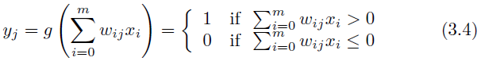….(3.4)

**•** update each of the weights individually using:

….(3.5)

* **Recall**
  + compute the activation of each neuron *j* using:

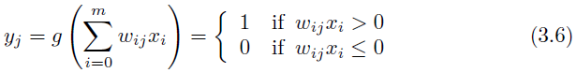….(3.6)

**_____________________________________________________________________________________**

Computing the computational complexity of this algorithm is very easy. The recall phase loops over the neurons, and within that loops over the inputs, so its complexity is O(*mn*). The training part does this same thing, but does it for *T* iterations, so costs O(*Tmn*).

It might be the first time that you have seen an algorithm written out like this, and it could be hard to see how it can be turned into code. Equally, it might be difficult to believe that something as simple as this algorithm can learn something. The only way to fix these things is to work through the algorithm by hand on an example or two, and to try to write the code and then see if it does what is expected. We will do both of those things next, first working through a simple example by hand.

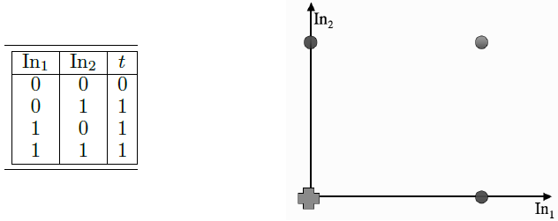

**FIGURE 3.4 Data for the OR logic function and a plot of the four datapoints.**



**FIGURE 3.5 The Perceptron network for the example in Section 3.3.4.**

### 3.3.4 An Example of Perceptron Learning: Logic Functions

The example we are going to use is something very simple that you already know about, the logical OR. This obviously isn’t something that you actually need a neural network to learn about, but it does make a nice simple example. So what will our neural network look like? There are two input nodes (plus the bias input) and there will be one output. The inputs and the target are given in the table on the left of Figure 3.4; the right of the figure shows a plot of the function with the circles as the true outputs, and a cross as the false one. The corresponding neural network is shown in Figure 3.5.

As you can see from Figure 3.5, there are three weights. The algorithm tells us to initialise the weights to small random numbers, so we’ll pick *w*0 = −0*.*05*, w*1 = −0*.*02*, w*2 = 0*.*02. Now we feed in the first input, where both inputs are 0: (0*,* 0). Remember that the input to the bias weight is always −1, so the value that reaches the neuron is −0*.*05 × −1 + −0*.*02 × 0 + 0*.*02 × 0 = 0*.*05. This value is above 0, so the neuron fires and the output is 1, which is incorrect according to the target. The update rule tells us that we need to apply Equation (3.3) to each of the weights separately (we’ll pick a value of *η* = 0*.*25 for the example):

*w*0: −0*.*05 − 0*.*25 × (1 − 0) × −1 = 0*.*2*,* (3.7)

*w*1: −0*.*02 − 0*.*25 × (1 − 0) × 0 = −0*.*02*,* (3.8)

*w*2: 0*.*02 − 0*.*25 × (1 − 0) × 0 = 0*.*02*.* (3.9)

Now we feed in the next input (0*,* 1) and compute the output (check that you agree that the neuron does not fire, but that it should) and then apply the learning rule again:

*w*0: 0*.*2 − 0*.*25 × (0 − 1) × −1 = −0*.*05*,* (3.10)

*w*1: −0*.*02 − 0*.*25 × (0 − 1) × 0 = −0*.*02*,* (3.11)

*w*2: 0*.*02 − 0*.*25 × (0 − 1) × 1 = 0*.*27*.* (3.12)

For the (1*,* 0) input the answer is already correct (you should check that you agree with this), so we don’t have to update the weights at all, and the same is true for the (1*,* 1) input. So now we’ve been through all of the inputs once. Unfortunately, that doesn’t mean we’ve finished—not all the answers are correct yet. We now need to start going through the inputs again, until the weights settle down and stop changing, which is what tells us that the algorithm has finished. For real-world applications the weights may never stop changing, which is why you run the algorithm for some pre-set number of iterations, *T*.

So now we carry on running the algorithm, which you should check for yourself either by hand or using computer code (which we’ll discuss next), eventually getting to weight values that settle and stop changing. At this point the weights stop changing, and the Perceptron has correctly learnt all of the examples. Note that there are lots of different values that we can assign to the weights that will give the correct outputs; the ones that the algorithm finds depend on the learning rate, the inputs, and the initial starting values. We are interested in finding a set that works; we don’t necessarily care what the actual values are, providing that the network generalises to other inputs.

## 3.4 LINEAR SEPARABILITY

What does the Perceptron actually compute? For our one output neuron example of the OR data it tries to separate out the cases where the neuron should fire from those where it shouldn’t. Looking at the graph on the right side of Figure 3.4, you should be able to draw a straight line that separates out the crosses from the circles without difficulty (it is done in Figure 3.6). In fact, that is exactly what the Perceptron does: it tries to find a straight line (in 2D, a plane in 3D, and a hyperplane in higher dimensions) where the neuron fires on one side of the line, and doesn’t on the other. This line is called the decision boundary or discriminant function, and an example of one is given in Figure 3.7.



**FIGURE 3.6 The decision boundary computed by a Perceptron for the OR function.**



**FIGURE 3.7 A decision boundary separating two classes of data.**

To see this, think about the matrix notation we used in the implementation, but consider just one input vector **x**. The neuron fires if **x**·**w***T* ≥ 0 (where **w** is the row of **W** that connects the inputs to one particular neuron; they are the same for the OR example, since there is only one neuron, and **w***T* denotes the transpose of **w** and is used to make both of the vectors into column vectors). The **a** · **b** notation describes the inner or scalar product between two vectors. It is computed by multiplying each element of the first vector by the matching element of the second and adding them all together. As you might remember from high school, **a** · **b** = ‖*a*‖ ‖*b*‖ cos θ, where θis the angle between **a** and **b** and ‖*a*‖ is the length of the vector **a**. So the inner product computes a function of the angle between the two vectors, scaled by their lengths. It can be computed in NumPy using the np.inner() function. Getting back to the Perceptron, the boundary case is where we find an input vector **x**1 that has **x**1 · **w***T* = 0. Now suppose that we find another input vector **x**2 that satisfies **x**2 · **w***T* = 0. Putting these two equations together we get:

**x**1 · **w***T* = **x**2 · **w***T* (3.16)

⇒ (**x**1 − **x**2) · **w***T* = 0*.* (3.17)

What does this last equation mean? In order for the inner product to be 0, either ‖*a*‖ or ‖*b*‖ or cos θneeds to be zero. There is no reason to believe that ‖*a*‖ or ‖*b*‖ should be 0, so cos θ= 0. This means that θ= *π/2* (or – π*/*2), which means that the two vectors are at right angles to each other. Now **x**1 − **x**2 is a straight line between two points that lie on the decision boundary, and the weight vector **w***T* must be perpendicular to that, as in Figure 3.7.

So given some data, and the associated target outputs, the Perceptron simply tries to find a straight line that divides the examples where each neuron fires from those where it does not. This is great if that straight line exists, but is a bit of a problem otherwise. The cases where there is a straight line are called linearly separable cases. What happens if the classes that we want to learn about are not linearly separable? It turns out that making such a function is very easy: there is even one that matches a logic function. Before we have a look at it, it is worth thinking about what happens when we have more than one output neuron. The weights for each neuron separately describe a straight line, so by putting together several neurons we get several straight lines that each try to separate different parts of the space. Figure 3.8 shows an example of decision boundaries computed by a Perceptron with four neurons; by putting them together we can get good separation of the classes.



**FIGURE 3.8 Different decision boundaries computed by a Perceptron with four neurons.**

### 3.4.1 The Exclusive OR (XOR) Function

The XOR has the same four input points as the OR function, but looking at Figure 3.9, you should be able to convince yourself that you can’t draw a straight line on the graph that separates true from false (crosses from circles). In our new language, the XOR function is not linearly separable. If the analysis above is correct, then the Perceptron will fail to get the correct answer.

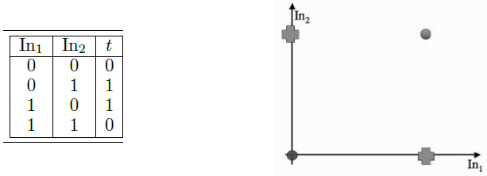

**FIGURE 3.9 Data for the XOR logic function and a plot of the four datapoints.**

So even for a simple logical function, the Perceptron can fail to learn the correct answer. This is what was demonstrated by Minsky and Papert in “Perceptrons,” and the discovery that the Perceptron was not capable of solving even these problems, let alone more interesting ones, is what halted neural network development for so long. There is an obvious solution to the problem, which is to make the network more complicated—add in more neurons, with more complicated connections between them, and see if that helps. The trouble is that this makes the problem of training the network much more difficult. In fact, working out how to do that is the topic of the next chapter.

### 3.4.2 A Useful Insight

From the discussion in Section 3.4.1 you might think that the XOR function is impossible to solve using a linear function. In fact, this is not true. If we rewrite the problem in three dimensions instead of two, then it is perfectly possible to find a plane (the 2D analogue of a straight line) that can separate the two classes. There is a picture of this in Figure 3.10. Writing the problem in 3D means including a third input dimension that does not change the data when it is looked at in the (*x, y*) plane, but moves the point at (0*,* 0) along a third dimension. So the truth table for the function is the one shown on the left side of Figure 3.10 (where ‘In3’ has been added, and only affects the point at (0*,* 0)).

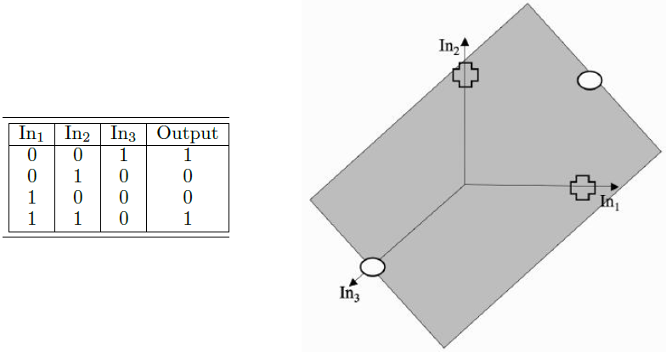

**FIGURE 3.10 A decision boundary (the shaded plane) solving the XOR problem in 3D with**

**the crosses below the surface and the circles above it.**

In fact, it is always possible to separate out two classes with a linear function, provided that you project the data into the correct set of dimensions. There is a whole class of methods for doing this reasonably efficiently, called kernel classifiers, which are the basis of Support Vector Machines.

For now, it is sufficient to point out that if you want to make your linear Perceptron do non-linear things, then there is nothing to stop you making non-linear variables. For example, Figure 3.11 shows two versions of the same dataset. On the left side, the coordinates are *x*1 and *x*2, while on the right side the coordinates are *x*1*, x*2 and *x*1 × *x*2. It is now easy to fit a plane (the 2D equivalent of a straight line) that separates the data.

Statistics has been dealing with problems of classification and regression for a long time, before we had computers in order to do difficult arithmetic for us, and so straight line methods have been around in statistics for many years. They provide a different (and useful) way to understand what is happening in learning, and by using both statistical and computer science methods we can get a good understanding of the whole area.

 

**FIGURE 3.11 Left: Non-separable 2D dataset. Right: The same dataset with third coordinate**

**x1 × x2, which makes it separable.**

### 3.4.3 Preprocessing: Data Preparation

Machine learning algorithms tend to learn much more effectively if the inputs and targets are prepared for analysis before the network is trained. As the most basic example, the neurons that we are using give outputs of 0 and 1, and so if the target values are not 0 and 1, then they should be transformed so that they are. In fact, it is normal to scale the targets to lie between 0 and 1 no matter what kind of activation function is used for the output layer neurons. This helps to stop the weights from getting too large unnecessarily. Scaling the inputs also helps to avoid this problem.

The most common approach to scaling the input data is to treat each data dimension independently, and then to either make each dimension have zero mean and unit variance in each dimension, or simply to scale them so that maximum value is 1 and the minimum -1. Both of these scalings have similar effects, but the first is a little bit better as it does not allow outliers to dominate as much. These scalings are commonly referred to as data normalisation, or sometimes standardisation. While normalisation is not essential for every algorithm, but it is usually beneficial, and for some of the other algorithms that we will see, the normalisation will be essential.

There is one thing to be careful of, which is that if you normalise the training and testing sets separately in this way then a datapoint that is in both sets will end up being different in the two, since the mean and variance are probably different in the two sets. For this reason, it is a good idea to normalise the dataset before splitting it into training and testing.

Normalisation can be done without knowing anything about the dataset in advance. However, there is often useful preprocessing that can be done by looking at the data. For example, in the Pima dataset, column 0 is the number of times that the person has been pregnant (did I mention that all the subjects were female?) and column 7 is the age of the person. Taking the pregnancy variable first, there are relatively few subjects that were pregnant 8 or more times, so rather than having the number there, maybe they should be replaced by an 8 for any of these values. Equally, the age would be better quantised into a set of ranges such as 21–30, 31–40, etc. (the minimum age is 21 in the dataset). If you make these changes and similar ones for the other values, then you should be able to get massively better results.

The last thing that we can do for now is to perform a basic form of feature selection and to try training the classifier with a subset of the inputs by missing out different features one at a time and seeing if they make the results better. If missing out one feature does improve the results, then leave it out completely and try missing out others as well. This is a simplistic way of testing for correlation between the output and each of the features.

# **CHAPTER-4 Multi-Layer Perceptron**

In the last chapter we saw that while linear models are easy to understand and use, they come with the inherent cost that is implied by the word ‘linear’; that is, they can only identify straight lines, planes, or hyperplanes. And this is not usually enough, because the majority of interesting problems are not linearly separable. In Section 3.4 we saw that problems can be made linearly separable if we can work out how to transform the features suitably.

We have pretty much decided that the learning in the neural network happens in the weights. So, to perform more computation it seems sensible to add more weights. There are two things that we can do: add some backwards connections, so that the output neurons connect to the inputs again, or add more neurons. The first approach leads into recurrent networks. These have been studied, but are not that commonly used. We will instead consider the second approach. We can add neurons between the input nodes and the outputs, and this will make more complex neural networks, such as the one shown in Figure 4.1.

We will think about why adding extra layers of nodes makes a neural network more powerful in Section 4.3.2, but for now, to persuade ourselves that it is true, we can check that a prepared network can solve the two-dimensional XOR problem, something that we have seen is not possible for a linear model like the Perceptron. A suitable network is shown in Figure 4.2. To check that it gives the correct answers, all that is required is to put in each input and work through the network, treating it as two different Perceptrons, first computing the activations of the neurons in the middle layer (labelled as C and D in Figure 4.2) and then using those activations as the inputs to the single neuron at the output. As an example, I’ll work out what happens when you put in (1*,* 0) as an input; the job of checking the rest is up to you.

Input (1*,* 0) corresponds to node A being 1 and B being 0. The input to neuron C is therefore −1 × 0*.*5 + 1 × 1 + 0 × 1 = −0*.*5 + 1 = 0*.*5. This is above the threshold of 0, and so neuron C fires, giving output 1. For neuron D the input is −1 × 1 + 1 × 1 + 0 × 1 = −1 + 1 = 0, and so it does not fire, giving output 0. Therefore, the input to neuron E is −1×0*.*5+1×1+0×−1 = 0*.*5, so neuron E fires. Checking the result of the inputs should persuade you that neuron E fires when inputs A and B are different to each other, but does not fire when they are the same, which is exactly the XOR function (it doesn’t matter that the fire and not fire have been reversed).

So far, so good. Since this network can solve a problem that the Perceptron cannot, it seems worth looking into further. However, now we’ve got a much more interesting problem to solve, namely how can we train this network so that the weights are adapted to generate the correct (target) answers? If we try the method that we used for the Perceptron we need to compute the error at the output. That’s fine, since we know the targets there, so we can compute the difference between the targets and the outputs. But now we don’t know which weights were wrong: those in the first layer, or the second? Worse, we don’t know what the correct activations are for the neurons in the middle of the network. This fact gives the neurons in the middle of the network their name; they are called the hidden layer (or layers), because it isn’t possible to examine and correct their values directly.



**FIGURE 4.1 The Multi-Layer Perceptron network, consisting of multiple layers of connected**

**neurons.**



**FIGURE 4.2 A Multi-Layer Perceptron network showing a set of weights that solve the**

**XOR problem.**

It took a long time for people who studied neural networks to work out how to solve this problem. In fact, it wasn’t until 1986 that Rumelhart, Hinton, and McClelland managed it. However, a solution to the problem was already known by statisticians and engineers—they just didn’t know that it was a problem in neural networks! In this chapter we are going to look at the neural network solution proposed by Rumelhart, Hinton, and McClelland, the Multi-Layer Perceptron (MLP), which is still one of the most commonly used machine learning methods around. The MLP is one of the most common neural networks in use. It is often treated as a ‘black box’, in that people use it without understanding how it works, which often results in fairly poor results. Getting to the stage where we understand how it works and what we can do with it is going to take us into lots of different areas of statistics, mathematics, and computer science, so we’d better get started.

## 4.1 GOING FORWARDS

Just as it did for the Perceptron, training the MLP consists of two parts: working out what the outputs are for the given inputs and the current weights, and then updating the weights according to the error, which is a function of the difference between the outputs and the targets. These are generally known as going forwards and backwards through the network. We’ve already seen how to go forwards for the MLP when we saw the XOR example above, which was effectively the recall phase of the algorithm. It is pretty much just the same as the Perceptron, except that we have to do it twice, once for each set of neurons, and we need to do it layer by layer, because otherwise the input values to the second layer don’t exist. In fact, having made an MLP with two layers of nodes, there is no reason why we can’t make one with 3, or 4, or 20 layers of nodes (we’ll discuss whether or not you might want to in Section 4.3.2). This won’t even change our recall (forward) algorithm much, since we just work forwards through the network computing the activations of one layer of neurons and using those as the inputs for the next layer.

So looking at Figure 4.1, we start at the left by filling in the values for the inputs. We then use these inputs and the first level of weights to calculate the activations of the hidden layer, and then we use those activations and the next set of weights to calculate the activations of the output layer. Now that we’ve got the outputs of the network, we can compare them to the targets and compute the error.

### 4.1.1 Biases

We need to include a bias input to each neuron. We do this in the same way as we did for the Perceptron in Section 3.3.2, by having an extra input that is permanently set to -1, and adjusting the weights to each neuron as part of the training. Thus, each neuron in the network (whether it is a hidden layer or the output) has 1 extra input, with fixed value.

## 4.2 GOING BACKWARDS: BACK-PROPAGATION OF ERROR

It is in the backwards part of the algorithm that things get tricky. Computing the errors at the output is no more difficult than it was for the Perceptron, but working out what to do with those errors is more difficult. The method that we are going to look at is called back-propagation of error, which makes it clear that the errors are sent backwards through the network. It is a form of gradient descent (which is described briefly below).

The best way to describe back-propagation properly is mathematically, but this can be intimidating and difficult to get a handle on at first. I’ve therefore tried to compromise by using words and pictures in the main text. Although it looks complicated, there are actually just three things that you need to know, all of which are from differential calculus: the derivative of $\frac{1}{2}x^{2}$, the fact that if you differentiate a function of *x* with respect to some other variable *t*, then the answer is 0, and the chain rule, which tells you how to differentiate composite functions.

When we talked about the Perceptron, we changed the weights so that the neurons fired when the targets said they should, and didn’t fire when the targets said they shouldn’t. What we did was to choose an error function for each neuron *k*: *Ek* = *yk* − *tk*, and tried to make it as small as possible. Since there was only one set of weights in the network, this was sufficient to train the network.

We still want to do the same thing—minimise the error, so that neurons fire only when they should—but, with the addition of extra layers of weights, this is harder to arrange. The problem is that when we try to adapt the weights of the Multi-Layer Perceptron, we have to work out which weights caused the error. This could be the weights connecting the inputs to the hidden layer, or the weights connecting the hidden layer to the output layer. (For more complex networks, there could be extra weights between nodes in hidden layers. This isn’t a problem—the same method works—but it is more confusing to talk about, so I’m only going to worry about one hidden layer here.)

The error function that we used for the Perceptron was $\sum_{k=1}^{N}{E_{k}= \sum_{k=1}^{N}{y_{k}- t_{k}}}$, where *N* is the number of output nodes. However, suppose that we make two errors. In the first, the target is bigger than the output, while in the second the output is bigger than the target. If these two errors are the same size, then if we add them up we could get 0, which means that the error value suggests that no error was made. To get around this we need to make all errors have the same sign. We can do this in a few different ways, but the one that will turn out to be best is the sum-of-squares error function, which calculates the difference between *y* and *t* for each node, squares them, and adds them all together:

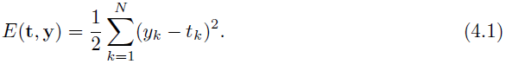….(4.1)

You might have noticed the $\frac{1}{2}$ at the front of that equation. It doesn’t matter that much, but it makes it easier when we differentiate the function, and that is the name of the game here: if we differentiate a function, then it tells us the gradient of that function, which is the direction along which it increases and decreases the most. So if we differentiate an error function, we get the gradient of the error. Since the purpose of learning is to minimise the error, following the error function downhill (in other words, in the direction of the negative gradient) will give us what we want. Imagine a ball rolling around on a surface that looks like the line in Figure 4.3. Gravity will make the ball roll downhill (follow the downhill gradient) until it ends up in the bottom of one of the hollows. These are places where the error is small, so that is exactly what we want. This is why the algorithm is called gradient descent. So what should we differentiate with respect to? There are only three things in the network that change: the inputs, the activation function that decides whether or not the node fires, and the weights. The first and second are out of our control when the algorithm is running, so only the weights matter, and therefore they are what we differentiate with respect to.



**FIGURE 4.3 The weights of the network are trained so that the error goes downhill until**

**it reaches a local minimum, just like a ball rolling under gravity.**

 

**FIGURE 4.4 The threshold function that we FIGURE 4.5 The sigmoid function, which looks**

**used for the Perceptron. Note the discontinuity qualitatively fairly similar, but varies smoothly**

**where the value changes from 0 to 1. and differentiably.**

Having mentioned the activation function, this is a good time to point out a little problem with the threshold function that we have been using for our neurons so far, which is that it is discontinuous (see Figure 4.4; it has a sudden jump in the middle) and so differentiating it at that point isn’t possible. The problem is that we need that jump between firing and not firing to make it act like a neuron. We can solve the problem if we can find an activation function that looks like a threshold function, but is differentiable so that we can compute the gradient. If you squint at a graph of the threshold function (for example, Figure 4.4) then it looks kind of S-shaped. There is a mathematical form of S-shaped functions, called sigmoid functions (see Figure 4.5). They have another nice property, which is that their derivative also has a nice form. The most commonly used form of this function (where βis some positive parameter) is:

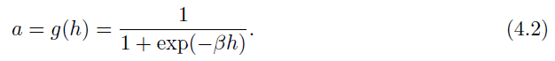….(4.2)

In some text you will see the activaction function given a different for, as:

….(4.3)

which is the hyperbolic tangent function. This is a different but similar function; it is still a sigmoid function, but it saturates (reaches its constant values) at ±1 instead of 0 and 1, which is sometimes useful. It also has a relatively simple derivative: $\frac{d}{dx}$ tanh(*x)* = (1 − tanh2(*x*)). We can convert between the two easily, because if the saturation points are (±1), then we can convert to (0*,* 1) by using 0*.*5 × (*x* + 1).

So now we’ve got a new form of error computation and a new activation function that decides whether or not a neuron should fire. We can differentiate it, so that when we change the weights, we do it in the direction that is downhill for the error, which means that we know we are improving the error function of the network. As far as an algorithm goes, we’ve fed our inputs forward through the network and worked out which nodes are firing. Now, at the output, we’ve computed the errors as the sum-squared difference between the outputs and the targets (Equation (4.1) above). What we want to do next is to compute the gradient of these errors and use them to decide how much to update each weight in the network. We will do that first for the nodes connected to the output layer, and after we have updated those, we will work *backwards* through the network until we get back to the inputs again. There are just two problems:

* for the output neurons, we don’t know the inputs.
* for the hidden neurons, we don’t know the targets; for extra hidden layers, we know neither the inputs nor the targets, but even this won’t matter for the algorithm we derive.

So we can compute the error at the output, but since we don’t know what the inputs were that caused it, we can’t update those second layer weights the way we did for the Perceptron. If we use the chain rule of differentiation that you all (possibly) remember from high school, then we can get around this problem. Here, the chain rule tells us that if we want to know how the error changes as we vary the weights, we can think about how the error changes as we vary the inputs to the weights, and multiply this by how those input values change as we vary the weights. This is useful because it lets us calculate all of the derivatives that we want to: we can write the activations of the output nodes in terms of the activations of the hidden nodes and the output weights, and then we can send the error calculations back through the network to the hidden layer to decide what the target outputs were for those neurons. Note that we can do exactly the same computations if the network has extra hidden layers between the inputs and the outputs. It gets harder to keep track of which functions we should be differentiating, but there are no new tricks needed.

The important thing to understand is that we compute the gradients of the errors with respect to the weights, so that we change the weights so that we go downhill, which makes the errors get smaller. We do this by differentiating the error function with respect to the weights, but we can’t do this directly, so we have to apply the chain rule and differentiate with respect to things that we know. This leads to two different update functions, one for each of the sets of weights, and we just apply these backwards through the network, starting at the outputs and ending up back at the inputs.



**FIGURE 4.6 The forward direction in a Multi-Layer Perceptron.**

### 4.2.1 Multi-Layer Perceptron Algorithm

We’ll get into the details of the basic algorithm here, and then, in the next section, have a look at some practical issues, such as how much training data is needed, how much training time is needed, and how to choose the correct size of network. We will assume that there are L input nodes, plus the bias, M hidden nodes, also plus a bias, and N output nodes, so that there are (L+1) ×M weights between the input and the hidden layer and (M+1) ×N between the hidden layer and the output. The sums that we write will start from 0 if they include the bias nodes and 1 otherwise, and run up to L, M, or N, so that x0 = −1 is the bias input, and a0 = −1 is the bias hidden node. The algorithm that is described could have any number of hidden layers, in which case there might be several values for M, and extra sets of weights between the hidden layers. We will also use i, j, k to index the nodes in each layer in the sums, and the corresponding Greek letters (ι, ζ, κ) for fixed indices.

1. an input vector is put into the input nodes
2. the inputs are fed *forward* through the network (Figure 4.6)
   1. the inputs and the first-layer weights (here labelled as *v*) are used to decide whether the hidden nodes fire or not. The activation function *g* (·) is the sigmoid function given in Equation (4.2) above
   2. the outputs of these neurons and the second-layer weights (labelled as *w*) are used to decide if the output neurons fire or not
3. the *error* is computed as the sum-of-squares difference between the network outputs and the targets
4. this error is fed *backwards* through the network in order to
   1. first update the second-layer weights
   2. and then afterwards, the first-layer weights

The Multi-Layer Perceptron Algorithm

* **Initialisation**
  + set all of the weights to small (positive and negative) random numbers
* **Training**
  + Repeat:

**\***for each input vector:

Forwards phase:

**•** compute the activation of each neuron *j* in hidden layer(s) using:

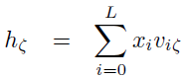 ….(4.4)

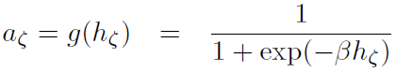 ….(4.5)

**•** work through the network until you get to the output layer neurons, which have activations (although see also Section 4.2.3):

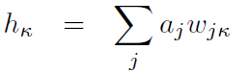 ….(4.6)

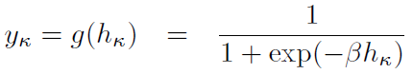 ….(4.7)

Backwards phase:

**•** compute the error at the output using:

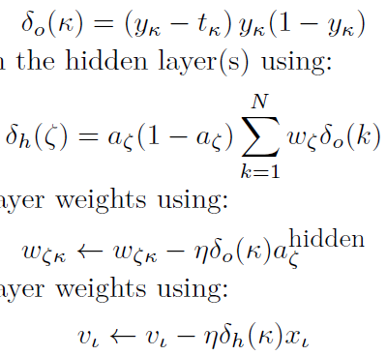 ….(4.8)

**•** compute the error in the hidden layer(s) using:

 ….(4.9)

**•** update the output layer weights using:

 ….(4.10)

**•** update the hidden layer weights using:

 ….(4.11)

**\***(if using sequential updating) randomise the order of the input vectors so that you don’t train in exactly the same order each iteration

* + until learning stops (see Section 4.3.3)
* **Recall**
  + use the Forwards phase in the training section above

**_____________________________________________________________________________________**

There are a few improvements that can be made to the algorithm, and there are some important things that need to be considered, such as how many training datapoints are needed, how many hidden nodes should be used, and how much training the network needs. We will look at the improvements first, and then move on to practical considerations in Section 4.3. The first thing that we can do is check that this MLP can indeed learn the logic functions, especially the XOR.

Also there are a few things to notice about this. One is that it does work, producing the correct answers, but the other is that even for the AND we need significantly more iterations than we did for the Perceptron. So the benefits of a more complex network come at a cost, because it takes substantially more computational time to fit those weights to solve the problem, even for linear examples. Sometimes, even 5000 iterations are not enough for the XOR function, and more have to be added.

### 4.2.2 Initialising the Weights

The MLP algorithm suggests that the weights are initialised to small random numbers, both positive and negative. The question is how small is small, and does it matter? One way to get a feeling for this would be to experiment with the code, setting all of the weights to 0, and seeing how well the network learns, then setting them all to large numbers and comparing the results. However, to understand why they should be small we can look at the shape of the sigmoid. If the initial weight values are close to 1 or -1 (which is what we mean by large here) then the inputs to the sigmoid are also likely to be close to ±1 and so the output of the neuron is either 0 or 1 (the sigmoid has saturated, reached its maximum or minimum value). If the weights are very small (close to zero) then the input is still close to 0 and so the output of the neuron is just linear, so we get a linear model. Both of these things can be useful for the final network, but if we start off with values that are inbetween it can decide for itself.

Choosing the size of the initial values needs a little more thought, then. Each neuron is getting input from *n* different places (either input nodes if the neuron is in the hidden layer, or hidden neurons if it is in the output layer). If we view the values of these inputs as having uniform variance, then the typical input to the neuron will be $w\sqrt{n}$, where *w* is the initialisation value of the weights. So a common trick is to set the weights in the range $-1/w\sqrt{n}$ *< w < $1/w\sqrt{n}$*  where *n* is the number of nodes in the input layer to those weights. This makes the total input to a neuron have a maximum size of about 1. Further, if the weights are large, then the activation of a neuron is likely to be at, or close to, 0 or 1 already, which means that the gradients are small, and so the learning is very slow. There is an interplay here with the value of β in the logistic function, which means that small values of β (say β = 3*.*0 or less) are more effective. We use random values for the initialisation so that the learning starts off from different places for each run, and we keep them all about the same size because we want all of the weights to reach their final values at about the same time. This is known as uniform learning and it is important because otherwise the network will do better on some inputs than others.

### 4.2.3 Different Output Activation Functions

In the algorithm described above, we used sigmoid neurons in the hidden layer and the output layer. This is fine for classification problems, since there we can make the classes be 0 and 1. However, we might also want to perform regression problems, where the output needs to be from a continuous range, not just 0 or 1. The sigmoid neurons at the output are not very useful in that case. We can replace the output neurons with linear nodes that just sum the inputs and give that as their activation (so *g*(*h*) = *h* in the notation of Equation (4.2)). This does not mean that we change the hidden layer neurons; they stay exactly the same, and we only modify the output nodes. They are not models of neurons anymore, since they don’t have the characteristic fire/don’t fire pattern. Even so, they enable us to solve regression problems, where we want a real number out, not just a 0/1 decision.

There is a third type of output neuron that is also used, which is the soft-max activation function. This is most commonly used for classification problems where the 1-of-*N* output encoding is used. The soft-max function rescales the outputs by calculating the exponential of the inputs to that neuron, and dividing by the total sum of the inputs to all of the neurons, so that the activations sum to 1 and all lie between 0 and 1. As an activation function it can be written as:

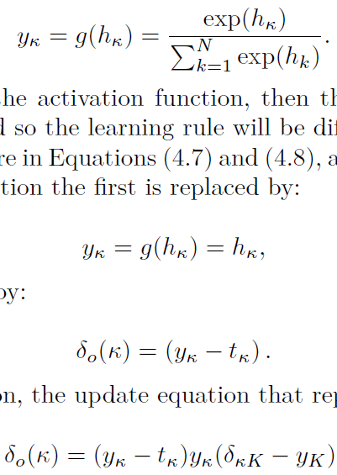….(4.12)

Of course, if we change the activation function, then the derivative of the activation function will also change, and so the learning rule will be different. The changes that need to be made to the algorithm are in Equations (4.7) and (4.8). For the linear activation function the first is replaced by:

….(4.13)

while the second is replaced by:

….(4.14)

For the soft-max activation, the update equation that replaces (4.8) is:

….(4.15)

where δkK = 1 if k = K and 0 otherwise. However, if we modify the error function as well, to have the cross-entropy form (where ln is the natural logarithm):

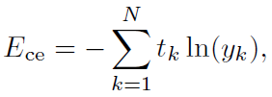….(4.16)

then the delta term is Equation (4.14), just as for the linear output; for more details, see Section 4.6.6. Computing these update equations requires computing the error function that is being optimised, and then differentiating it.

### 4.2.4 Sequential and Batch Training

The MLP is designed to be a batch algorithm. All of the training examples are presented to the neural network, the average sum-of-squares error is then computed, and this is used to update the weights. Thus there is only one set of weight updates for each epoch (pass through all the training examples). This means that we only update the weights once for each iteration of the algorithm, which means that the weights are moved in the direction that most of the inputs want them to move, rather than being pulled around by each input individually. The batch method performs a more accurate estimate of the error gradient, and will thus converge to the local minimum more quickly.

The algorithm that was described earlier was the sequential version, where the errors are computed and the weights updated after each input. This is not guaranteed to be as efficient in learning, but it is simpler to program when using loops, and it is therefore much more common. Since it does not converge as well, it can also sometimes avoid local minima, thus potentially reaching better solutions. While the description of the algorithm is sequential, the NumPy implementation on the book website is a batch version, because the matrix manipulation methods of NumPy make that easy. It is, however, relatively simple to modify it to use sequential update (making this change to the code is suggested as an exercise at the end of the chapter). In a sequential version, the order of the weight updates can matter, which is why the pseudocode version of the algorithm include a suggestion about randomising the order of the input vectors at each iteration. This can significantly improve the speed with which the algorithm learns.

### 4.2.5 Local Minima

The driving force behind the learning rule is the minimisation of the network error by gradient descent (using the derivative of the error function to make the error smaller). This means that we are performing an optimisation: we are adapting the values of the weights in order to minimise the error function. As should be clear by now, the way that we are doing this is by approximating the gradient of the error and following it downhill so that we end up at the bottom of the slope. However, following the slope downhill only guarantees that we end up at a local minimum, a point that is lower than those close to it. If we imagine a ball rolling down a hill, it will settle at the bottom of a dip. However, there is no guarantee that it will have stopped at the lowest point—only the lowest point locally. There may be a much lower point over the next hill, but the ball can’t see that, and it doesn’t have enough energy to climb over the hill and find the global minimum (have another look at Figure 4.3 to see a picture of this).



**FIGURE 4.7 In 2D, downhill means at right angles to the lines of constant contour. Imagine**

**walking down a hill with your eyes closed. If you find a direction that stays flat, then it is**

**quite likely that perpendicular to that the ground goes uphill or downhill. However, this**

**is not the direction that takes you directly towards the local minimum.**

Gradient descent works in the same way in two or more dimensions, and has similar (and worse) problems. The problem is that efficient downhill directions in two dimensions and higher are harder to compute locally. Standard contour maps provide beautiful images of gradients in our three-dimensional world, and if you imagine that you are walking in a hilly area aiming to get to the bottom of the nearest valley then you can get some idea of what is going on. Now suppose that you close your eyes, so that you can only feel which direction to go by moving one step and checking if you are higher up or lower down than you were. There will be places where going downwards as steeply as possible at the current point will not take you much closer to the valley bottom. There can be two reasons for this. The first is that you find a nearby local minimum, while the second is that sometimes the steepest direction is effectively across the valley, not towards the global minimum. This is shown in Figure 4.7.

All of these things are true for most of our optimisation problems, including the MLP. We don’t know where the global minimum is because we don’t know what the error landscape looks like; we can only compute local features of it for the place we are in at the moment. Which minimum we end up in depends on where we start. If we begin near the global minimum, then we are very likely to end up in it, but if we start near a local minimum we will probably end up there. In addition, how long it will take to get to the minimum that we do find depends upon the exact appearance of the landscape at the current point.

We can make it more likely that we find the global minimum by trying out several different starting points by training several different networks, and this is commonly done. However, we can also try to make it less likely that the algorithm will get stuck in local minima. There is a moderately effective way of doing this, which is discussed next.



**FIGURE 4.8 Adding momentum can help to avoid local minima, and also makes the dynamics**

**of the optimisation more stable, improving convergence.**

### 4.2.6 Picking Up Momentum

Let’s go back to the analogy of the ball rolling down the hill. The reason that the ball stops rolling is because it runs out of energy at the bottom of the dip. If we give the ball some weight, then it will generate momentum as it rolls, and so it is more likely to overcome a small hill on the other side of the local minimum, and so more likely to find the global minimum. We can implement this idea in our neural network learning by adding in some contribution from the previous weight change that we made to the current one. In two dimensions it will mean that the ball rolls more directly towards the valley bottom, since on average that will be the correct direction, rather than being controlled by the local changes. This is shown in Figure 4.8.

There is another benefit to momentum. It makes it possible to use a smaller learning rate, which means that the learning is more stable. The only change that we need to make to the MLP algorithm is in Equations (4.10) and (4.11), where we need to add a second term to the weight updates so that they have the form:

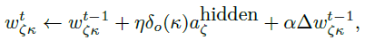….(4.17)

where *t* is used to indicate the current update and *t* − 1 is the previous one. $Δw_{ζk}^{t-1}$ is the previous update that we made to the weights (so = ηδ0(k)aζhidden+αΔ $w_{ζk}^{t-1}$) and 0 *< α <* 1 is the momentum constant. Typically, a value of *α* = 0*.*9 is used. This is a very easy addition to the code, and can improve the speed of learning a lot.

Another thing that can be added is known as weight decay. This reduces the size of the weights as the number of iterations increases. The argument goes that small weights are better since they lead to a network that is closer to linear (since they are close to zero, they are in the region where the sigmoid is increasing linearly), and only those weights that are essential to the non-linear learning should be large. After each learning iteration through all of the input patterns, every weight is multiplied by some constant 0 < ε < 1. This makes the network simpler and can often produce improved results, but unfortunately, it isn’t fail-safe: occasionally it can make the learning significantly worse, so it should be used with care. Setting the value of ε is typically done experimentally.

### 4.2.7 Minibatches and Stochastic Gradient Descent

In Section 4.2.4 it was stated that the batch algorithm converges to a local minimum faster than the sequential algorithm, which computes the error for each input individually and then does a weight update, but that the latter is sometimes less likely to get stuck in local minima. The reason for both of these observations is that the batch algorithm makes a better estimate of the steepest descent direction, so that the direction it chooses to go is a good one, but this just leads to a local minimum.

The idea of a minibatch method is to find some happy middle ground between the two, by splitting the training set into random batches, estimating the gradient based on one of the subsets of the training set, performing a weight update, and then using the next subset to estimate a new gradient and using that for the weight update, until all of the training set have been used. The training set are then randomly shuffled into new batches and the next iteration takes place. If the batches are small, then there is often a reasonable degree of error in the gradient estimate, and so the optimisation has the chance to escape from local minima, albeit at the cost of heading in the wrong direction.

A more extreme version of the minibatch idea is to use just one piece of data to estimate the gradient at each iteration of the algorithm, and to pick that piece of data uniformly at random from the training set. So a single input vector is chosen from the training set, and the output and hence the error for that one vector computed, and this is used to estimate the gradient and so update the weights. A new random input vector (which could be the same as the previous one) is then chosen and the process repeated. This is known as stochastic gradient descent, and can be used for any gradient descent problem, not just the MLP. It is often used if the training set is very large, since it would be very expensive to use the whole dataset to estimate the gradient in that case.

### 4.2.8 Other Improvements

There are a few other things that can be done to improve the convergence and behaviour of the back-propagation algorithm. One is to reduce the learning rate as the algorithm progresses. The reasoning behind this is that the network should only be making large-scale changes to the weights at the beginning, when the weights are random; if it is still making large weight changes later on, then something is wrong.

Something that results in much larger performance gains is to include information about the second derivatives of the error with respect to the weights. In the back-propagation algorithm we use the first derivatives to drive the learning. However, if we have knowledge of the second derivatives as well, we can use them as well to improve the network.

## 4.3 THE MULTI-LAYER PERCEPTRON IN PRACTICE

The previous section looked at the design and implementation of the MLP network itself. In this section, we are going to look more at choices that can be made about the network in order to use it for solving real problems. We will then apply these ideas to using the MLP to find solutions to four different types of problem: regression, classification, time-series prediction, and data compression.

### 4.3.1 Amount of Training Data

For the MLP with one hidden layer there are (*L* + 1) ×*M* + (*M* + 1) × *N* weights, where *L, M, N* are the number of nodes in the input, hidden, and output layers, respectively. The extra +1s come from the bias nodes, which also have adjustable weights. This is a potentially huge number of adjustable parameters that we need to set during the training phase. Setting the values of these weights is the job of the back-propagation algorithm, which is driven by the errors coming from the training data. Clearly, the more training data there is, the better for learning, although the time that the algorithm takes to learn increases. Unfortunately, there is no way to compute what the minimum amount of data required is, since it depends on the problem. A rule of thumb that has been around for almost as long as the MLP itself is that you should use a number of training examples that is at least 10 times the number of weights. This is probably going to be a very large number of examples, so neural network training is a fairly computationally expensive operation, because we need to show the network all of these inputs lots of times.

### 4.3.2 Number of Hidden Layers

There are two other considerations concerning the number of weights that are inherent in the calculation above, which is the choice of the number of hidden nodes, and the number of hidden layers. Making these choices is obviously fundamental to the successful application of the algorithm. We will shortly see a pictorial demonstration of the fact that two hidden layers is the most that you ever need for normal MLP learning. In fact, this result can be strengthened: it is possible to show mathematically that one hidden layer with lots of hidden nodes is sufficient. This is known as the Universal Approximation Theorem; see the Further Reading section for more details. However, the bad news is that there is no theory to guide the choice of the number of hidden nodes. You just have to experiment by training networks with different numbers of hidden nodes and then choosing the one that gives the best results.

We can use the back-propagation algorithm for a network with as many layers as we like, although it gets progressively harder to keep track of which weights are being updated at any given time. Fortunately, as was mentioned above, we will never normally need more than two layers (that is, one hidden layer and the output layer). This is because we can approximate any smooth functional mapping using a linear combination of localised sigmoidal functions. There is a sketchy demonstration that two hidden layers are sufficient using pictures in Figure 4.9. The basic idea is that by combining sigmoid functions we can generate ridge-like functions, and by combining ridge-like functions we can generate functions with a unique maximum. By combining these and transforming them using another layer of neurons, we obtain a localised response (a ‘bump’ function), and any functional mapping can be approximated to arbitrary accuracy using a linear combination of such bumps. The way that the MLP does this is shown in Figure 4.10. Note that Figure 4.9 shows that two hidden layers are sufficient. In fact, they aren’t necessary: one hidden layer will do, although it may require an arbitrarily large number of hidden nodes. This is known as the Universal Approximation Theorem, and the (mathematical) paper that shows this is provided in the references at the end of the chapter.

Two hidden layers are sufficient to compute these bump functions for different inputs, and so if the function that we want to learn (approximate) is continuous, the network can compute it. It can therefore approximate any decision boundary, not just the linear one that the Perceptron computed.



**FIGURE 4.9 The learning of the MLP can be shown as the output of a single sigmoidal neuron (a), which can be added to others, including reversed ones, to get a hill shape (b). Adding another hill at 90_ produces a bump (c), which can be sharpened to any extent we want (d), with the bumps added together in the output layer. Thus the MLP learns a local representation of individual inputs.**



**FIGURE 4.10 Schematic of the effective learning shape at each stage of the MLP.**

### 4.3.3 When to Stop Learning

The training of the MLP requires that the algorithm runs over the entire dataset many times, with the weights changing as the network makes errors in each iteration. The question is how to decide when to stop learning, and this is a question that we are now ready to answer. It is unfortunate that the most obvious options are not sufficient: setting some predefined number *N* of iterations, and running until that is reached runs the risk that the network has overfitted by then, or not learnt sufficiently, and only stopping when some predefined minimum error is reached might mean the algorithm never terminates, or that it overfits. Using both of these options together can help, as can terminating the learning once the error stops decreasing.

However, the validation set gives us something rather more useful, since we can use it to monitor the generalisation ability of the network at its current stage of learning. If we plot the sum-of-squares error during training, it typically reduces fairly quickly during the first few training iterations, and then the reduction slows down as the learning algorithm performs small changes to find the exact local minimum. We don’t want to stop training until the local minimum has been found, but, as we’ve just discussed, keeping on training too long leads to overfitting of the network. This is where the validation set comes in useful. We train the network for some predetermined amount of time, and then use the validation set to estimate how well the network is generalising. We then carry on training for a few more iterations, and repeat the whole process. At some stage the error on the validation set will start increasing again, because the network has stopped learning about the function that generated the data, and started to learn about the noise that is in the data itself (shown in Figure 4.11). At this stage we stop the training. This technique is called early stopping.



**FIGURE 4.11 The effect of overfitting on the training and validation error curves, with the point at which early stopping will stop the learning marked.**

## 4.4 A RECIPE FOR USING THE MLP

We have covered a lot in this chapter, so I’m going to give you a ‘recipe’ for how to use the Multi-Layer Perceptron when presented with a dataset. This is, by necessity, a simplification of the problem, but it should serve to remind you of many of the important features.

**Select inputs and outputs for your problem** Before anything else, you need to think about the problem you are trying to solve, and make sure that you have data for the problem, both input vectors and target outputs. At this stage you need to choose what features are suitable for the problem (something we’ll talk about more in other chapters) and decide on the output encoding that you will use — standard neurons, or linear nodes. These things are often decided for you by the input features and targets that you have available to solve the problem. Later on in the learning it can also be useful to re-evaluate the choice by training networks with some input feature missing to see if it improves the results at all.

**Normalise inputs** Rescale the data by subtracting the mean value from each element of the input vector, and divide by the variance (or alternatively, either the maximum or minus the minimum, whichever is greater).

**Split the data into training, testing, and validation sets** You cannot test the learning ability of the network on the same data that you trained it on, since it will generally fit that data very well (often too well, overfitting and modelling the noise in the data as well as the generating function). We generally split the data into three sets, one for training, one for testing, and then a third set for validation, which is testing how well the network is learning during training. The ratio between the sizes of the three groups depends on how much data you have, but is often around 50:25:25. If you do not have enough data for this, use cross-validation instead.

**Select a network architecture** You already know how many input nodes there will be, and how many output neurons. You need to consider whether you will need a hidden layer at all, and if so how many neurons it should have in it. You might want to consider more than one hidden layer. The more complex the network, the more data it will need to be trained on, and the longer it will take. It might also be more subject to overfitting. The usual method of selecting a network architecture is to try several with different numbers of hidden nodes and see which works best.

**Train a network** The training of the neural network consists of applying the Multi-Layer Perceptron algorithm to the training data. This is usually run in conjunction with early stopping, where after a few iterations of the algorithm through all of the training data, the generalisation ability of the network is tested by using the validation set. The neural network is very likely to have far too many degrees of freedom for the problem, and so after some amount of learning it will stop modelling the generating function of the data, and start to fit the noise and inaccuracies inherent in the training data. At this stage the error on the validation set will start to increase, and learning should be stopped.

**Test the network** Once you have a trained network that you are happy with, it is time to use the test data for the first (and only) time. This will enable you to see how well the network performs on some data that it has not seen before, and will tell you whether this network is likely to be usable for other data, for which you do not have targets.

# **CHAPTER-5 Using Neural Network To Recognize Handwritten Digits**

The human visual system is one of the wonders of the world. Consider the following sequence of handwritten digits:

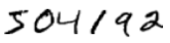

Most people effortlessly recognize those digits as 504192. That ease is deceptive. In each hemisphere of our brain, humans have a primary visual cortex, also known as V1, containing 140 million neurons, with tens of billions of connections between them. And yet human vision involves not just V1, but an entire series of visual cortices - V2, V3, V4, and V5 - doing progressively more complex image processing.

We carry in our heads a supercomputer, tuned by evolution over hundreds of millions of years, and superbly adapted to understand the visual world.

Rather, we humans are stupendously, astoundingly good at making sense of what our eyes show us. But nearly all that work is done unconsciously. And so we don't usually appreciate how tough a problem our visual systems solve.

The difficulty of visual pattern recognition becomes apparent if you attempt to write a computer program to recognize digits like those above. What seems easy when we do it ourselves suddenly becomes extremely difficult. Simple intuitions about how we recognize shapes - "a 9 has a loop at the top, and a vertical stroke in the bottom right" - turn out to be not so simple to express algorithmically. When you try to make such rules precise, you quickly get lost in a morass of exceptions and caveats and special cases. It seems hopeless.

Neural networks approach the problem in a different way. The idea is to take a large number of handwritten digits, known as training examples (Figure 5.1),

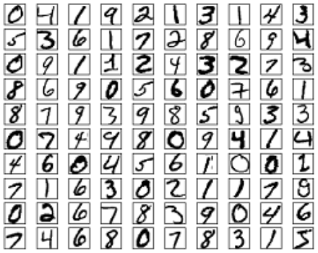

**FIGURE 5.1 Training examples**

and then develop a system which can learn from those training examples. In other words, the neural network uses the examples to automatically infer rules for recognizing handwritten digits. Furthermore, by increasing the number of training examples, the network can learn more about handwriting, and so improve its accuracy. So while we've shown just 100 training digits above, perhaps we could build a better handwriting recognizer by using thousands or even millions or billions of training examples.

## 5.1 Usage of perceptron in digital systems

So how do perceptrons work? A perceptron takes several binary inputs, x1, x2,..., and produces a single binary output:

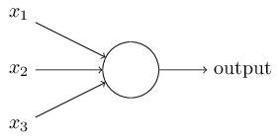

**FIGURE 5.2 Perceptron**

In the example shown the perceptron has three inputs, x1, x2, x3. In general it could have more or fewer inputs. [Frank Rosenblatt](http://en.wikipedia.org/wiki/Frank_Rosenblatt), a scientist who developed perceptron, proposed a simple rule to compute the output. He introduced weights, w1, w2 ,… , real numbers expressing the importance of the respective inputs to the output. The neuron's output, 0 or 1, is determined by whether the weighted sum $\sum_{j}{w_{j}x_{j}}$ is less than or greater than some threshold value. Just like the weights, the threshold is a real number which is a parameter of the neuron. To put it in more precise algebraic terms:

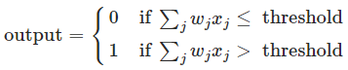

That's all there is to how a perceptron works!

That's the basic mathematical model. A way you can think about the perceptron is that it's a device that makes decisions by weighing up evidence. Let’s make an example. It's not a very realistic example, but it's easy to understand. Suppose the weekend is coming up, and you've heard that there's going to be a cheese festival in your city. You like cheese, and are trying to decide whether or not to go to the festival. You might make your decision by weighing up three factors:

1. Is the weather good?
2. Does your boyfriend or girlfriend want to accompany you?
3. Is the festival near public transit? (You don't own a car).

We can represent these three factors by corresponding binary variables x1, x2, and x3. For instance, we'd have x1=1 if the weather is good, and x1=0 if the weather is bad. Similarly, x2=1 if your boyfriend or girlfriend wants to go, and x2=0 if not. And similarly again for x3 and public transit.

Now, suppose you absolutely adore cheese, so much so that you're happy to go to the festival even if your boyfriend or girlfriend is uninterested and the festival is hard to get to. But perhaps you really loathe bad weather, and there's no way you'd go to the festival if the weather is bad. You can use perceptrons to model this kind of decision-making. One way to do this is to choose a weight w1=6 for the weather, and w2=2 and w3=2 for the other conditions. The larger value of w1 indicates that the weather matters a lot to you, much more than whether your boyfriend or girlfriend joins you, or the nearness of public transit. Finally, suppose you choose a threshold of 5 for the perceptron. With these choices, the perceptron implements the desired decision-making model, outputting 1 whenever the weather is good, and 0 whenever the weather is bad. It makes no difference to the output whether your boyfriend or girlfriend wants to go, or whether public transit is nearby.

By varying the weights and the threshold, we can get different models of decision-making. For example, suppose we instead chose a threshold of 3. Then the perceptron would decide that you should go to the festival whenever the weather was good or when both the festival was near public transit and your boyfriend or girlfriend was willing to join you. In other words, it'd be a different model of decision-making. Dropping the threshold means you're more willing to go to the festival.

Obviously, the perceptron isn't a complete model of human decision-making! But what the example illustrates is how a perceptron can weigh up different kinds of evidence in order to make decisions. And it should seem plausible that a complex network of perceptrons could make quite subtle decisions:

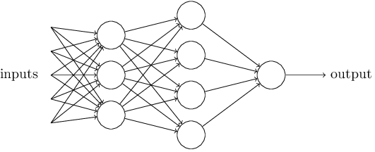

**FIGURE 5.3 Example of simple MLP network**

In this network, the first column of perceptrons - what we'll call the first layer of perceptrons - is making three very simple decisions, by weighing the input evidence. What about the perceptrons in the second layer? Each of those perceptrons is making a decision by weighing up the results from the first layer of decision-making. In this way a perceptron in the second layer can make a decision at a more complex and more abstract level than perceptrons in the first layer. And even more complex decisions can be made by the perceptron in the third layer. In this way, a many-layer network of perceptrons can engage in sophisticated decision making.

In the network above the perceptrons look like they have multiple outputs. In fact, they're still single output. The multiple output arrows are merely a useful way of indicating that the output from a perceptron is being used as the input to several other perceptrons. It's less unwieldy than drawing a single output line which then splits.

Let's simplify the way we describe perceptrons. The condition $\sum_{j}{w_{j}x_{j}}$ > threshold is cumbersome, and we can make two notational changes to simplify it. The first change is to write $\sum_{j}{w_{j}x_{j}}$ as a dot product, wj ≡ , where w and x are vectors whose components are the weights and inputs, respectively. The second change is to move the threshold to the other side of the inequality, and to replace it by what's known as the perceptron's bias, b ≡ - threshold. Using the bias instead of the threshold, the perceptron rule can be rewritten:

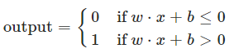

You can think of the bias as a measure of how easy it is to get the perceptron to output a 1. Or to put it in more biological terms, the bias is a measure of how easy it is to get the perceptron to fire. For a perceptron with a really big bias, it's extremely easy for the perceptron to output a 1. But if the bias is very negative, then it's difficult for the perceptron to output a 1. Obviously, introducing the bias is only a small change in how we describe perceptrons, but we'll see later that it leads to further notational simplifications. Because of this, in the remainder of the book we won't use the threshold, we'll always use the bias.

Perceptrons are described as a method for weighing evidence to make decisions. Another way perceptrons can be used is to compute the elementary logical functions we usually think of as underlying computation, functions such as AND, OR, and NAND.

## 5.2 Implementing logic gates by perceptron

For example, suppose we have a perceptron with two inputs, each with weight −2, and an overall bias

of 3. Here's our perceptron:

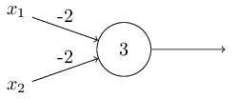

**FIGURE 5.4 Example of perceptron with two inputs and one output**

Then we see that input 00 produces output 1, since $(-2)*0+(-2)*0+3=3(-2)*0+(-2)*0+3 = 3$ is positive. Here, we've introduced the ∗ symbol to make the multiplications explicit. Similar calculations show that the inputs 01 and 10 produce output 1. But the input 11 produces output 0, since $\left(-2\right)*1+\left(-2\right)*1+3=-1\left(-2\right)*1+\left(-2\right)*1+3==-1$ is negative. And so our perceptron implements a NAND gate!

The NAND example shows that we can use perceptrons to compute simple logical functions. In fact, we can use networks of perceptrons to compute any logical function at all. The reason is that the NAND gate is universal for computation, that is, we can build any computation up out of NAND gates.

For example, we can use NAND gates to build a circuit which adds two bits, x1 and x2. This requires computing the bitwise sum, x1 ⊕ x2, as well as a carry bit which is set to 1 when both x1 and x2 are 1, i.e., the carry bit is just the bitwise product x1 $*$ x2:

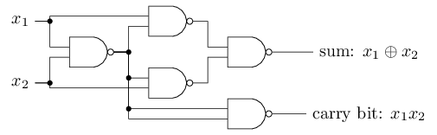

**FIGURE 5.5 Full Adder using NAND gates**

To get an equivalent network of perceptrons we replace all the NAND gates by perceptrons with two inputs, each with weight −2, and an overall bias of 3. Here's the resulting network.

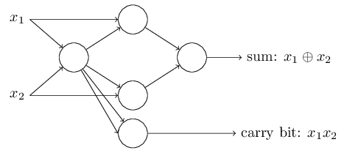

**FIGURE 5.6 Full Adder using MLP network**

We have possibility to simply merge the two lines, into a single connection with a weight of -4 instead of two connections with -2 weights. With that change, the network looks as follows, with all unmarked weights equal to -2, all biases equal to 3, and a single weight of -4, as marked:

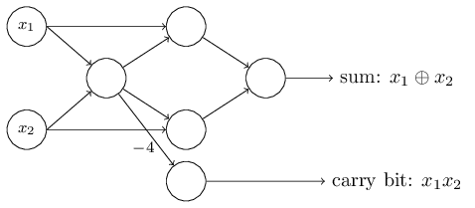

**FIGURE 5.7 Full Adder using MLP network, representing x1 and x2 as input perceptrons**

The adder example demonstrates how a network of perceptrons can be used to simulate a circuit containing many NAND gates. And because NAND gates are universal for computation, it follows that perceptrons are also universal for computation.

The computational universality of perceptrons is simultaneously reassuring and disappointing. It's reassuring because it tells us that networks of perceptrons can be as powerful as any other computing device. But it's also disappointing, because it makes it seem as though perceptrons are merely a new type of NAND gate. That's hardly big news!

However, the situation is better than this view suggests. It turns out that we can devise learning algorithms which can automatically tune the weights and biases of a network of artificial neurons. This tuning happens in response to external stimuli, without direct intervention by a programmer. These learning algorithms enable us to use artificial neurons in a way which is radically different to conventional logic gates. Instead of explicitly laying out a circuit of NAND and other gates, our neural networks can simply learn to solve problems, sometimes problems where it would be extremely difficult to directly design a conventional circuit.

## 5.3 The architecture of neural network

In the next section we'll introduce a neural network that can do a pretty good job classifying handwritten digits. In preparation for that, it helps to explain some terminology that lets us name different parts of a network. Suppose we have the network (Figure 5.8):

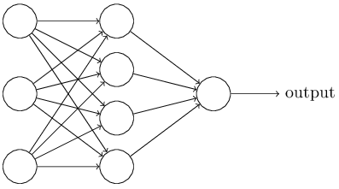

**FIGURE 5.8 Simple MLP network with one input, one output and one hidden layer**

The leftmost layer in this network is called the input layer, and the neurons within the layer are called input neurons. The rightmost or output layer contains the output neurons, or, as in this case, a single output neuron. The middle layer is called a hidden layer, since the neurons in this layer are neither inputs nor outputs. The term "hidden" perhaps sounds a little mysterious - the first time I heard the term I thought it must have some deep philosophical or mathematical significance - but it really means nothing more than "not an input or an output". The network above has just a single hidden layer, but some networks have multiple hidden layers. For example, the following four-layer network has two hidden layers (Figure 5.9):

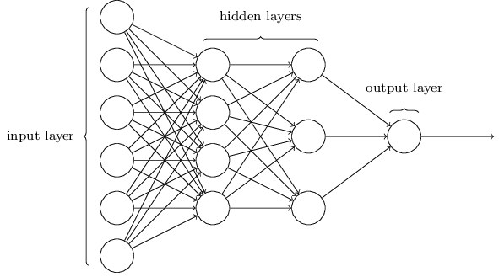

**FIGURE 5.9 MLP network with one input, one output and two hidden layers**

The design of the input and output layers in a network is often straightforward. For example, suppose we're trying to determine whether a handwritten image depicts a "9" or not. A natural way to design the network is to encode the intensities of the image pixels into the input neurons. If the image is a 64 by 64 greyscale image, then we'd have 4,096 = 64 $*$ 64 input neurons, with the intensities scaled appropriately between 0 and 1. The output layer will contain just a single neuron, with output values of less than 0.5 indicating "input image is not a 9", and values greater than 0.5 indicating "input image is a 9 ".

While the design of the input and output layers of a neural network is often straightforward, there can be quite an art to the design of the hidden layers. In particular, it's not possible to sum up the design process for the hidden layers with a few simple rules of thumb. Instead, neural networks researchers have developed many design heuristics for the hidden layers, which help people get the behaviour they want out of their nets. For example, such heuristics can be used to help determine how to trade off the number of hidden layers against the time required to train the network.

Up to now, we've been discussing neural networks where the output from one layer is used as input to the next layer. Such networks are called feedforward neural networks. This means there are no loops in the network - information is always fed forward, never fed back. If we did have loops, we'd end up with situations where the input to the sigmoid function depended on the output. That'd be hard to make sense of, and so we don't allow such loops.

### 5.3.1 Recurrent neural network

However, there are other models of artificial neural networks in which feedback loops are possible. These models are called recurrent neural networks. The idea in these models is to have neurons which fire for some limited duration of time, before becoming quiescent. That firing can stimulate other neurons, which may fire a little while later, also for a limited duration. That causes still more neurons to fire, and so over time we get a cascade of neurons firing. Loops don't cause problems in such a model, since a neuron's output only affects its input at some later time, not instantaneously.

Recurrent neural nets have been less influential than feedforward networks, in part because the learning algorithms for recurrent nets are (at least to date) less powerful. But recurrent networks are still extremely interesting. They're much closer in spirit to how our brains work than feedforward networks. And it's possible that recurrent networks can solve important problems which can only be solved with great difficulty by feedforward networks. However, to limit our scope, in this book we're going to concentrate on the more widely-used feedforward networks.

## 5.4 A simple network to classify handwritten digits

Having defined neural networks, let's return to handwriting recognition. We can split the problem of recognizing handwritten digits into two sub-problems. First, we'd like a way of breaking an image containing many digits into a sequence of separate images, each containing a single digit. For example, we'd like to break the image

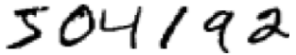

into six separate images,

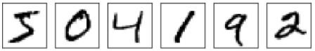

We humans solve this segmentation problem with ease, but it's challenging for a computer program to correctly break up the image. Once the image has been segmented, the program then needs to classify each individual digit. So, for instance, we'd like our program to recognize that the first digit above,



is a 5.

We'll focus, in this chapter, on writing a program to solve the second problem, that is, classifying individual digits.

To recognize individual digits, we will use a three-layer neural network:

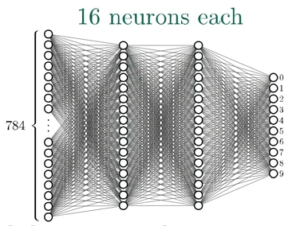

**FIGURE 5.10 MLP network for recognizing handwritten digits**

The input layer of the network contains neurons encoding the values of the input pixels. As discussed in the next section, our training data for the network will consist of many 28 by 28 pixel images of scanned handwritten digits, and so the input layer contains 784 = 28 $*$ 28 neurons. For simplicity I've omitted most of the 784 input neurons in the diagram above. The input pixels are greyscale, with a value of 0.0 representing white, a value of 1.0 representing black, and in between values representing gradually darkening shades of grey.

The second and third layer of the network are hidden layers.

The output layer of the network contains 10 neurons. If the first neuron fires, i.e., has an output ≈1, then that will indicate that the network thinks the digit is a 0. If the second neuron fires then that will indicate that the network thinks the digit is a 1. And so on. A little more precisely, we number the output neurons from 0 through 9, and figure out which neuron has the highest activation value. If that neuron is, say, neuron number 6, then our network will guess that the input digit was a 6. And so on for the other output neurons.

You might wonder why we use 10 output neurons. After all, the goal of the network is to tell us which digit (0, 1, 2, …, 9) corresponds to the input image. A seemingly natural way of doing that is to use just 4 output neurons, treating each neuron as taking on a binary value, depending on whether the neuron's output is closer to 0 or to 1. Four neurons are enough to encode the answer, since 24 = 16 is more than the 10 possible values for the input digit. Why should our network use 10 neurons instead? Isn't that inefficient? The ultimate justification is empirical: we can try out both network designs, and it turns out that, for this particular problem, the network with 10 output neurons learns to recognize digits better than the network with 4 output neurons. But that leaves us wondering why using 10 output neurons works better. Is there some heuristic that would tell us in advance that we should use the 10-output encoding instead of the 4-output encoding?

To understand why we do this, it helps to think about what the neural network is doing from first principles. Consider first the case where we use 10 output neurons. Let's concentrate on the first output neuron, the one that's trying to decide whether or not the digit is a 0. It does this by weighing up evidence from the hidden layer of neurons. What are those hidden neurons doing? Well, just suppose for the sake of argument that the first neuron in the hidden layer detects whether or not an image like the following is present:

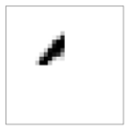

It can do this by heavily weighting input pixels which overlap with the image, and only lightly weighting the other inputs. In a similar way, let's suppose for the sake of argument that the second, third, and fourth neurons in the hidden layer detect whether or not the following images are present:

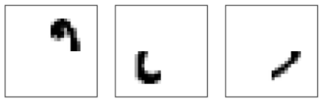

As you may have guessed, these four images together make up the 00image that we saw in the line of digits shown [earlier](http://neuralnetworksanddeeplearning.com/chap1.html#complete_zero):

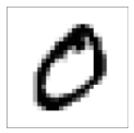

So if all four of these hidden neurons are firing then we can conclude that the digit is a 0. Of course, that's not the only sort of evidence we can use to conclude that the image was a 0 - we could legitimately get a 0 in many other ways (say, through translations of the above images, or slight distortions). But it seems safe to say that at least in this case we'd conclude that the input was a 0.

Supposing the neural network functions in this way, we can give a plausible explanation for why it's better to have 10 outputs from the network, rather than 4. If we had 4 outputs, then the first output neuron would be trying to decide what the most significant bit of the digit was. And there's no easy way to relate that most significant bit to simple shapes like those shown above. It's hard to imagine that there's any good historical reason the component shapes of the digit will be closely related to (say) the most significant bit in the output.

Now, with all that said, this is all just a heuristic. Nothing says that the three-layer neural network has to operate in the way I described, with the hidden neurons detecting simple component shapes. Maybe a clever learning algorithm will find some assignment of weights that lets us use only 4 output neurons. But as a heuristic the way of thinking I've described works pretty well, and can save you a lot of time in designing good neural network architectures.

## 5.5 GETTING COEFFICIENTS USING PYTHON SCRIPT

We used a program that learns how to recognize handwritten digits, using stochastic gradient descent and the MNIST training data. The first thing we need is to get the MNIST data. MNIST data is split into 60,000 training images, and 10,000 test images. Actually, we're going to split the data a little differently. We'll leave the test images as is, but split the 60,000-image MNIST training set into two parts: a set of 50,000 images, which we'll use to train our neural network, and a separate 10,000 image *validation set*. We won't use the validation data in this project.

Apart from the MNIST data we also need a Python library called [**Numpy**](http://numpy.org/), for doing fast linear algebra.

We will explain the core features of the neural networks code. The centerpiece is a Network class, which we use to represent a neural network. Here's the code we use to initialize a Network object:

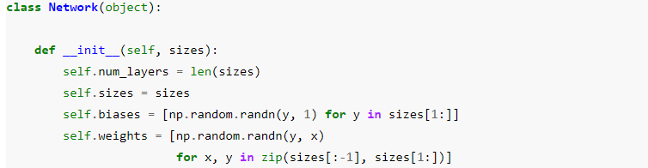

In this code, the list sizes contains the number of neurons in the respective layers. So, for example, if we want to create a Network object with 2 neurons in the first layer, 3 neurons in the second layer, and 1 neuron in the final layer, we'd do this with the code:



The biases and weights in the Network object are all initialized randomly, using the *Numpy np.random.randn* function to generate Gaussian distributions with mean 0 and standard deviation 1. This random initialization gives our stochastic gradient descent algorithm a place to start from. Note that the Network initialization code assumes that the first layer of neurons is an input layer, and omits to set any biases for those neurons, since biases are only ever used in computing the outputs from later layers. It's easy to write code computing the output from a Network instance. We begin by defining the sigmoid function:



Note that when the input z is a vector or Numpy array, Numpy automatically applies the function sigmoid elementwise, that is, in vectorized form. We then add a *feedforward* method to the *Network* class, which, given an input a for the network, returns the corresponding output.

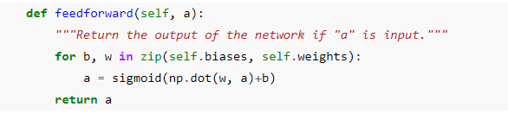

Of course, the main thing we want our *Network* objects to do is to learn. To that end we'll give them an *SGD* method which implements stochastic gradient descent. Here's the code. It's a little mysterious in a few places, but we'll break it down below, after the listing.

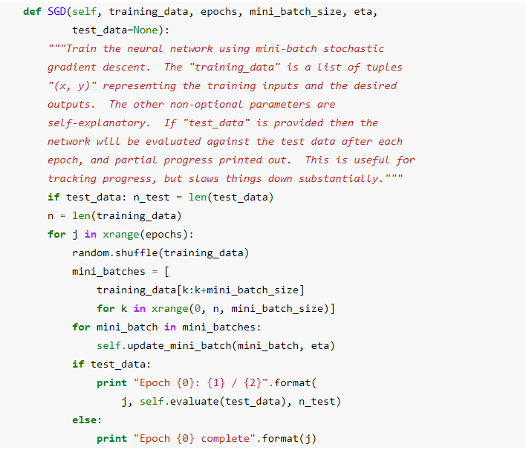

The *training_data* is a list of tuples (x, y) representing the training inputs and corresponding desired outputs. The variables epochs and *mini_batch_size* are what you'd expect - the number of *epochs* to train for, and the size of the mini-batches to use when sampling. *eta* is the learning rate, *η*. If the optional argument *test_data* is supplied, then the program will evaluate the network after each epoch of training, and print out partial progress. This is useful for tracking progress, but slows things down substantially.

The code works as follows. In each epoch, it starts by randomly shuffling the training data, and then partitions it into mini-batches of the appropriate size. This is an easy way of sampling randomly from the training data. Then for each *mini_batch* we apply a single step of gradient descent. This is done by the *codeself.update_mini_batch(mini_batch, eta)*, which updates the network weights and biases according to a single iteration of gradient descent, using just the training data in *mini_batch*. Here's the code for the *update_mini_batch* method:

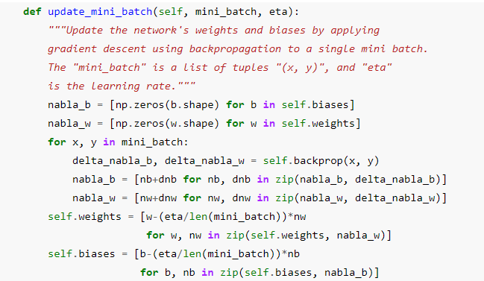

Most of the work is done by the line:



This invokes something called the *backpropagation* algorithm, which is a fast way of computing the gradient of the cost function. So *update_mini_batch* works simply by computing these gradients for every training example in the *mini_batch*, and then updating *self.weights* and *self.biases* appropriately.

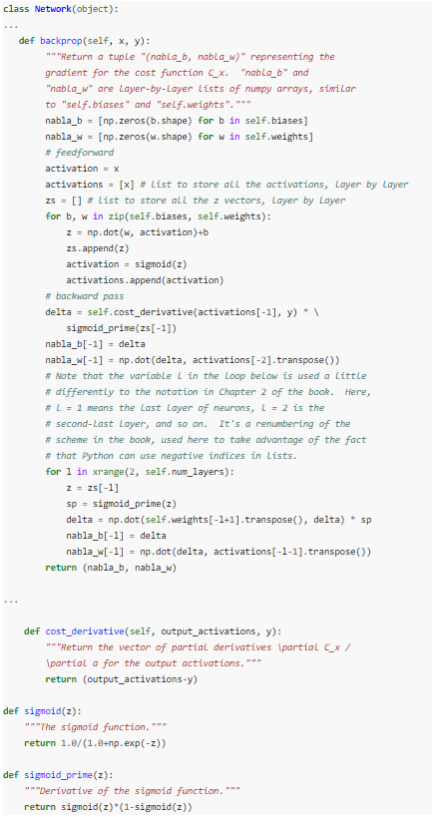

### 5.5.1 How well does the program recognize handwritten digits?

Well, let's start by loading in the MNIST data. We'll do this using a little helper program, *mnist_loader.py*, to be described below. We execute the following commands in a Python shell,

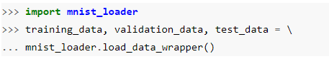

After loading the MNIST data, we'll set up a *Network* with 30 hidden neurons. We do this after importing the Python program listed above, which is named *network*,

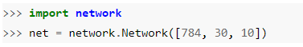

Finally, we'll use stochastic gradient descent to learn from the MNIST *training_data* over 30 epochs, with a mini-batch size of 10, and a learning rate of η=3.0,



After repeating these steps many times we get this graphic:

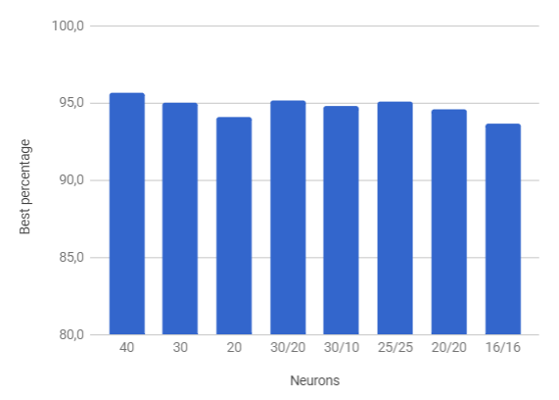

and we decided that we will make a neural network with two hidden layers where each contains 16 neurons. Reason for that was desire to make hardware accelerator for deep neural network, on another hand it achieved good accuracy.

# **CHAPTER-6 Hardware (FPGA) Implementation**

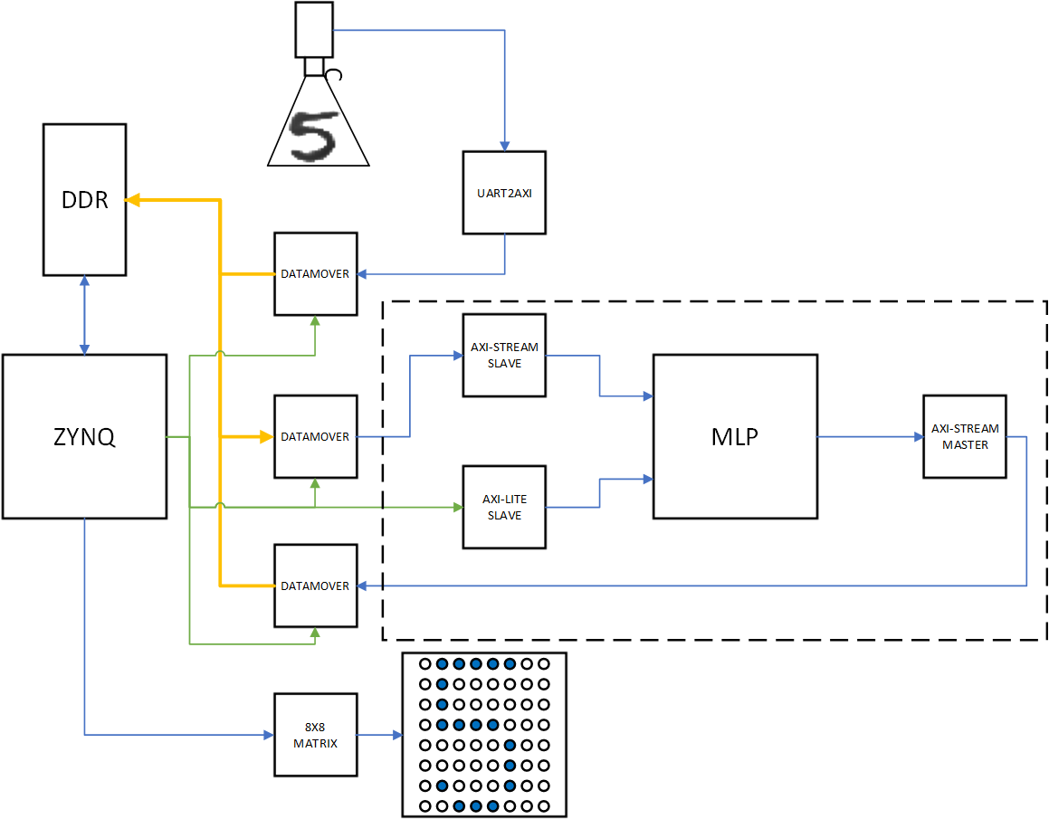

**FIGURE 6.1 General Block Diagram.**

As we are able to see in figure 6.1, a system contains few bigger subsystems. Also, a functionality of the system is divided into four phases.

1. Taking pictures of a number via camera “uCam III” by 4D Systems and sending it via UART2AXI protocol bridge to DDR memory.

2. Softver compression of an image taken by a camera

3. Sending compressed image to MLP Neural Network so the number can be detected

4. Showing detected number on 8X8 Matrix

After implementing diagram from figure 6.1 by using Vivado IP Integrator tool we get something like shown in figure 6.2.

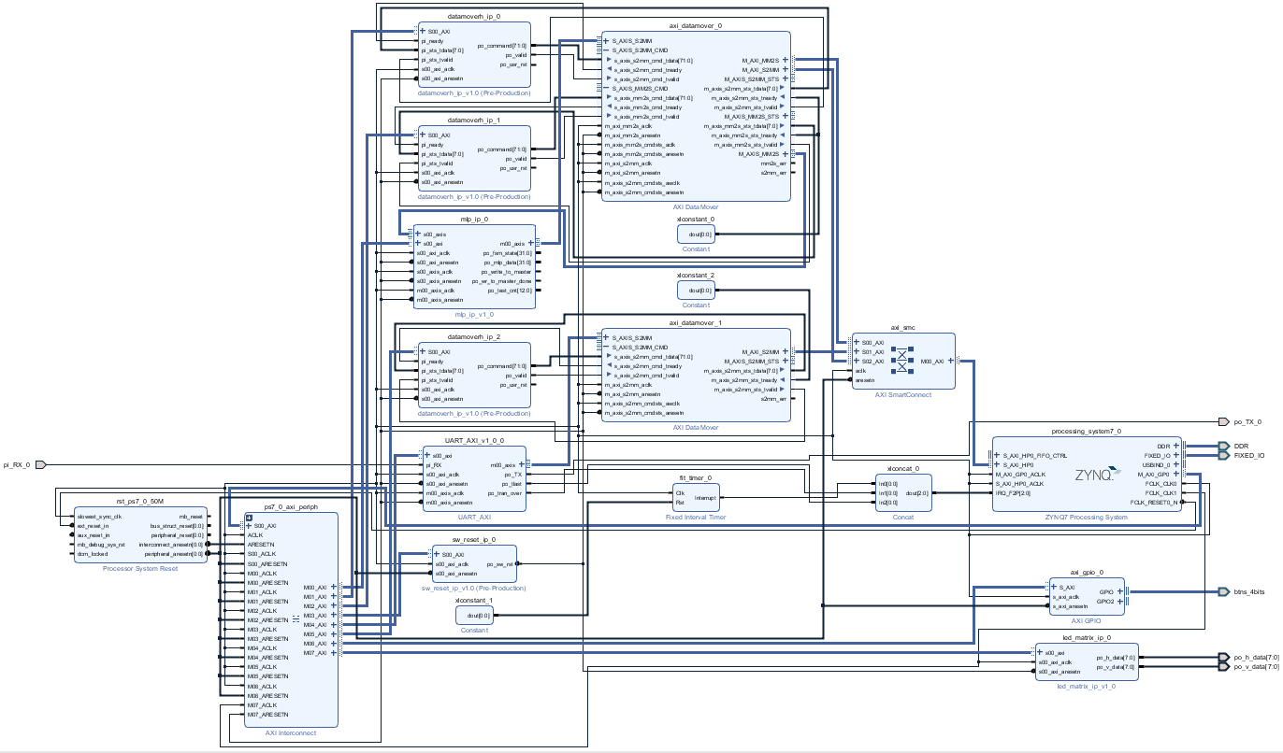

**FIGURE 6.2 General Block Diagram implemented in Vivado IP Integrator tool.**

After creating block diagram inside Vivado IP Integrator tool we should set up each IP core. For additional options, we can simply double click on IP. All IPs settings are outside the scope of this documentation (every option can be seen in the project folder), so we are gonna mention just the most important ones.

Inside PS-PL Configuration we should enable HP interface as it’s shown in figure 6.3. This interface is used by Datamover to send data from and to DDR memory.

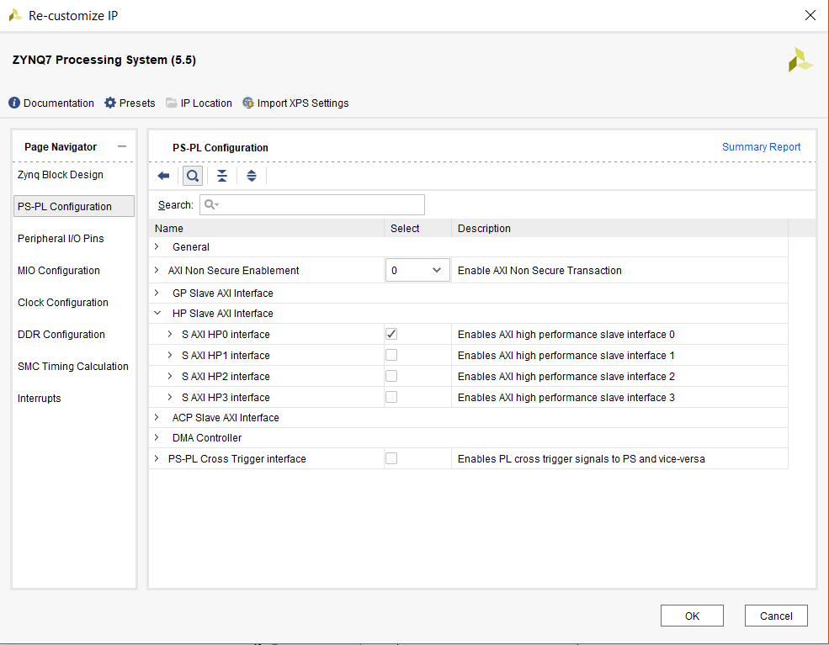

**FIGURE 6.3 Zynq enabling HP interface.**

A second thing that should be enabled is second clock domain. First one is 50 MHz and it’s used for everything except Matrix. LEDs are not able to work properly on high frequencies, for that reason we need to enable the second clock and set it to 1 as it’s shown in figure 6.4.

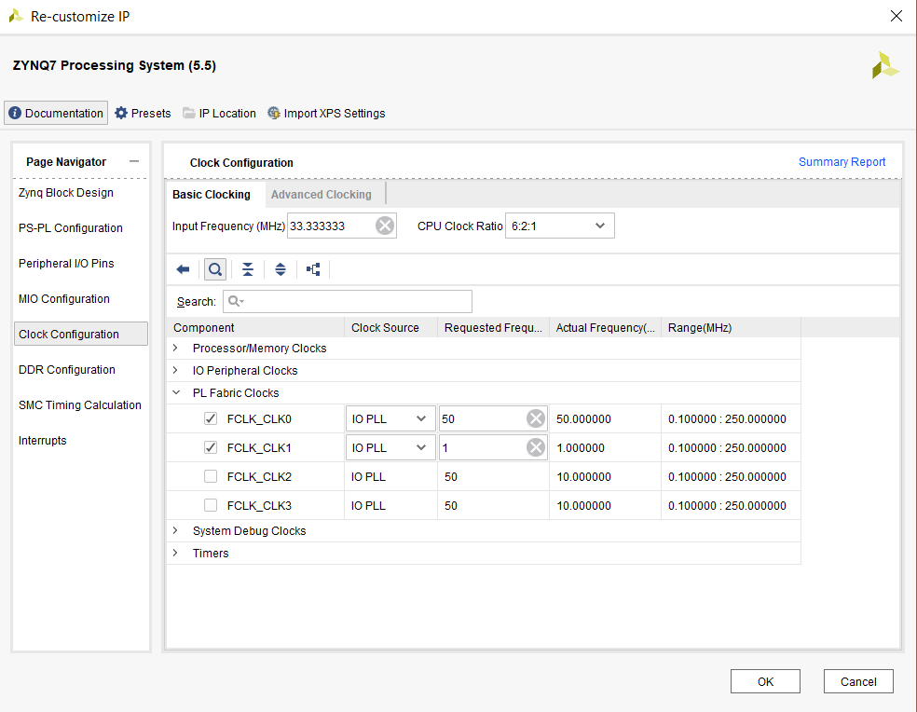

**FIGURE 6.4 Zynq two clocks for system.**

The last thing we need to enable is to interrupt ports. These ports are used for UART interrupts and for time measuring. By “Time measuring” we mean interrupt which provide an option for delay function inside the software. A graphic explanation is shown in figure 6.5.

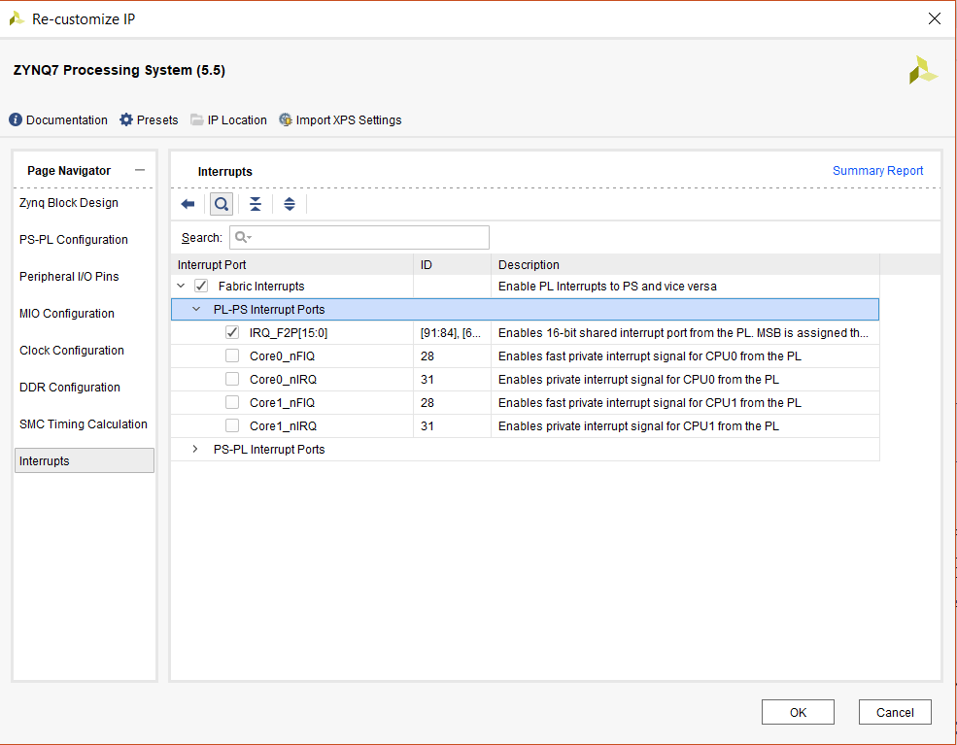

**FIGURE 6.5 Zynq enabling Interrupt ports**

As we said before it’s worth noticing that our system has two clock domains 50MHz and 1MHz and also we have two kinds of reset. Part of the system is reset by hardware, part is reset by software reset. This is done due to lack of functional verification (UVM) part. The system is verified by using bare SystemVerilog, as a result of lack of time, there was no any UVM applied. Consequently, verification isn’t thorough. Everything mentioned above can be seen in figures 6.6, 6.7, 6.8 and 6.9.

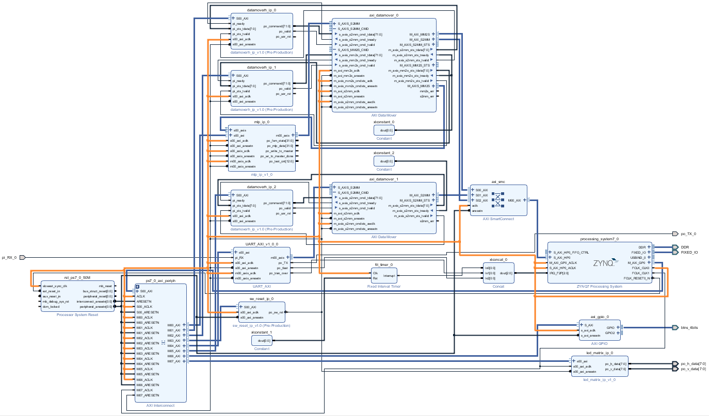

**FIGURE 6.6 System’s 50MHz clock distribution**

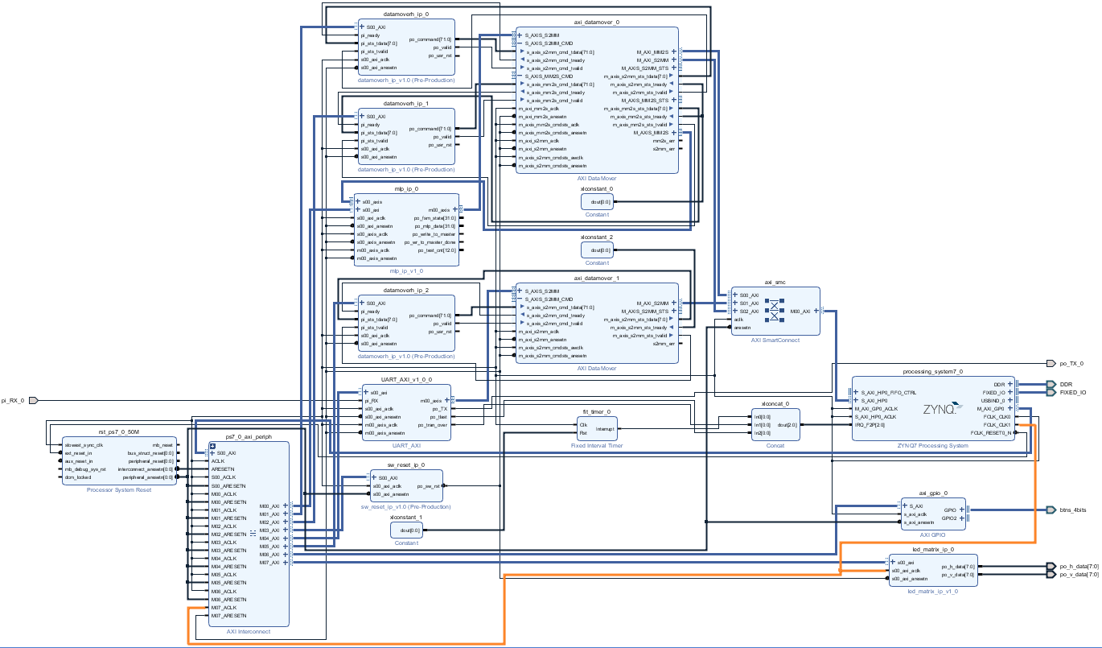

**FIGURE 6.7 System’s 1MHz clock distribution**

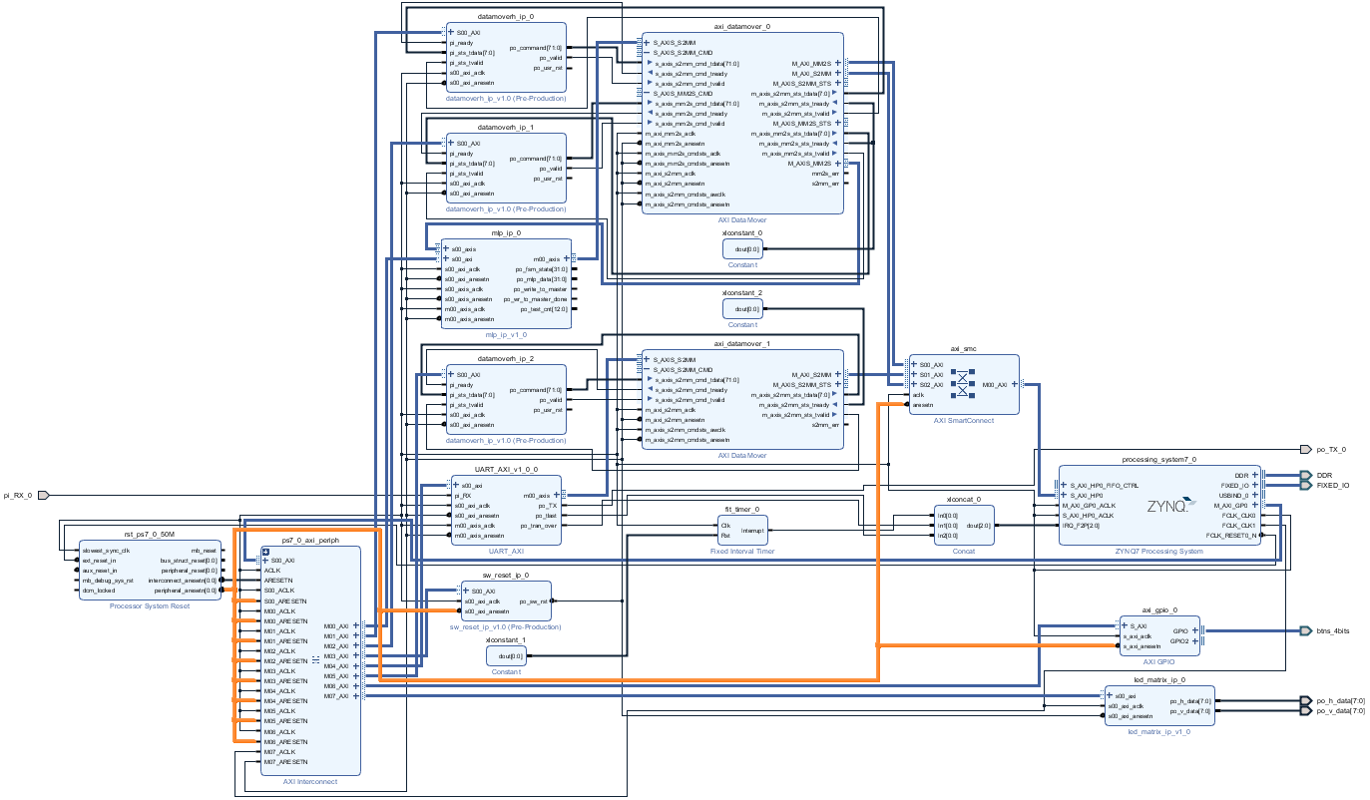

**FIGURE 6.8 System’s hardware reset distribution**

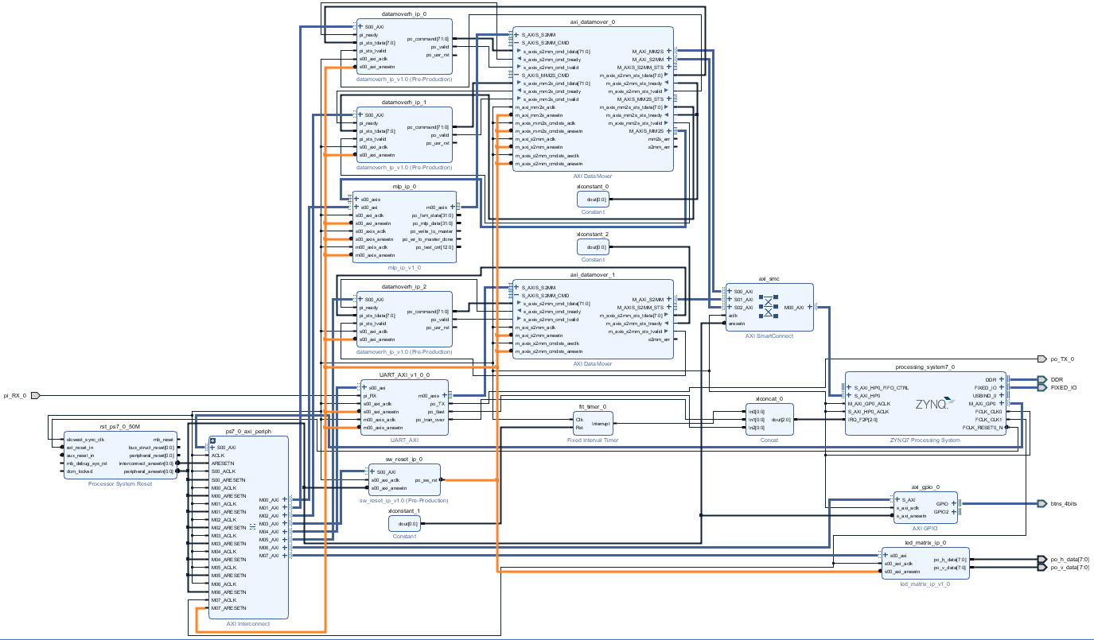

**FIGURE 6.9 System’s software reset distribution**

## 6.1 AXI INTERFACE

### 6.1.1 What is AXI?

AXI is part of ARM AMBA, a family of micro controller buses first introduced in 1996. The

first version of AXI was first included in AMBA 3.0, released in 2003. AMBA 4.0, released in

2010, includes the second major version of AXI, AXI4.

There are three types of AXI4 interfaces:

* + - **AXI4**: For high-performance memory-mapped requirements.
    - **AXI4-Lite**: For simple, low-throughput memory-mapped communication (for example, to and from control and status registers).
    - **AXI4-Stream**: For high-speed streaming data.

Xilinx introduced these interfaces in the ISE® Design Suite, release 12.3. Xilinx continues to use and support AXI and AXI4 interfaces in the Vivado® Design Suite.

### 6.1.2 Summary of AXI4 benefits

AXI4 is widely adopted in Xilinx product offerings, providing benefits to Productivity, Flexibility, and Availability:

* + - **Productivity**: By standardizing on the AXI interface, developers need to learn only a single protocol for IP.
    - **Flexibility**: Providing the right protocol for the application:
      * AXI4 is for memory-mapped interfaces and allows high throughput bursts of up to 256 data transfer cycles with just a single address phase.
      * AXI4-Lite is a light-weight, single transaction memory-mapped interface. It has a small logic footprint and is a simple interface to work with both in design and usage.
      * AXI4-Stream removes the requirement for an address phase altogether and allows unlimited data burst size. AXI4-Stream interfaces and transfers do not have address phases and are therefore not considered to be memory-mapped.
    - **Availability**: By moving to an industry-standard, you have access not only to the Vivado IP Catalog, but also to a worldwide community of ARM partners.
      * Many IP providers support the AXI protocol.
      * A robust collection of third-party AXI tool vendors is available that provide many verification, system development, and performance characterization tools. As you begin developing higher performance AXI-based systems, the availability of these tools is essential.

### 6.1.3 How AXI Works

This section provides a brief overview of how the AXI interface works. Consult the *AMBA AXI specifications* for the complete details on AXI operation. The AXI specifications describe an interface between a single AXI master and AXI slave, representing IP cores that exchange information with each other. Multiple memory-mapped AXI masters and slaves can be connected together using AXI infrastructure IP blocks. The Xilinx AXI Interconnect IP and the newer AXI SmartConnect IP contain a configurable number of AXI-compliant master and slave interfaces, and can be used to route transactions between one or more AXI masters and slaves.

Both AXI4 and AXI4-Lite interfaces consist of five different channels:

* Read Address Channel
* Write Address Channel
* Read Data Channel
* Write Data Channel
* Write Response Channel

Data can move in both directions between the master and slave simultaneously, and data transfer sizes can vary. The limit in AXI4 is a burst transaction of up to 256 data transfers. AXI4-Lite allows only one data transfer per transaction.

The following figure shows how an AXI4 read transaction uses the read address and read data channels.

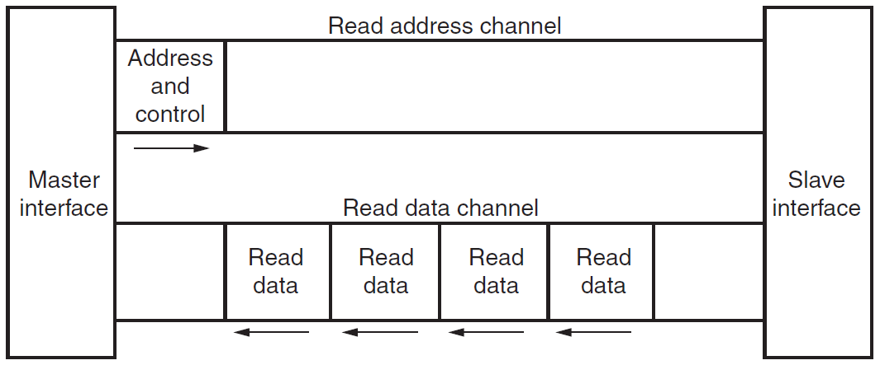

**FIGURE 6.10 Channel Architecture of Reads**

Figure 6.10 shows how a write transaction uses the write address, write data, and write response channels.

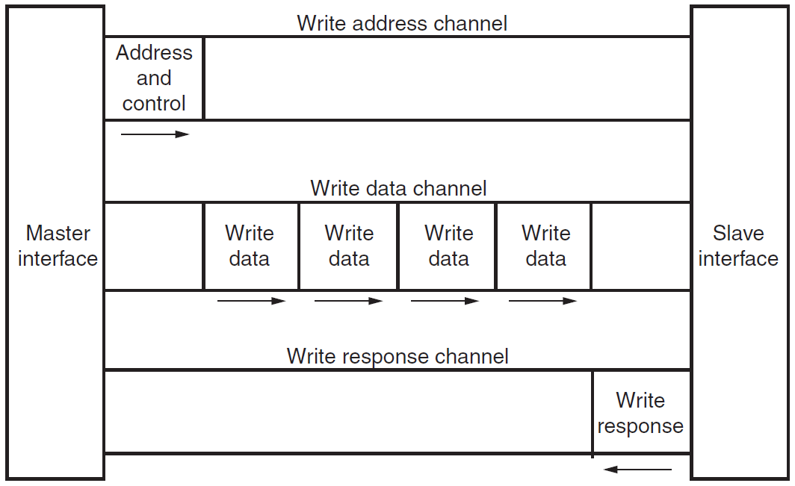

**FIGURE 6.11 Channel Architecture of Writes**

As shown in the preceding figures, AXI4:

* Provides separate data and address connections for reads and writes, which allows simultaneous, bidirectional data transfer.
* Requires a single address and then bursts up to 256 words of data.

The AXI4 protocol describes options that allow AXI4-compliant systems to achieve very high data throughput. Some of these features, in addition to bursting, are: data upsizing and downsizing, multiple outstanding addresses, and out-of-order transaction processing.

At a hardware level, AXI4 allows systems to be built with a different clock for each AXI master-slave pair. In addition, the AXI4 protocol allows the insertion of register slices (often called pipeline stages) to aid in timing closure.

AXI4-Lite is similar to AXI4 with some exceptions: The most notable exception is that bursting is not supported. The AXI4-Lite chapter of the *ARM AMBA AXI Protocol Specification* describes the AXI4-Lite protocol in more detail.

The AXI4-Stream protocol defines a single channel for transmission of streaming data. The AXI4-Stream channel models the write data channel of AXI4. Unlike AXI4, AXI4-Stream interfaces can burst an unlimited amount of data. There are additional, optional capabilities described in the *AMBA4 AXI4-Stream Protocol SpecificationThe* specification describes how you can split, merge, interleave, upsize, and downsize AXI4-Stream compliant interfaces.

* **Memory-Mapped Protocols:** In memory-mapped protocols (AXI3, AXI4, and AXI4-Lite), all transactions involve the concept of transferring a target address within a system memory space and data.

Memory-mapped systems often provide a more homogeneous way to view the system, because the IP operates around a defined memory map.

AXI3-based IP can be integrated into AXI4-based systems for interoperability, however most Xilinx IP natively adopt AXI4 which contains protocol enhancements compared to AXI3.

Note: The processing system block in the Zynq-7000 AP SoC devices use AXI3 memory-mapped interfaces. AXI3 is a subset of AXI4 and Xilinx tools automatically insert the necessary adaptation logic to translate between AXI3 and AXI4.

* **AXI4-Stream Protocol:** Use the AXI4-Stream protocol for applications that typically focus on a data-centric and data-flow paradigm where the concept of an address is not present or not required. Each AXI4-Stream acts as a single unidirectional channel with a handshaking data flow.

At this lower level of operation (compared to the memory-mapped protocol types), the mechanism to move data between IP is defined and efficient, but there is no unifying address context between IP. The AXI4-Stream IP can be better optimized for performance in data flow applications, but also tends to be more specialized around a given application space.

* **Infrastructure IP:** An infrastructure IP is a building block used to help assemble systems. Infrastructure IP tends to be a generic IP that moves or transforms data around the system using general-purpose AXI4 interfaces and does not interpret data.

Examples of infrastructure IP are:

* AXI Register slices (for pipelining)
* AXI FIFOs (for buffering/clock conversion)
* AXI Interconnect IP and AXI SmartConnect IP (for connecting memory-mapped IP together)
* AXI Direct Memory Access (DMA) engines (for memory-mapped to stream conversion)
* AXI Performance Monitors and Protocol Checkers (for analysis and debug)
* AXI Verification IP (for simulation-based verification and performance analysis) These IP are useful for connecting IP together into a system, but are not generally endpoints for data.

### 6.1.4 Combining AXI4-Stream and Memory-Mapped Protocols

A common approach is to build systems that combine AXI4-Stream and AXI memory-mapped IP together. Often a DMA or Datamover engines can be used to move streams in and out of memory.

For example, a processor can work with DMA or Datamover engines to decode packets or implement a protocol stack on top of the streaming data to build more complex systems where data moves between different application spaces or different IP.

### 6.1.5 Using Vivado AXI IP in RTL projects

In the Vivado Integrated Development Environment (IDE), you can access Xilinx IP with an AXI4 interface directly from the Vivado IP Catalog and instantiate that IP directly into an register transfer logic (RTL) design as it’s shown in figure 6.12.

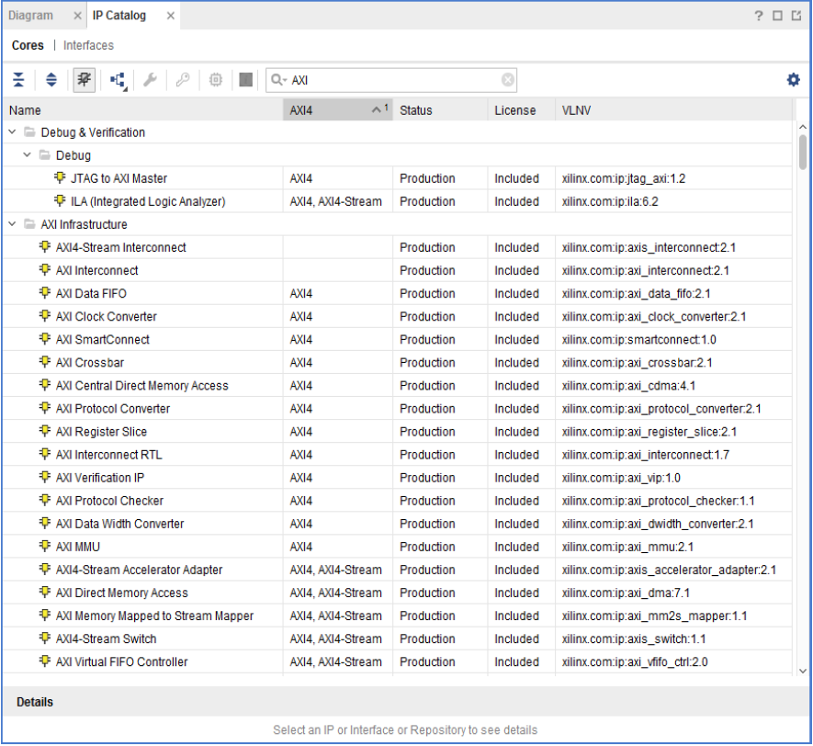

**FIGURE 6.12 IP Catalog in Xilinx Tools**

In the IP catalog, the AXI4 column shows IP with AXI4 interfaces that are supported and displays the which interfaces are supported by the IP interface: AXI4 (memory-mapped), AXI4-Stream, or none.

Xilinx IP are designed to support AXI where applicable. For more information about using IP from the Vivado IP catalog in an RTL flow, see the *Vivado Design Suite User Guide: Designing with IP (UG896).*

The Vivado IDE provides a Create and Package IP wizard that takes you through all the required steps and settings for AXI IP. To create and package new IP:

1. From the **Tools** menu, select **Create and Package IP**, as shown in the following figure.



**FIGURE 6.13 Create and Package IP Option**

The Create And Package IP wizard opens, as shown in figure 6.14.



**FIGURE 6.14 Create and Package IP Dialog Box**

1. Select **Create a new AXI4 Peripheral**, to create template AXI4 peripheral that includes HDL, drivers, a test application, and a BFM example template.
2. Click **Next**.

The choose Create Peripheral or Package IP page opens, as shown in figure 6.15.



**FIGURE 6.15 Create and Package IP Dialog Box**

1. Click **Next**.

The Peripheral Details page opens.

1. Enter the IP details in the Peripheral Details page, as shown in figure 6.16.

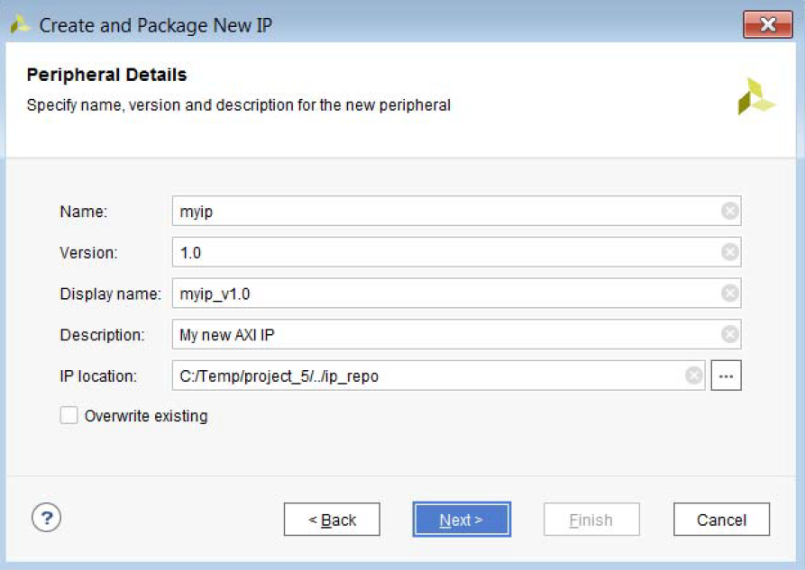

**FIGURE 6.16 IP Details**

The **Display** **Name** you provide shows in the Vivado IP catalog.

You can have different names in the **Name** and **Display** **Name** fields; any change in **Name** reflects automatically in the **Display** **Name**, which is concatenated with the **Version** field.

1. Click **Next**.
2. Select the IP location where ypu want the IP repository list.
3. Click **Next**.
4. Add interfaces to yout IP based on the functionality and the required AXI type, as shown in the following figure.

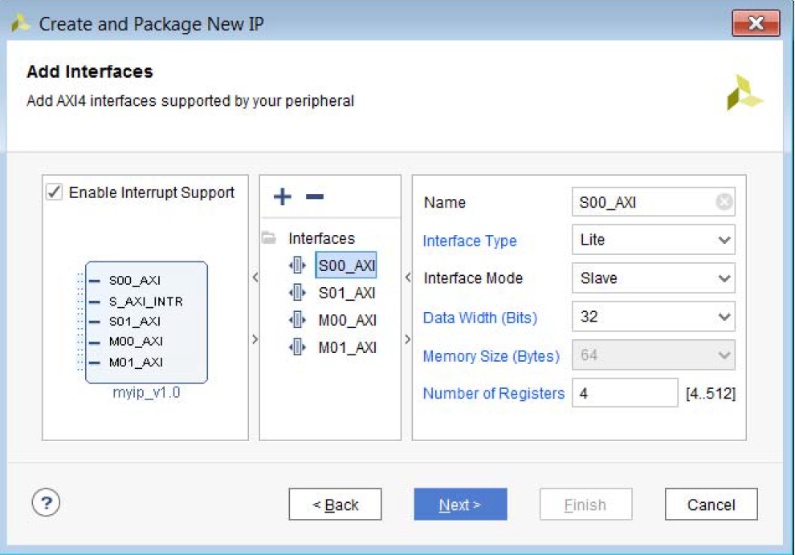

**FIGURE 6.17 Create and Package New IP**

1. To include interrupts to be acailable in your IP, check the **Enable Interrupt Support** check box.

The IP that this example shows would support edge or level interrupt (generated locally on the counter), which can be extended to input ports by user and IRQ output.

The data width and the number of registers vary, based on the AXI4 selection type.

1. Click **Next** and review your selections.

The final page of the wizard lists the details of your IP, as shown in figure 6.18.



**FIGURE 6.18 Create Peripheral Summary Page**

After you generate the IP, additional options are available.

See the *Vivado Design Suite User Guide: Creating and Packaging Custom IP (UG1118)* for more information regarding creating and packaging AXI IP.

### 6.1.6 Adding AXI IP to the IP Catalog using Vivado IP Packager

The Vivado IP packager tool, shown in Figure 6.19, lets you prepare a design for use in the Vivado IP catalog. You can then instantiate this IP into a design in the Vivado Design Suite using the Vivado IP integrator.

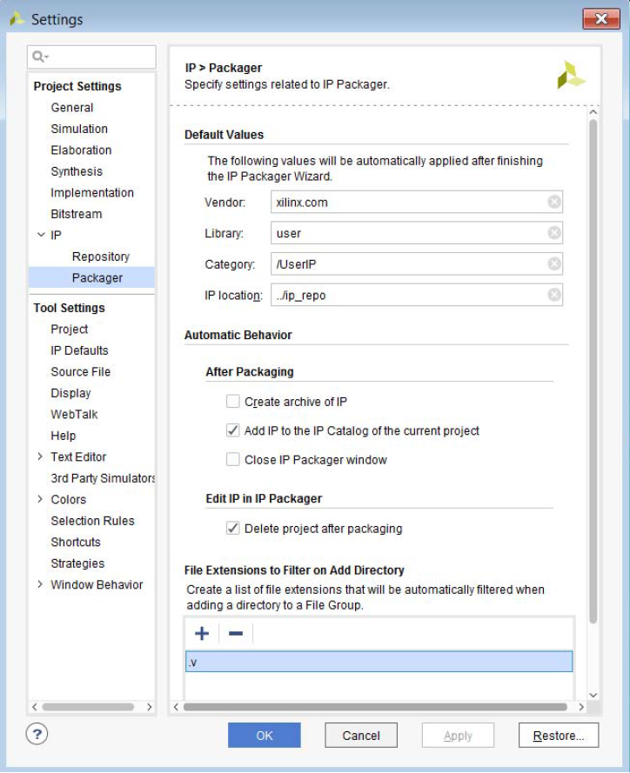

**FIGURE 6.18 Vivado IP Packager Tool**

When you use the Vivado Design Suite IP packaging flow for IP development, you have a more consistent user experience, better tool integration, and greater facilitation for reuse of the IP design in the Vivado IDE. The IP packager is AXI-aware, and can auto-recognize AXI signals. See Appendix A, AXI Adoption Summary, for a summary of the Xilinx AXI adoption per signal.

See the following documens for more information:

* *Vivado Design Suite User Guide: Designing IP Subsystems Using IP Integrator (UG994)*
* *Vivado Design Suite User Guide: Creating and Packaging Custom IP (UG1118)*

### 6.1.7 AXI4 Interface signals

Only AXI Lite and Stream interfaces will be shown. For more informations check *Vivado AXI Reference Guide (UG1037).*

|  |  |
| --- | --- |
| Signal Name | Signal Description |
| s_axi_aclk | Clock signal of AXI’s interface |
| s_axi_aresetn | Reset signal of AXI’s interface |
| Address channel for writting | |
| s_axi_awaddr | The start address of the block from which data will be entered |
| s_axi_awprot | Type of access, rarely used |
| s_axi_awvalid | Indication of addresses |
| s_axi_awready | An indication that AXI slave is ready to accept the address and other control signals from the channel |
| Channel of written data | |
| s_axi_wdata | Data to be entered |
| s_axi_wstrb | The signal validity of individual bytes within the data to be entered. Each bit that is set indicates that the byte in the data is valid. |
| s_axi_wvalid | An indication of the validity of the data to be entered. When high, the current data is valid |
| s_axi_wready | An indication that AXI slave is ready to accept the data |
| Status channel of entry | |
| s_axi_bresp | Status of the completed enrollment transaction |
| s_axi_bvalid | An indication that the transaction status data is valid |
| s_axi_bready | An indication that the AXI master is ready to accept the status information |
| Address channel for reading | |
| s_axi_araddr | The starting address of the block from which the data will be read |
| s_axi_arprot | Type of access, rarely used |
| s_axi_arvalid | An indication of the validity of the address. When high, the current address is valid |
| s_axi_arready | An indication that AXI slave is ready to accept the address and other control signals from the channel |
| Channel of read data | |
| s_axi_rdata | Data that has been read |
| s_axi_rresp | The status of the completed reading transaction |
| s_axi_rvalid | An indication of the validity of the data to be read. When high, the current data is valid |
| s_axi_rready | An indication that AXI mother is ready to accept the data |

**FIGURE 6.19 Signals of AXI-Lite interface in case of slave component**

|  |  |
| --- | --- |
| Signal Name | Signal Description |
| m_axis_aclk | AXI interface synchronization signal |
| m_axis_aresetn | Reset signal of AXI interface |
| m_axis_tdata | Data bus |
| m_axis_tvalid | An indication that the current data is valid |
| m_axis_tready | Acknowledgment that AXI slave is ready to receive the following information |
| m_axis_tlast | An indication that the current data is also the last information to be transmitted |

**FIGURE 6.20 Signals of AXI-Stream interface in case of master component**

### 6.1.8 AXI4 Protocol Waveforms

Figure 16.21 shows the waveforms of the relevant AXI-Lite AXI-Lite signal of the hypothetical IP core in the case of a data entry transaction. The data entry transaction begins with the AXI master setting the s_axi_awaddr bus to the value of the address of the location within the IP core to which it wants to enter the data. In the example from Figure 16.21, the address of the location to which the data is to be entered is 0x38. At the same time, AXI master also sets the s_axi_awvalid signal to the unit, signaling the IP core that a new valid address is set up on the s_axi_awaddr bus. When the IP core is ready to accept the address, it sets the s_axi_awready signal to the unit. In the next clock, the AXI master sets the s_axi_awvalid signal to zero and removes the address from the s_axi_awaddr bus. At the same time, or earlier than in the case of Figure 16.21, the AXI master sets the data that wants to write to the addressed location within the IP core on the s_axi_wdata bus (in Figure 16.21, the word is 0x40). It also sets an indication of which bytes within the data are valid and should be entered into the address, setting the corresponding bits of the s_axi_wstrb bus to the unit. AXI master also sets the s_axi_wvalid signal on the unit to signal the IP core that the s_axi_wdata has validated the valid data. When the IP core is ready to write the data to the address, s_axi_wready signal to the unit, and at the same time enter the data (in Figure 16.21, the 0x40 data is entered into the hypothetical Device register, because it is located at 0x38). After detecting a high level on the s_axi_wready signal, the AXI master removes the data from the s_axi_wdata and s_axi_wstrb bus and sets the s_axi_wvalid signal to zero. At the same time, the IP core sets the signal s_axi_wready to zero. The last part of the data entry transaction is an indication of the final status of the transaction. This information generates the IP core, through the status entry channel. The IP core sets the required status code on the s_axi_bresp bus, simultaneously setting the s_axi_bvalid signal to the unit and then waiting for the s_axi_bready signal to become high. AXI master signals that it is ready to accept the final status of an entry transaction, setting s_axi_bready signal to the unit. When, after setting up the valid final status of an entry transaction, the IP core detects that the s_axi_bready signal is high, in the following manner it removes this information from the status registration channel, thus completing the AXI-Lite data entry transaction.

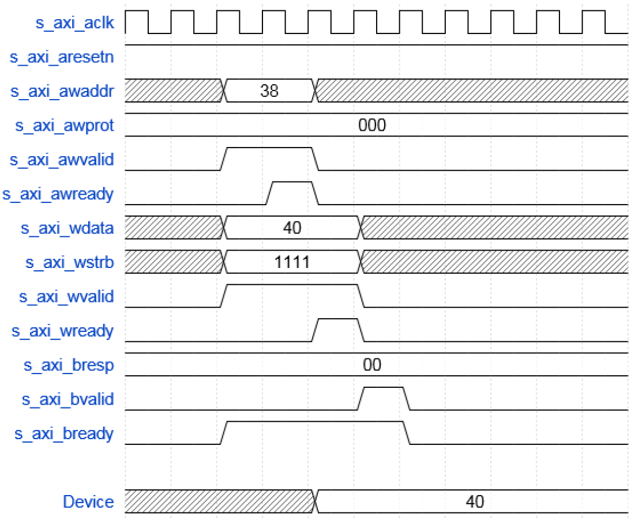

**FIGURE 6.20 A data entry transaction using the AXI-Lite interface**

Figure 6.21 shows the waveforms of the relevant AXI-Lite AXI-Lite signal of the hypothetical IP core in the case of a data read transaction. The data reading transaction begins by the AXI master setting s_axi_araddr the master to the value of the address of the location within the IP core from which it wants to read the data. In the example from Figure 6.21, the address of the location from which the data is to be read is 0x3C. At the same time, AXI master also sets the signal s_axi_arvalid on the unit, signaling the IP core that the new valid address is set to a s_axi_araddr bus. When the IP core is ready to accept the address, it sets the s_axi_arready signal to the unit. In the next clock, AXI master sets the s_axi_arvalid signal to zero and removes the address from the s_axi_araddr bus. At the same time, or even earlier, as in Figure 6.21, the AXI master also sets the s_axi_rready signal to the unit to signal the IP core that it is ready to receive data. When the IP core is ready to forward the read data from the addressed location to the AXI mother, it sets it to the s_axi_rdata mainline (in Figure 6.21 the read data represents the content of the hypothetical Registry Status, and has a value of 0x7F). At the same time, the IP core also sets the s_axi_rvalid signal to the unit, signaling the AXI master to have valid data on the s_axi_rdata mainline. After detecting a high level on the s_axi_rready signal, the IP core removes data from the s_axi_rdata bus and sets the s_axi_rvalid signal to zero. This completes the AXI-Lite transaction of data reading.

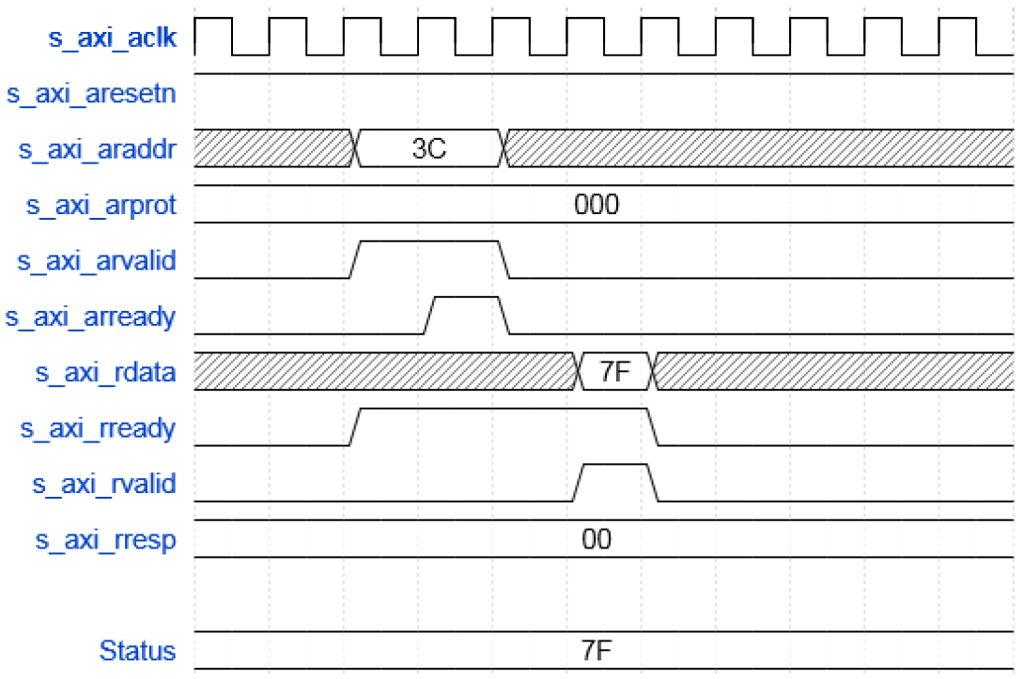

**FIGURE 6.21 Transaction of data reading using AXI-Lite interface**

The latest version of the AXI4 interface that we will present is the AXI-Stream protocol. As already mentioned, the AXI-Stream protocol does not use address information as an indication of the location to be stored or read data. Instead, AXI Stream simply transfers data as one continuous stream (hence its name, AXI-Stream). Data is transmitted in blocks and as such are then processed. This is a very common case in audio, video applications, data transfer, etc. On the other hand, the lack of address information allows the AXI-Stream protocol to be much simpler than AXI-Full, and even from the AXI-Lite protocol. Note that in the case of AXI-Stream protocol there is no point in talking about the operation of reading or writing data. In this case, the data is simply transferred from the AXI-Stream master to the AXI-Stream slot, and this is the only possible transaction in this protocol.

Table 6.20 shows the list of all signals that make up the AXI-Stream interface, in the case of the AXI master component along with a brief explanation of each of the signals. In the case of the AXI slider component, AXI-Stream interface would consist of the same signals, only the direction of each of them would be inverted.

As in the case of the AXI-Stream interface, the data is transmitted in only one direction, from the AXI-Stream master to the AXI-Stream slave, Figure 6.22 shows waveforms of the AXI-Stream AXI-Stream interface of the AXI-Stream master during the transaction of the data block transmission. The transfer process starts when the AXI-Stream master sets the first data on the m_axis_tdata bus and raises the m_axis_tvalid signal to the unit. The data set remains on the m_axis_tdata bus until the AXI-Stream slave module signals the AXI-Stream master to be ready to accept the next data, setting the m_axis_tready signal to the unit, which can be clearly seen in Figure 6.22. When the AXI-Stream master learns that AXI-Stream slot is ready to receive the next data, he sets the following data on the m_axis_tdata master's next time. If for some reason the AXI-Stream Master is not able to set the following data on the m_axis_tdata bus, this fact signals the AXI-Stream slider by lowering the m_axis_valid data. The described data transfer process continues until the last data to be transmitted is reached. When the AXI-Stream master sets the last data on the m_axis_tdata bus and marks it as valid, setting the m_axis_tvalid signal to the unit, at the same time, sets the m_axis_tlast signal to the unit, signaling that this is the last data from the current package. After the AXI-Stream slave takes over this data, placing the m_axis_tready signal on the unit, the current data transfer transaction is completed.

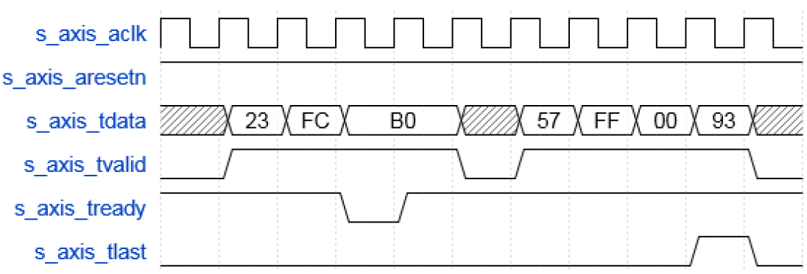

**FIGURE 6.22 Transfer the data block using the AXI-Stream interface**

## 6.2 DATAMOVER

### 6.2.1 Overview

The AXI DataMover is a key interconnect infrastructure IP that enables high throughput transfer of data between the AXI4 memory-mapped and AXI4-Stream domains. The AXI DataMover provides the MM2S and S2MM AXI4-Stream channels that operate independently in a full-duplex like method. The AXI DataMover IP core is a key building block with 4 KB address boundary protection, automatic burst partitioning, and provides the ability to queue multiple transfer requests using nearly the full bandwidth capabilities of the AXI4-Stream protocol. Furthermore, the AXI DataMover provides byte-level data realignment allowing memory reads and writes to any byte offset location. Based on the requirement of the channels, they can be configured as Basic or Full.

Figure 6.23 and 6.24 show block diagrams of the AXI DataMover core. There are two sub blocks:

* **MM2S**: This block handles transactions from the AXI4 to the AXI4-Stream domain. It has its dedicated AXI4-Stream compliant command and status queues, reset block, and error signals. Based on command inputs, the MM2S block issues a read request on the AXI4 interface. Read data can be optionally stored inside the MM2S block. Datapath interfaces (AXI4-Read and AXI4-Stream Master) can optionally be made asynchronous to command and status interfaces (AXI4-Stream Command and AXI4-Stream Status).
* **S2MM**: This block handles transactions from the AXI4-Stream to AXI4 domain. It has its dedicated AXI4-Stream compliant command and status queues, reset block, and error signals. Based on command inputs and input data from the AXI4-Stream interface, the S2MM block issues a write request on the AXI4 interface. Input stream data can be optionally stored inside a S2MM block. Datapath interfaces (AXI4-Read and AXI4-Stream Master) can optionally be made asynchronous to command and status interfaces (AXI4-Stream Command and AXI4-Stream Status).

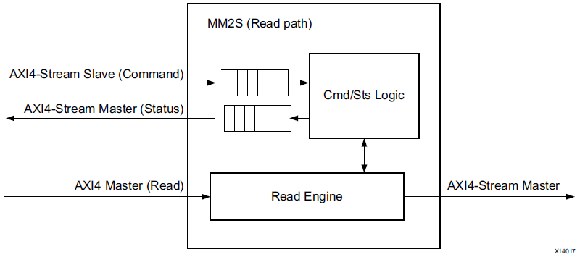

**FIGURE 6.23 AXI DataMover Read Path**

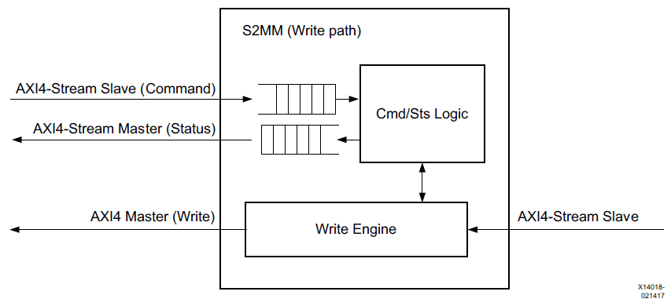

**FIGURE 6.24 AXI DataMover Write Path**

### 6.2.2 Feature Summary

The AXI DataMover core is fully compliant with the AXI4 interface and the AXI4-Stream interface.

**AXI4 Data Width**

The AXI DataMover core supports the primary AXI4 data bus width of 32, 64, 128, 256, 512, and 1,024 bits.

**AXI4-Stream Data Width**

The AXI DataMover core supports the primary AXI4-Stream data bus width of 8, 16, 32, 64, 128, 256, 512, and 1,024 bits. The AXI4-Stream data width must be less than or equal to the AXI4 data width for the respective channel.

**Maximum Memory Map Burst Length**

The AXI DataMover core supports parameterized maximum size of the burst cycles on the AXI MM2S Memory Map interface. In other words, this setting specifies the granularity of burst partitioning. For example, if the burst length is set to 16, the maximum burst on the memory map interface is 16 data beats. Smaller values reduce throughput but result in less impact on the AXI infrastructure. Larger values increase throughput but result in a greater impact on the AXI infrastructure. Valid supported values are 2, 4, 8, 16, 32, 64, 128, and 256 based on the data width that is selected.

**Unligned Transfers**

The AXI DataMover core optionally supports the Data Realignment Engine (DRE). When DRE is enabled, data is realigned to the byte (8 bits) level on the Memory Map datapath. DRE support is provided on the AXI4-Stream interface for TDATA widths up to 64 bits. If the DRE is enabled, data reads can start from any Buffer Address byte offset, and the read data is aligned such that the first byte read is the first valid byte out on the AXI4-Stream. Similarly, when the DRE is enabled, the writes can happen at any byte offset address. What is considered aligned or unaligned is based on the Memory Map data width. For example, if Memory Map Data Width = 32, data is aligned if it is located at address offsets of 0x0, 0x4, 0x8, 0xC, etc. Data is unaligned if it is located at address offsets of 0x1, 0x2, 0x3 and so forth.

**Note**: Performing unaligned transfers when DRE is disabled will give unpredictable results.

**Asynchronous Clocks**

The AXI DataMover core supports asynchronous clock domain for Command/Status Stream interface and Memory Map interface.

**Store and Forward**

The AXI DataMover core supports the optional General Purpose Store-And-Forward feature. Store and Forward buffer is sized based on Memory map data width and Burst size support. It is sized to allow up to six outstanding requests on MM2S channel.

**Indeterminate BTT Mode**

The AXI DataMover core supports the optional Indeterminate BTT mode for the S2MM channel. This is needed when the number of bytes to be received on the input S2MM Stream Channel is unknown.

### 6.2.3 Command Interface

The DataMover operations are controlled by an AXI slave stream interface that receives transfer commands from the user logic. The MM2S and the S2MM each have a dedicated command interface. A command is loaded with a single data beat on the input command stream interface. The width of the command word is normally 72 bits if 32- bit AXI addressing is being used in the system. However, the command word width is extended (by parameterization) if the system address space grows beyond 32 bits. For example, a 64-bit address system requires the command word to be 104 bits wide to accommodate the wider starting address field. The command interface is an AXI4-Stream interface so the total number of bits should be an integer multiple of 8. For example, if the address space is configured as 33 bits, the address portion in the command should be stuffed to make it 40 bits. This is to ensure compliance with the AXI4-Stream protocol. AXI Datamover will internally ignore the stuffed bits.

The format of the command word is shown in Figure 6.25 and detailed in Figure 6.26. It is the same for either the MM2S or S2MM DataMover elements. The command format allows the specification of a single data transfer from 1- byte to 8,388,607 bytes (7FFFFF hex bytes). A command loaded into the command interface is often referred to as the parent command of a transfer. The DataMover automatically breaks up large transfers into intermediate bursts (child transfers) that comply with the AXI4 protocol requirements.

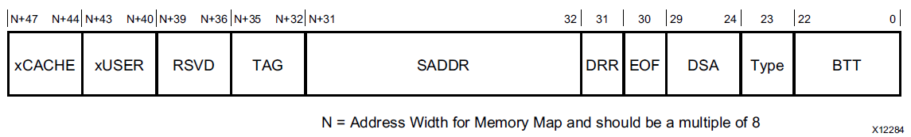

**FIGURE 6.25 Command Word Layout**

|  |  |  |
| --- | --- | --- |
| Bits | Field Name | Description |
| (N+47) – (N+44) | xCACHE | The value written in this field appears on m_axis_mm2s_arcache for MM2S block and m_axis_s2mm_awcache for S2MM block. |
| (N+43) – (N+40) | xUSER | The value written in this field appears on m_axis_mm2s_aruser for MM2S block and m_axis_s2mm_awuser for S2MM block. |
| (N+39) – (N+36) | RSVD | **Reserved** |
| (N+35) – (N+32) | TAG | **Command TAG**  This field is an arbitrary value assigned that is user assigned to the command. The TAG flows through the DataMover execution pipe and gets inserted into the corresponding status word for the command. |
| (N+31) –  32 | SADDR | **Start Address**  This field indicates the starting address to use for the memory-mapped side of the transfer requested by the command. If DRE is enabled, the lower order address bits of this field indicate the starting alignment to load on the memory mapped side of the DRE. |
| 31 | DDR | **DRE ReAlignment Request**  This bit is only used if the optional DRE is included by parameterization. The bit indicates that the DRE alignment needs to be re-established prior to the execution of the associated command. The DRE stream side alignment is derived from the DSA field of the command. The Memory Mapped side alignment is derived from the least significant bits of the SADDR field. |
| 30 | EOF | **End of Frame**  This bit indicates that the command is an End of Frame command. This generally affects the MM2S element (Read Master) because it causes the stream output logic to assert the TLAST output on the last data beat of the last transfer needed to complete the command. If DRE is included, this also causes the DRE to flush out any intermediate data at the conclusion of the last transfer of the command and submit it to the stream output (in the case of the MM2S Read Master) or to the AXI Write Data Channel (in the case of the S2MM Write Master). This bit should be set for S2MM commands (when the Indeterminate BTT mode is disabled) when TLAST is expected to arrive with the number of bytes programmed in the command. |

**FIGURE 6.26 Command Word Description**

|  |  |  |
| --- | --- | --- |
| Bits | Field Name | Description |
| 29  - 24 | DSA | **DRE Stream Alignment**  This field is only used by the MM2S and if the optional MM2S DRE is included by parameterization. The field is only used when the DRR bit of the associated command is also set to 1. This 6-bit field indicates the reference alignment of the MM2S Stream Data Channel for the optional DRE. The value is byte-lane relative. A value of 0 indicates byte lane 0 (least significant byte) is the reference byte lane; a value of 1 indicates byte lane 1, and so on. Valid values are dependent upon the parameterized data width of the stream data channel. For example, a 32-bit wide data channel has only 4-byte lane positions and thus the DSA field can only have values of 0 to 3.  **Note**: DRE alignment on the associated memory-mapped side is derived from the least significant bits of the SADDR value of the command. |
| 23 | Type | This field determines the type of AXI4 access. Setting this to 1 enables INCR. A value of 0 enables FIXED address AXI4 transaction. |
| 22  -  0 | BTT | **Bytes to Transfer**  This 23-bit field indicates the total number of bytes to transfer for the command. Transfers can be from 1 up to 8,388,607 bytes. A value of 0 is not allowed and causes an internal error from the DataMover. The actual number of BTT bits used by the DataMover is controlled by the parameters 'Width of BTT field' for MM2S and S2MM respectively. |

**FIGURE 6.26 Command Word Description**

**Notes:**

1. N is the width of memory-mapped address bus. If the address width is configured as 33, then N should be considered as 40 while generating the command and the upper 7 address bits should be stuffed. The stuffed bits are ignored by the AXI Datamover. This must be done to ensure that the width of command bus is a multiple of 8.
2. These fields are valid only when **Enable xUSERxCACHE** is checked in the Vivado Integrated Design Environment (IDE).

### 6.2.4 Command FIFO

The command interface of a DataMover element is designed to allow command queuing. The commands are queued in a FIFO. The command FIFO is by default a synchronous FIFO using the same clock as the memory mapped data and address channels of the associated DataMover element. However, you can specify an asynchronous command interface FIFO. This allows the command interface to be clocked at a different (generally much slower) frequency than the memory-mapped interface.

**Command Stream Interface Timing**

Loading a command into the command FIFO is mechanized by a single AXI4-Stream data beat. An example of loading five commands into the MM2S Command FIFO is shown in Figure 6.27. In this scenario, the command FIFO is synchronous to the memory-mapped interface. The tlast and tstrb signals are ignored.

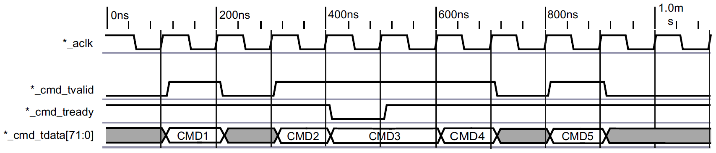

**FIGURE 6.27 Loading Commands via the Command Interface**

### 6.2.5 Status Interface

The status of DataMover transfer operations is provided by an AXI Master Stream interface that relays transfer status to the user logic. The MM2S and the S2MM each have a dedicated Status Interface. A status word is read with a single data beat on the Status Stream interface. The width of the status word is fixed at 8 bits except when S2MM is enabled in indeterminate mode (S2MM Status Format in Indeterminate BTT Mode (IBTT).) The format of the status word is shown in Figure 6.28 and detailed in Figure 6.29. It is the same for either the MM2S or S2MM DataMover elements.

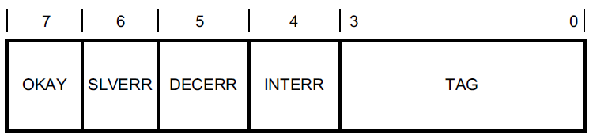

**FIGURE 6.28 Normal Status Word Layout**

|  |  |  |
| --- | --- | --- |
| Bits | Field Name | Description |
| 7 | OKAY | **Transfer OKAY**  This bit indicates that the associated transfer command has been completed with the OKAY response on all intermediate transfers.  0 = Command had a non-OKAY response during all associated transfers.  1 = Command had a OKAY response during all associated transfers. |
| 6 | SLVERR | **Slave Error**  Indicates the DataMover encountered a slave reported error condition for the associated command. This is received by the response inputs from the AXI4 interface.  0 = No Error  1 = Slave Asserted Error Condition |
| 5 | DECERR | **Decode Error**  Indicates the DataMover encountered an address decode error condition for the associated command. This is received by the response inputs from the AXI4 interface and indicates an address decode timeout occurred on an address generated by the DataMover element while executing the corresponding command.  0 = No Error  1 = Address Decode Error Condition |
| 4 | INTERR | **Internal Error**  Indicates the DataMover encountered an internal error condition for the associated command. A BTT (Bytes to Transfer) value of 0 (zero) in the command word can cause this assertion. This error is also flagged by the S2MM function when the Indeterminate BTT mode is not enabled and the number of bytes received on the AXIS is not the same as what was programmed in the BTT field of the command. In other words, this error is flagged if TLAST comes early or late or never.  0 = No Error  1 = Internal Error Condition |
| 3  -  0 | TAG | **TAG**  This 4-bit field echoes the value of the TAG field of the associated input command whose completion generated the status. |

**FIGURE 6.29 Status Word Details**

### 6.2.6 Status FIFO

The Status Interface of a DataMover is designed to allow for status queuing corresponding to the available command queuing on the Command Interface. The status values are “queued” in a FIFO.

The Status FIFO is by default a synchronous FIFO using the same clock as the memory mapped interface of the associated DataMover element. However, you can specify an asynchronous Command/Status Interface FIFO. This allows the command and status interfaces to be clocked at a different (generally much slower) frequency than the associated memory-mapped interface.

**Status Read Interface Timing**

Reading a status word from the Status FIFO is mechanized by a single AXI4-Stream data beat. An example of reading five status entries from the MM2S Status FIFO is shown in Figure 6.30. In this scenario, the Status FIFO is synchronous to the memory-mapped address and data channel clock. The example illustrates that a status word is considered read from the Status FIFO only when the tvalid and tready handshake signals are both asserted at the rising edge of the synchronizing clock.

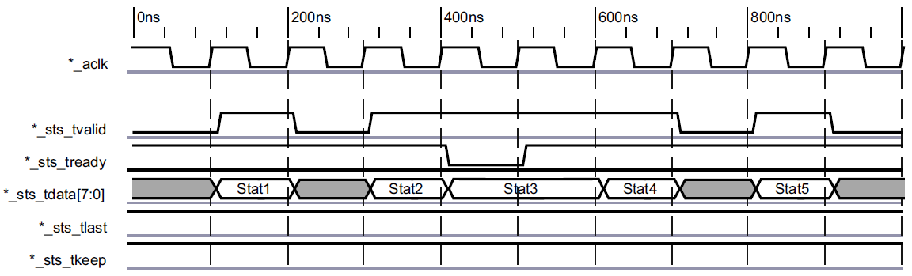

**FIGURE 6.30 Reading Status over the Status Interface**

## 6.3 uCAM III – UART2AXI INTERFACE

### 6.3.1 Why UART and why uCAM III

We had a discussion which camera to use for our project. In the first moment, we thought that USB camera is a good choice but we realized that USB protocol is very complicated to be done in FPGA. So we were searching for some other protocol and we found UART camera. On the first hand, we were pessimistic about speed but it turned out to be no problem. So we chose uCAM III camera with RAW image format and UART communication protocol.The uCAM-III (microCAM-III) is a highly integrated serial camera module.The module uses a CMOS VGA colour sensor along with a JPEG compression chip that provides a low cost and low powered camera system. The uCAM-III is capable of outputting both RAW format and JPEG format images.



**FIGURE 6.31 uCAM III features**

### 6.3.2 General about UART protocol

A **universal asynchronous receiver-transmitter** (**UART)** is computer hardware device for asynchronous serial communication in which the data format and transmission speeds are configurable. The electric signaling levels and methods are handled by a driver circuit external to the UART. The universal asynchronous receiver-transmitter (UART) takes bytes of data and transmits the individual bits in a sequential fashion.At the destination, a second UART re-assembles the bits into complete bytes. Each UART contains a shift register, which is the fundamental method of conversion between serial and parallel forms. Serial transmission of digital information (bits) through a single wire or other medium is less costly than parallel transmission through multiple wires.Communication may be *simplex* (in one direction only, with no provision for the receiving device to send information back to the transmitting device), *full duplex* (both devices send and receive at the same time) or *half duplex* (devices take turns transmitting and receiving).



**FIGURE 6.32 UART data format**

The idle, no data state is high-voltage, or powered. Each character is framed as a logic low start bit, data bits, possibly a parity bit, and one or more stop bits. In most applications the least significant data bit (the one on the left in this diagram) is transmitted first. The start bit signals the receiver that a new character is coming. The next five to nine bits, depending on the code set employed, represent the character. If a parity bit is used, it would be placed after all of the data bits. The next one or two bits are stop bit(s). They signal the receiver that the character is completed. Since the start bit is logic low (0) and the stop bit is logic high (1) there are always at least two guaranteed signal changes between characters.

All operations of the UART hardware are controlled by a clock signal which runs at a multiple of the data rate, typically 8 times the bit rate. The receiver tests the state of the incoming signal on each clock pulse, looking for the beginning of the start bit. If the apparent start bit lasts at least one-half of the bit time, it is valid and signals the start of a new character. If not, it is considered a spurious pulse and is ignored. After waiting a further bit time, the state of the line is again sampled and the resulting level clocked into a shift register. After the required number of bit periods for the character length (5 to 8 bits, typically) have elapsed, the contents of the shift register are made available (in parallel fashion) to the receiving system. The UART will set a flag indicating new data is available, and may also generate a processor interrupt signal.

It is a standard feature for a UART to store the most recent character while receiving the next. This "double buffering" gives a receiving computer an entire character transmission time to fetch a received character. Many UARTs have a small first-in, first-out FIFO buffer memory between the receiver shift register and the host system interface. This allows the host processor even more time to handle an interrupt from the UART and prevents loss of received data at high rates.

Transmission operation is simpler as the timing does not have to be determined from the line state, nor is it bound to any fixed timing intervals. As soon as the sending system deposits a character in the shift register (after completion of the previous character), the UART generates a start bit, shifts the required number of data bits out to the line, generates and sends the parity bit (if used), and sends the stop bits. Since full-duplex operation requires characters to be sent and received at the same time, UARTs use two different shift registers for transmitted and received characters.

### 6.3.3 Hardware implementation

The UART we implemented is the same as the one below the image below consists of a FIFO buffer, a SIPO register, and a circuit that realizes the UART protocol logic.

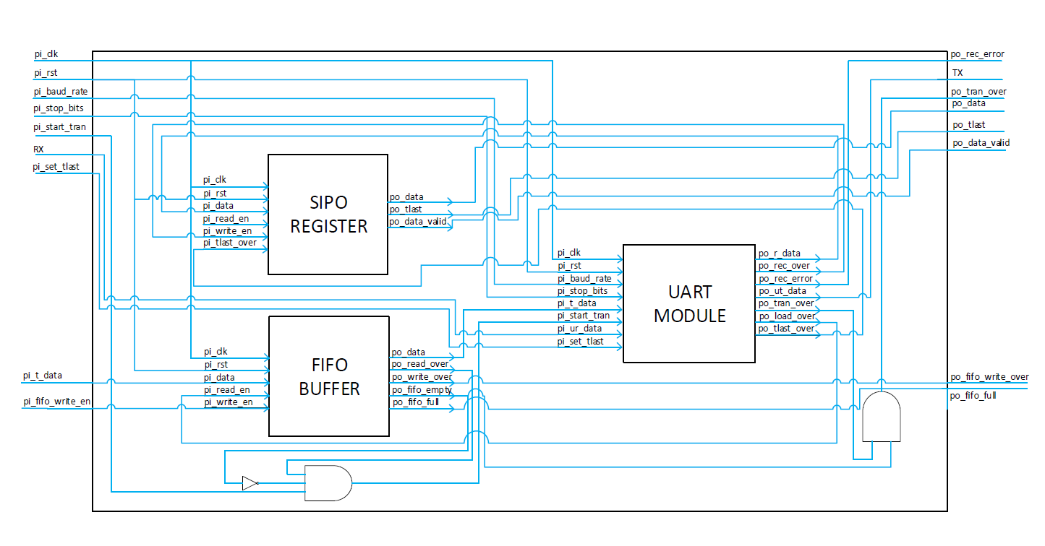

**FIGURE 6.33 Block diagram of UART top module**

At the very beginning, before the synthesis and implementation of the circuit in which our module is located, it is necessary to adjust the generic parameters such as the depth of the FIFO buffer, the width of the register and the number of bits that will be sent.

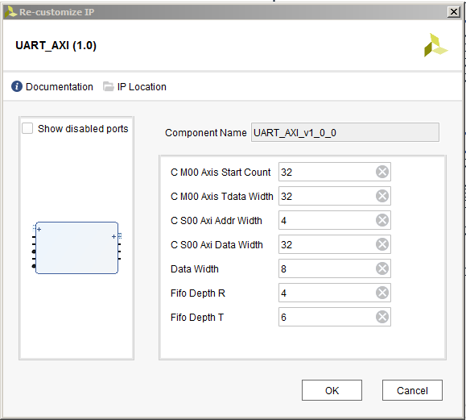

**FIGURE 6.34 Parametar configuration**

After setting the desired parameters, it is necessary to perform the synthesis and implementation of the circuit.

Once the implementation is complete, we can start using our UART module.

To begin with, it is necessary to initialize the module by setting the baud rate using the following formula:

$$pi_baud_rate = \frac{pi_clk}{baud rate value}$$

After we set the baud rate, it is necessary to set the number of the stop bits. If we bring the "1" pin to “pi_stop_bits”, the protocol will work with two stop bits if we bring "0" the protocol will work with a single stop bit.

It remains to be set up after how many bytes we want to generate a "tlast" signal that is necessary for the correct operation of the axi stream protocol.

After successfully executing the initialization of the module, we can start with the data exchange. First, we will describe the process of sending data. In order to send the data, it is necessary first to enter it into the FIFO buffer. Enrollment in the FIFO buffer is performed by simultaneously bringing the data and the enable signal to the buffer input.

The only thing left is to bring the impulse to the pi_start tran pin in order to start sending the data.

After that, a transaction starts with a start bit having a logical zero value, followed by 8 data bits and finally one or two stop bits depending on the initialization. 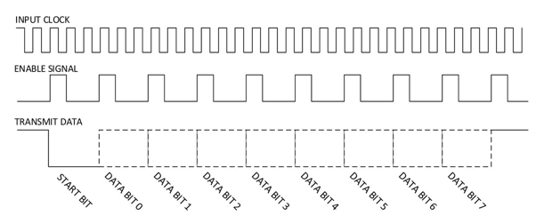

**FIGURE 6.35 Transmission waveform**

After sending the last data from the buffer, a pulse is generated (pin po_tran_over) that informs the user that the sending is completed.

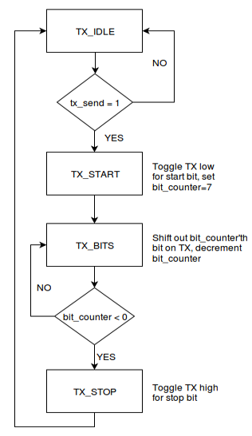

**FIGURE 6.36 UART transmission algorithm**

Now we will discuss how data is being received. As long as the logic “0” on the RX pin of UART module does not appear, our FSM, which is in charge of receiving data, is in the IDLE state. After receiving the start bit, we wait for one and a half of the clock period and start with the data sampling.

After 8 sampled data, the stop bit value is sampled and checked for the expected value. If the expected value is sampled, data will be written in SIPO register.

Receiving data is done in the same way as sending only this time, we do not set up subnets, but we collect the line values. The principle is shown in the picture below.

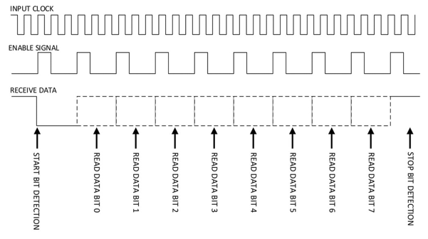

**FIGURE 6.37 Receive waveform**

Data is recorded directly in DDR with the help of axi stream protocol and datamover.

As already mentioned, the entry in DDR is executed using axi stream protocol. In addition to axi stream protocol, we also use the axi lite protocol used to configure and initialize the UART modules.

When we discussed how the UART module worked and adopted the fact that the data after receiving are written directly to DDR via axi stream protocol and that the data sent to the uart module is delivered to the uart module through the axi lite protocol, it is time to process communication between the uart modules and the camera .

### 6.3.4 Camera commands

In the picture below, we can see the list of instructions that the camera recognizes. We see that intrusions are six-byte.

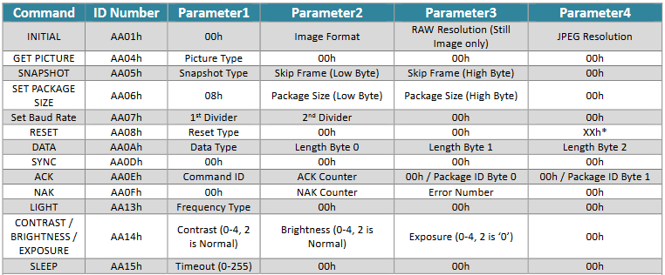

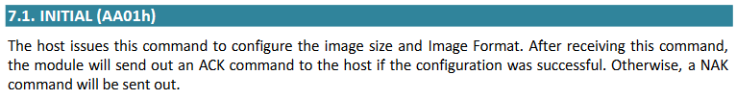

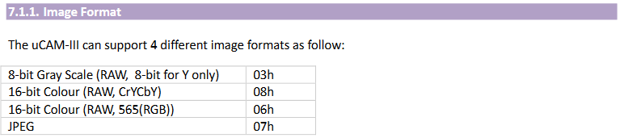

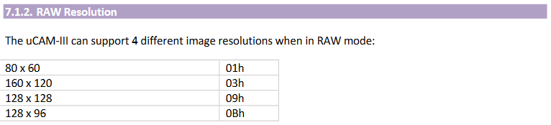

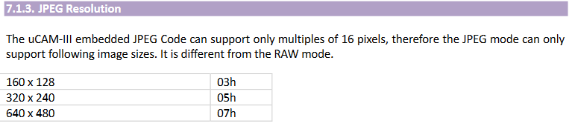

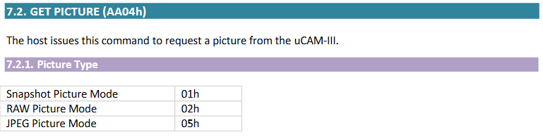

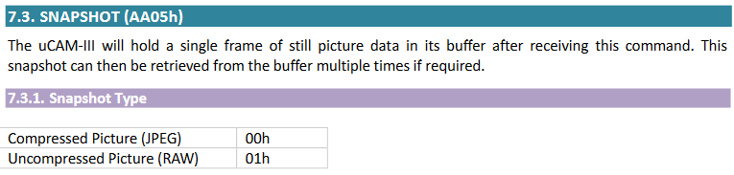

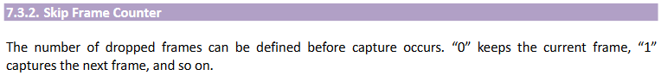

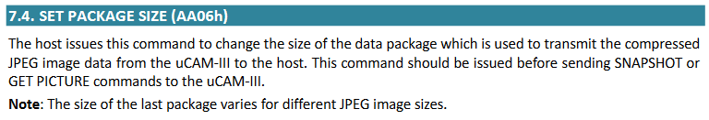

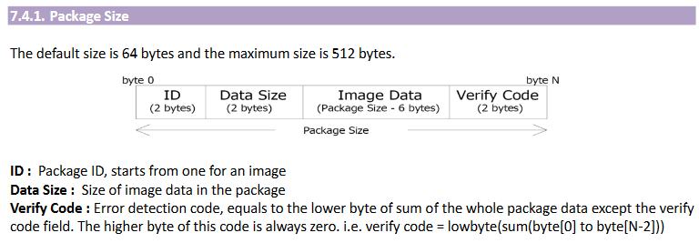

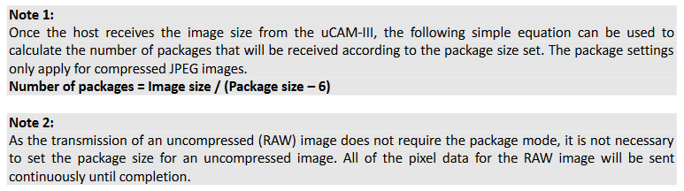

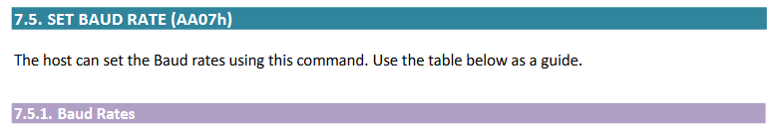

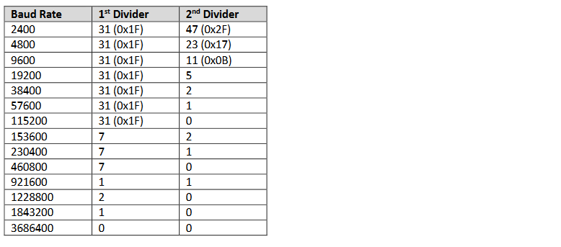



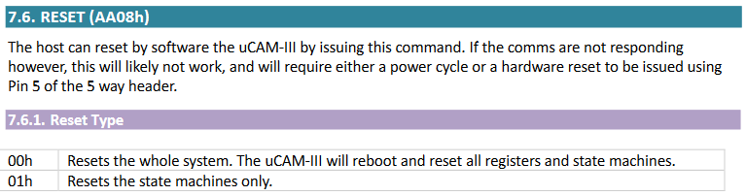

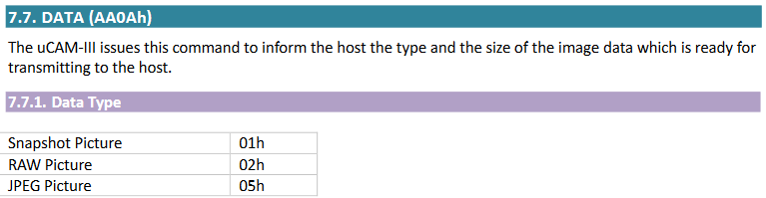



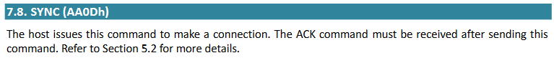

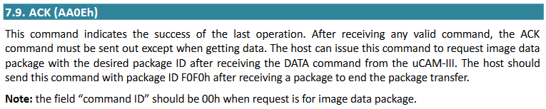











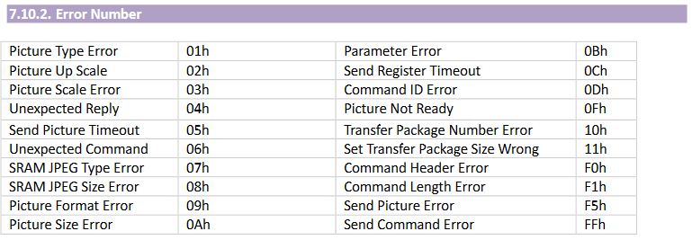



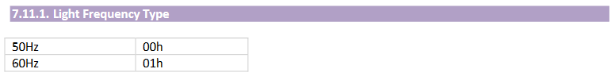

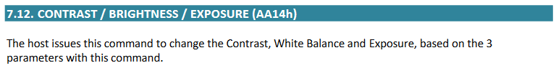

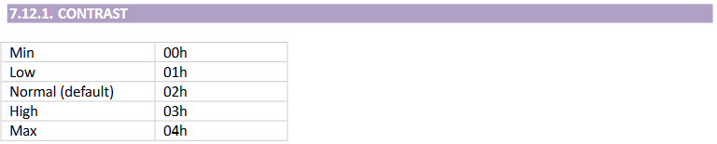

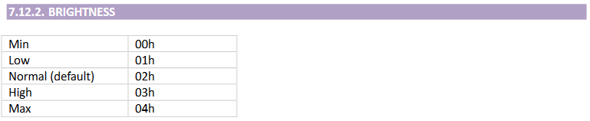

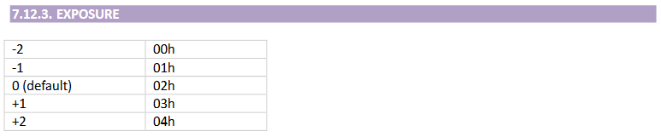

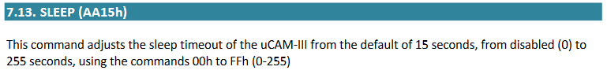

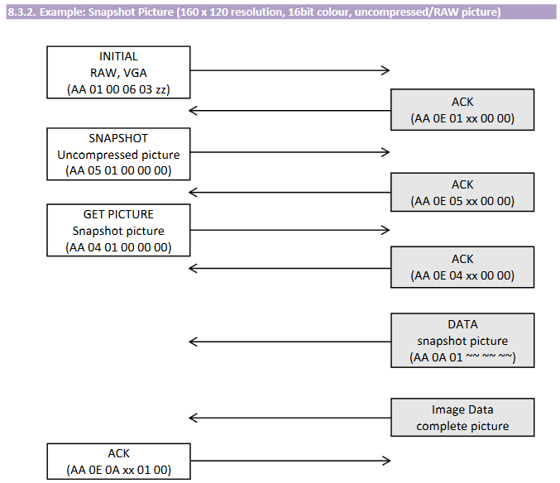

## 6.4 SOFTWARE IMAGE COMPRESSION

As previously mentioned for image capture, the uCAM-III camera was used, Figure 6.38.

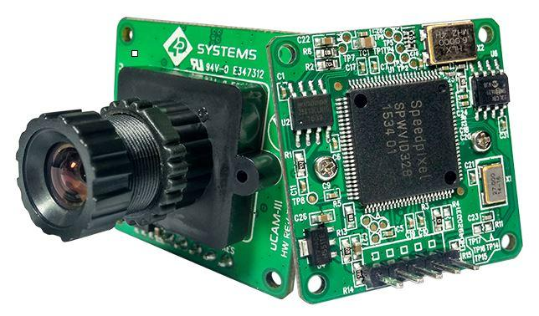

**FIGURE 6.38 4D Systems uCAM-III**

The camera has several modes of operation, in our case the following is used:

* Color Type: 16-bit Color
* Raw Resolution: 160x120
* Contrast: Max
* Brightness: Max
* Exposure: 2

The goal of the compression algorithm is to adapt the camera image to the neural network so it can recognize the number easier. Accordingly, the compression algorithm is divided into several phases:

1. **Slicing an image from a resolution of 160x120 to 112x112.**

This is implemented because of the easier scaling of the bigger RGB picture into a smaller grayscale one. The neural network requires a black and white 28x28 resolution picture. If the 112x112 resolution picture were compressed with a factor of 4, output resolution would be 28x28.

1. **RGB to Grayscale**

**Short intro**

Humans perceive color through wavelength-sensitive sensory cells called cones. There are three different types of cones, each with a different sensitivity to electromagnetic radiation (light) of different wavelength. One type of cone is mainly sensitive to red light, one to green light, and one to blue light. By emitting a controlled combination of these three basic colors (red, green and blue), and hence stimulate the three types of cones at will, we are able to generate almost any perceivable color. This is the reasoning behind why color images are often stored as three separate image matrices; one storing the amount of red (R) in each pixel, one the amount of green (G) and one the amount of blue (B). We call such color images as stored in an RGB format.

In grayscale images, however, we do not differentiate how much we emit of the different colors, we emit the same amount in each channel. What we can differentiate is the total amount of emitted light for each pixel; little light gives dark pixels and much light is perceived as bright pixels.

When converting an RGB image to grayscale, we have to take the RGB values for each pixel and make as output a single value reflecting the brightness of that pixel. One such approach is to take the average of the contribution from each channel: (R+B+C)/3. However, since the perceived brightness is often dominated by the green component, a different, more "human-oriented", method is to take a weighted average, e.g.: 0.299R + 0.587G + 0.114B. This weights are used in our algorithm.

Actual code to implement such an algorithm looks something like:

*For Each Pixel in Image*

*{*

*Red = CamPic.Red;*

*Green = CamPic.Green;*

*Blue = CamPic.Blue;*

*Gray = (Red * 0.299 + Green * 0.587 + Blue * 0.114);*

*CamPicGray.PixelValue = Gray;*

*}*

1. **Compressing image from resolution 112x112 to 28x28**

This algorithm is quite simple to implement, it is necessary to simply take a pixel matrix of 4x4, add up its values, then divide the result by 16 and thus get the result of one-pixel for 28x28 resolution image. In Figure 6.39 we can see the illustration of this algorithm. This time the compression factor is 3, in other words, the initial matrix is 3x3.

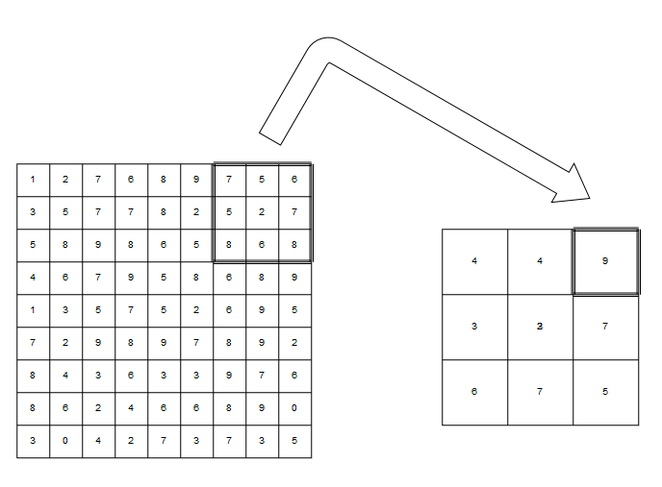

**FIGURE 6.39 Image compression algorithm**

In Figure 6.40 we are able to se our setup for taking pictures. Figure 6.41 shows image that camera takes (image before compression) and Figure 6.42 shows look of image afterr compression.



**FIGURE 6.40 Setup for taking pictures**



**FIGURE 6.41 4D Systems uCAM-III taken picture**



**FIGURE 6.42 uCAM’s picture after compression**

## 6.5 DEEP NEURAL NETWORK (MLP)

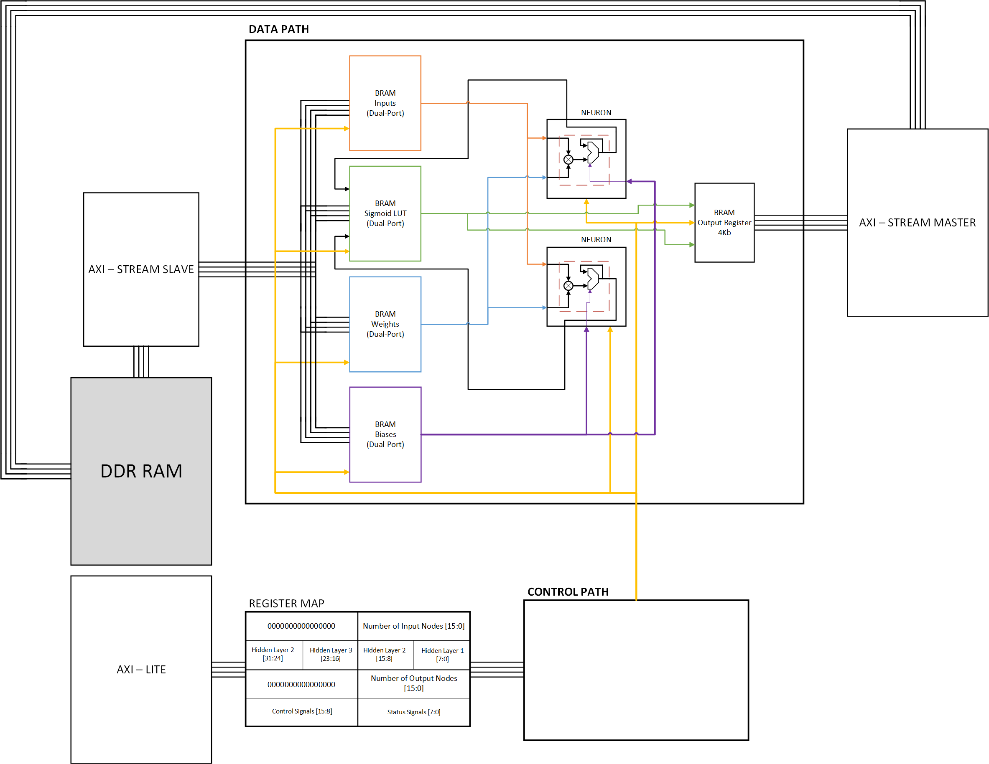

**FIGURE 6.43 MLP Neural Network**

We will dedicate this part of the documentation to explain how the Neuron network works at the hardware level. The MLP network system is shown in Figure 6.43. It can be seen from the picture that we have several parts of this IP core:

1. **AXI-LITE and REGISTER MAP**

AXI-Lite is primarily used to set up the network's operation, through this interface user has the ability to set the parameters shown in the table below.

|  |  |  |  |  |  |
| --- | --- | --- | --- | --- | --- |
| Address | Register Map | | | | Field Name |
| 0x00 | Numb. of Input Nodes | | | | NIN |
| 0x04 | Numb. of hidden nodes 4 | Numb. of hidden nodes 3 | Numb. of hidden nodes 2 | Numb. of hidden nodes 1 | NHN |
| 0x08 | RESERVED | | Numb. of output Nodes | | NON |
| 0x0C | Control Signals | | Status Signals | | CTRL|STAT |

**FIGURE 6.43 MLP Register Map Layout**

Control and Status bits layout can be seen in Figures 6.44.

|  |  |  |
| --- | --- | --- |
| Bits | Field Name | Description |
| 31 – 18 | RSVD | **Reserved** |
| 17 | DAT_RDY | **Data Ready**  1 = Valid data is set on Neural Network AXI stream interface  0 = Non-Valid data is set on Neural Network AXI stream interface |
| 16 | NN_EN | **Neural Network Enable**  1 = Neural Network is enabled  0 = Neural Network is disabled |
| 15 – 2 | RSVD | **Reserved** |
| 1 | NN_DONE | **Neural Network Done**  1 = Neural Network calculated one whole layer  0 = Neural Network is’t done |
| 0 | NN_BSY | **Neural Network Busy**  1 = Neural Network is busy by calculating layer  0 = Neural Network is’t busy |

**FIGURE 6.44 Control and Status bits layout**

It is important to note that the hardware algorithm that reads the nodes values works on the following principle. The first read field is the number of nodes in the input layer, the algorithm then reads further values from the rest fields. When a field with zero value is found, the field before it automatically becomes the output layer. All other fields between the input and the output are hidden layers. Practically, this means that the register map for our neural network would look like in Figure 6.45.

|  |  |  |  |  |  |
| --- | --- | --- | --- | --- | --- |
| Address | Register Map | | | | Field Name |
| 0x00 | 784 | | | | NIN |
| 0x04 | 0 | 10 | 16 | 16 | NHN |
| 0x08 | RESERVED | | 0 | | NON |
| 0x0C | Control Signals | | Status Signals | | CTRL|STAT |

**FIGURE 6.45 MLP Register Map Layout for our project (784-16-16-10)**

1. **CONTROL PATH**

Figure 6.46 is detailed diagram of whole Control Path algorithm.



**FIGURE 6.46 MLP ASM Diagram**

1. **AXI-STREAM SLAVE**

AXI-Stream Slave is used for sending Inputs, Weights and Biases to Network.

As Figure 6.47 shows the process of calculating the value of the first hidden layer, we can conclude that one of the possible ways to load values within the MLP network is as follows:

* Loading 784 inputs
* Loading 784 * 2 Weights: The reason for this is the existence of 2 neurons in the hardware so the calculation can be performed simultaneously for 2 nodes.
* Loading two biases: one for each neuron

By this procedure, we have loaded the necessary values for the calculation of the first 2 neurons (Small image, up-left). Since the inputs are the same for all other neurons in the first hidden layer, for the next iterations it is enough to load only the weights and the biases.

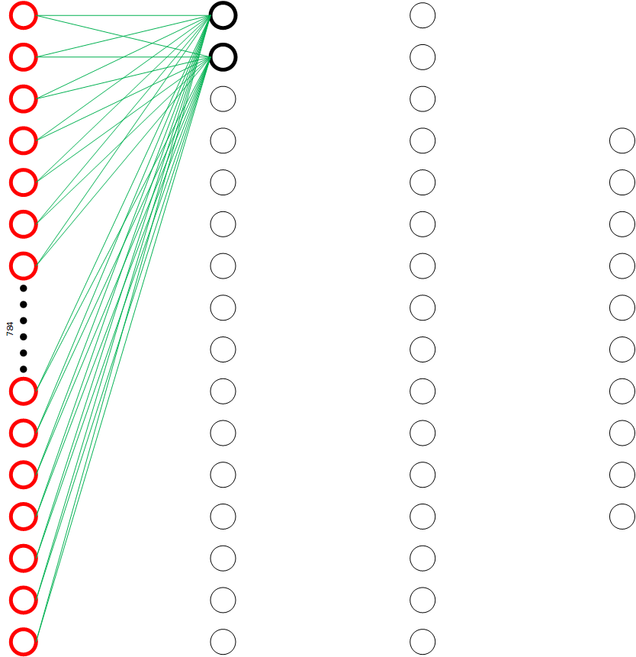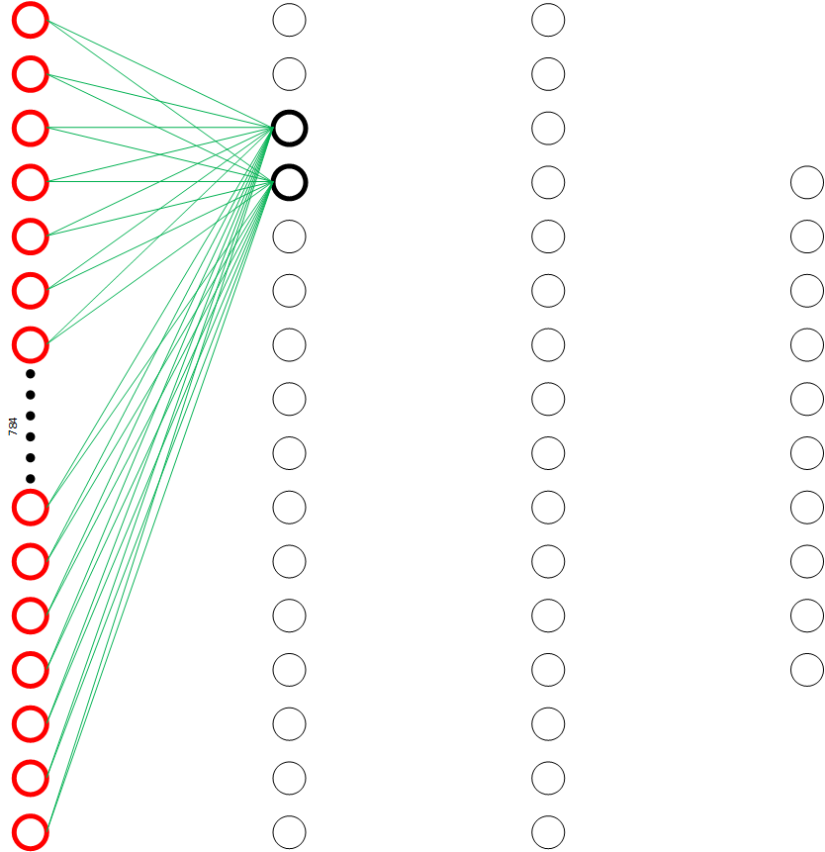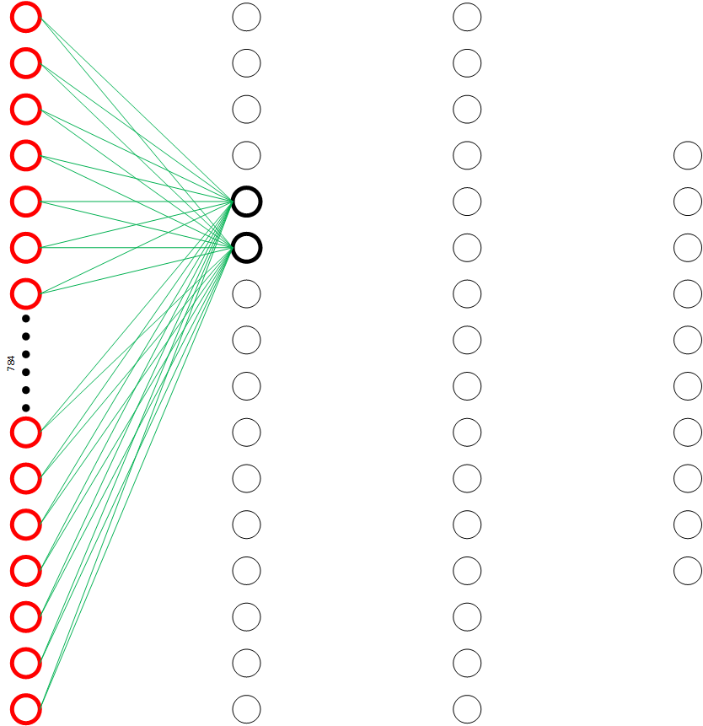

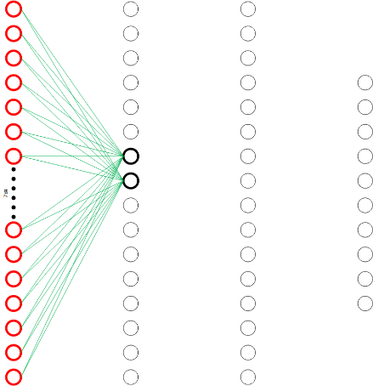 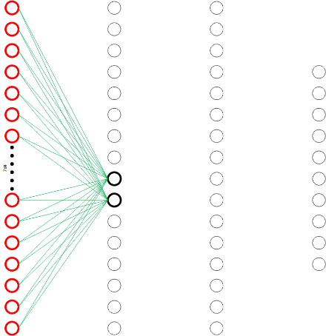

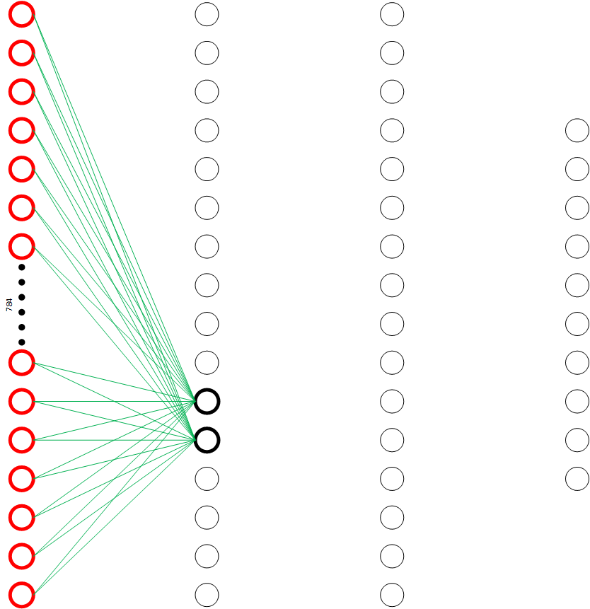

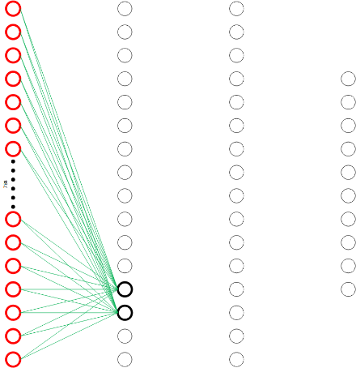

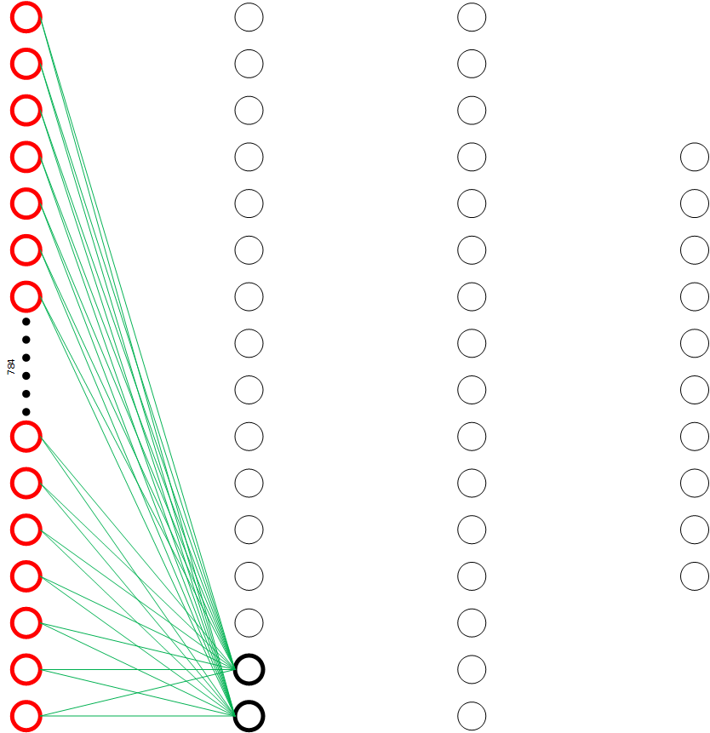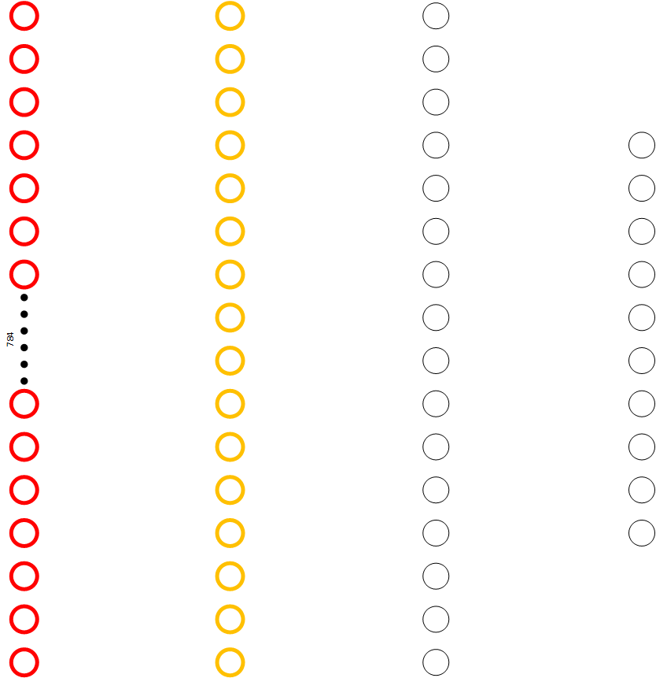

**FIGURE 6.47 Process of calculating first hidden layer values**

Pseudo code for layer calculation would be something like:

repeat(NumberOfNodesInCurrentLayer / NumberOfUsedNeurons)

{

layer_calc(int numberOfInputs, int numberOfOutputs, int numberOfUsedNeurons)

{

mlp.loadInputs(numberOfInputs);

mlp.loadBiases(numberOfUsedNeurons);

mlp.loadWeights(numberOfInputs * numberOfUsedNeurons);

}

**}**

As you can see, order of functions is INPUTS – BIASES – WEIGHTS, that’s because our algorithm first takes inputs, then biases and last weights.

To calculate whole network function layer_calc() could be used like:

layer_calc(16 / 2); // First hidden layer

layer_calc(16 / 2); // Second hidden layer

layer_calc(10 / 2); // Output layer

Second hidden layer and output layer calculations are shown below.

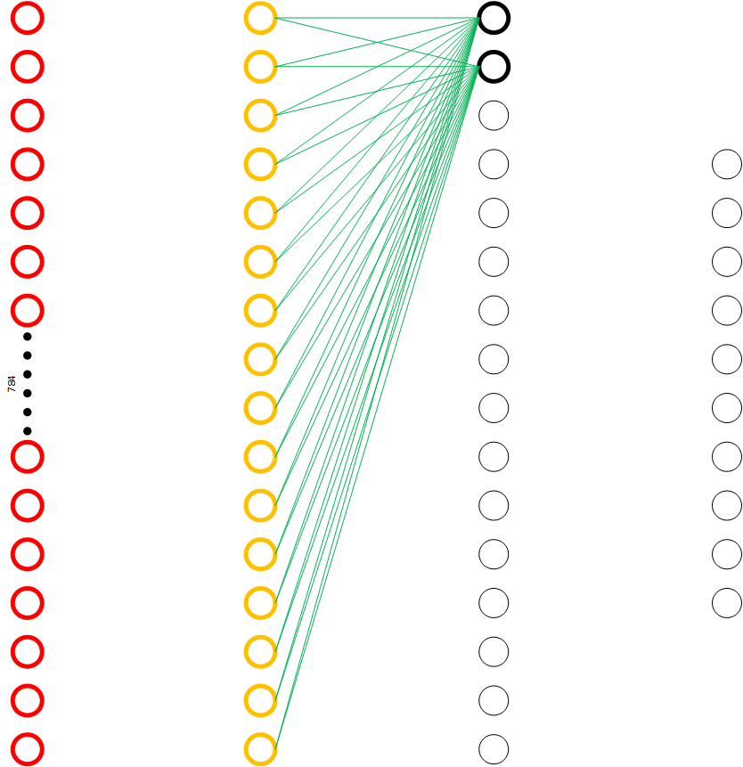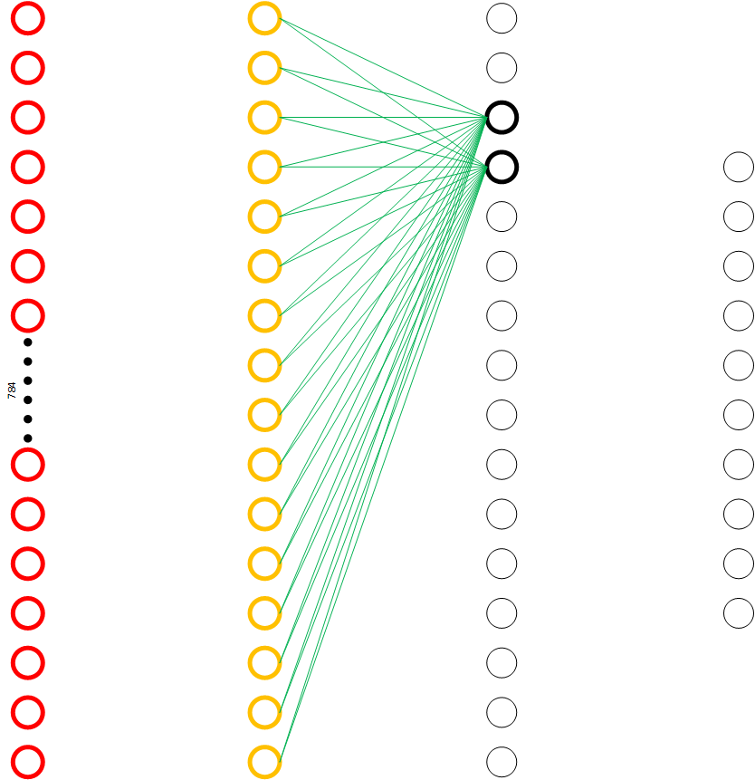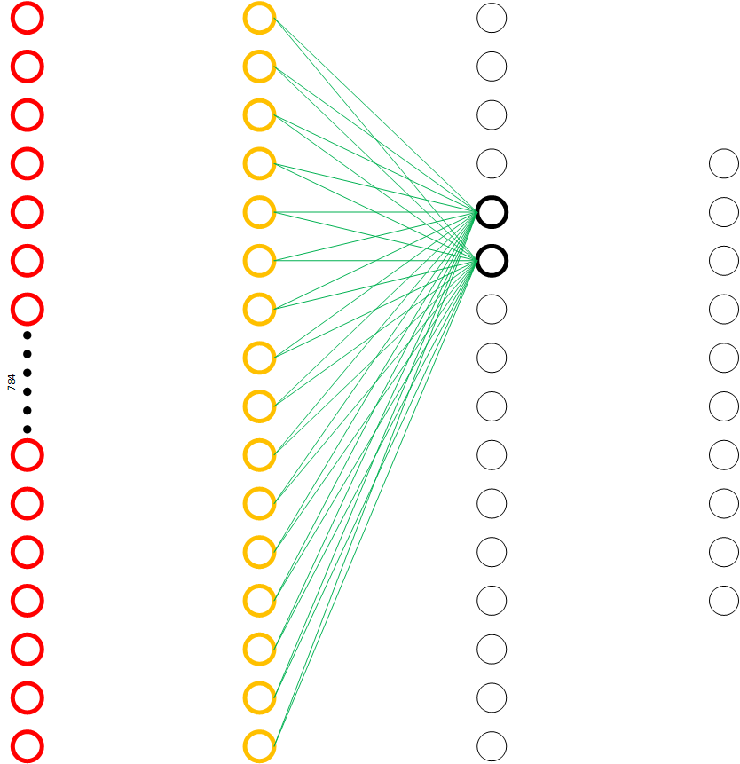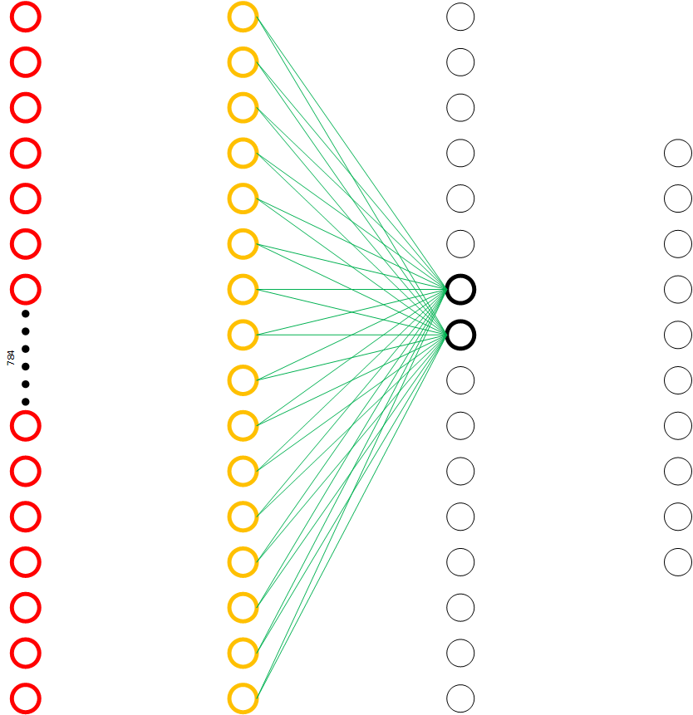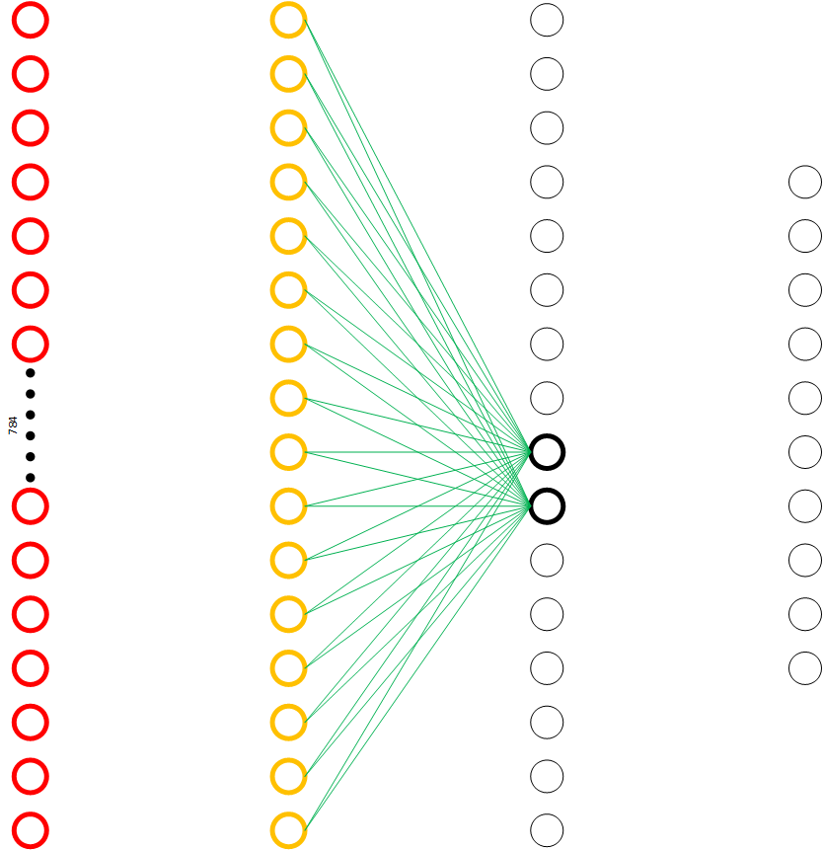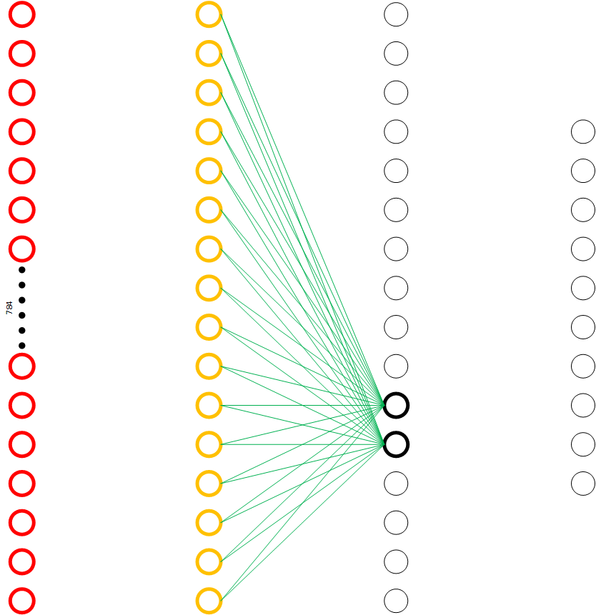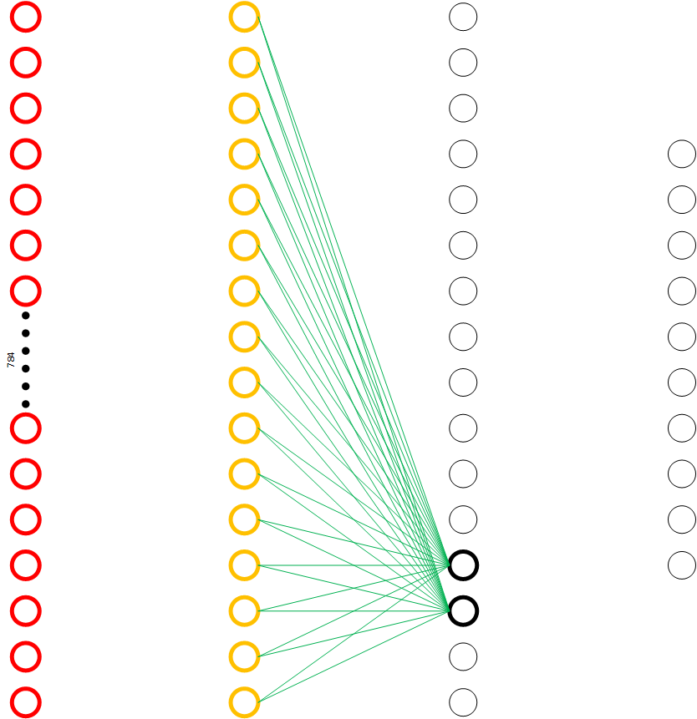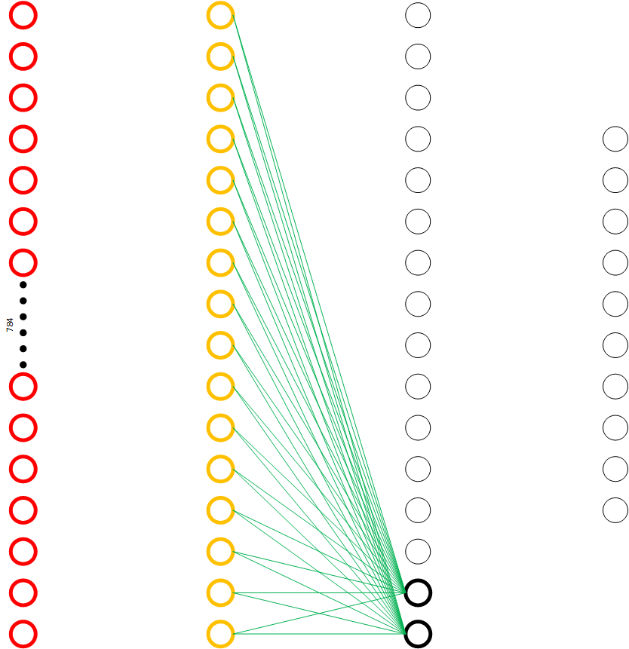

**FIGURE 6.48 Process of calculating second hidden layer values**

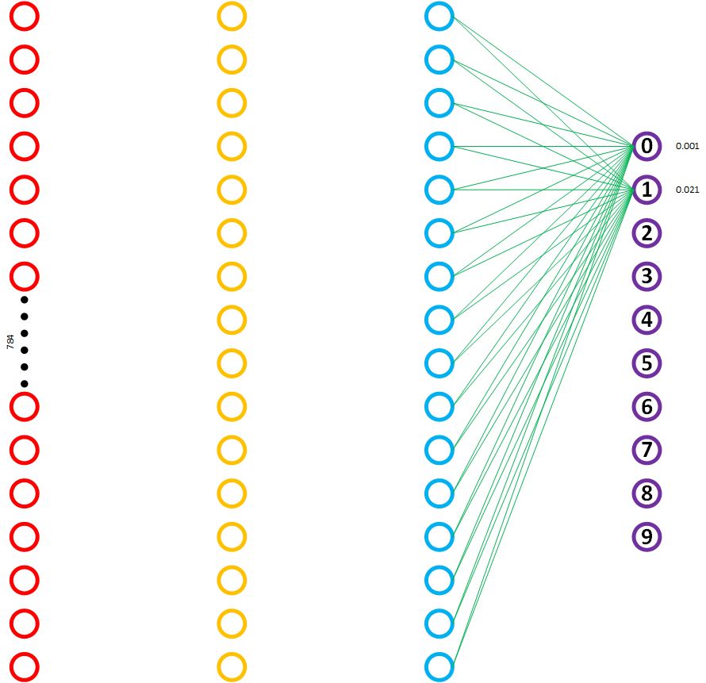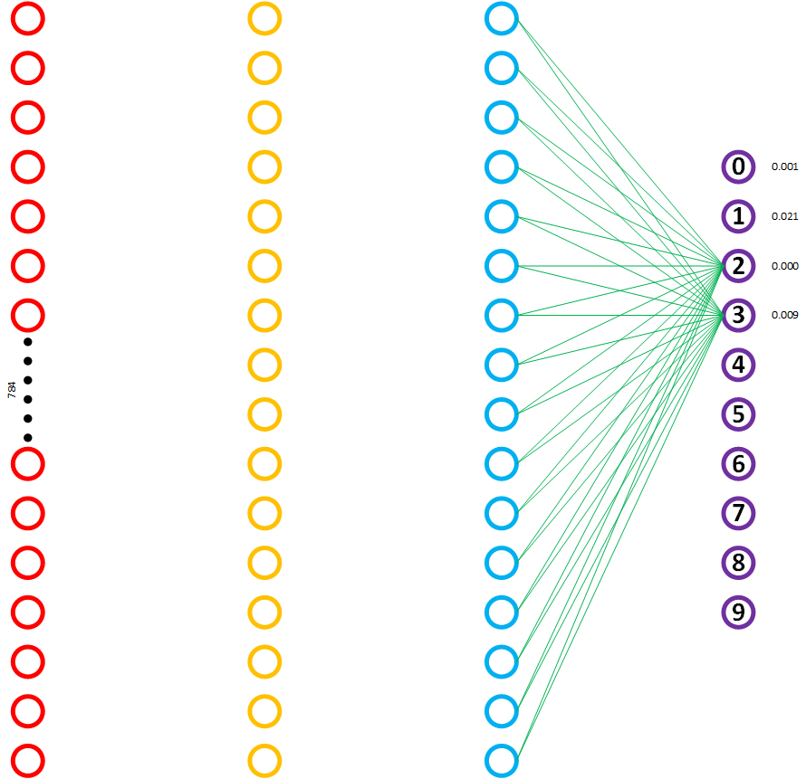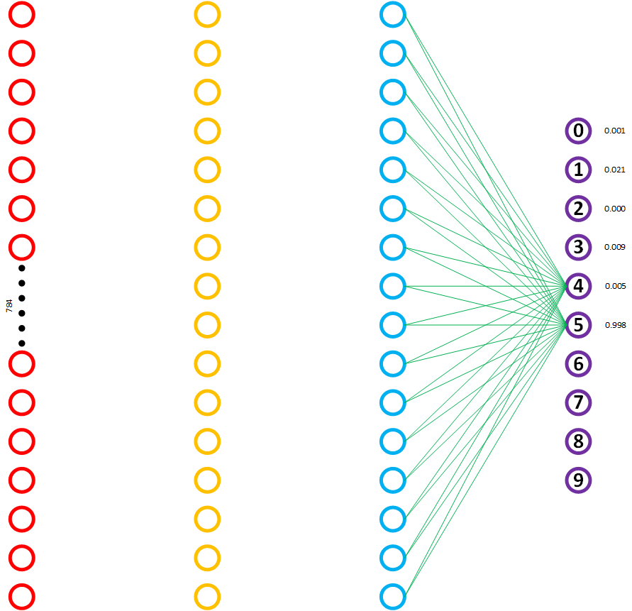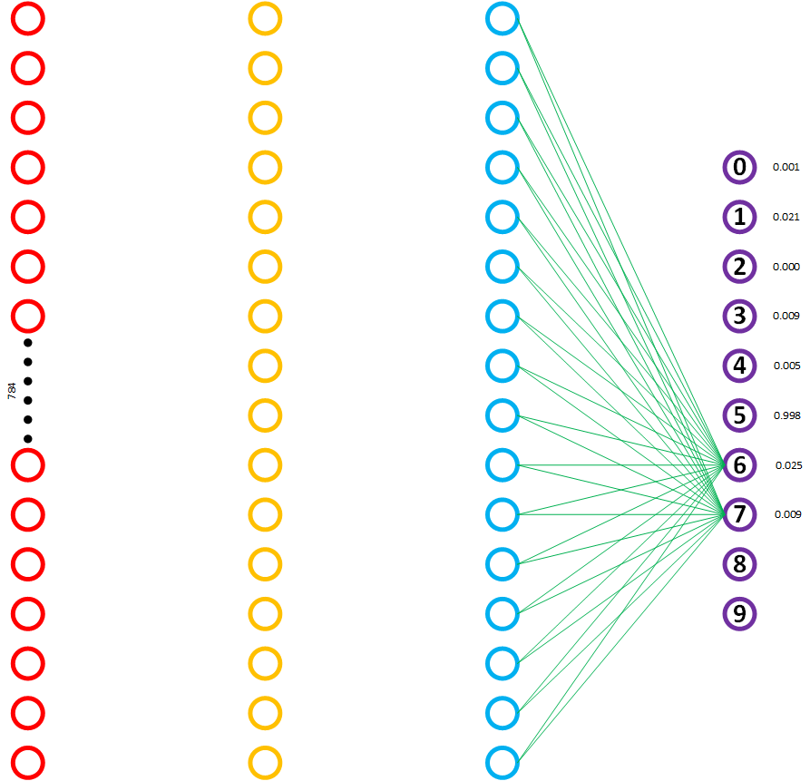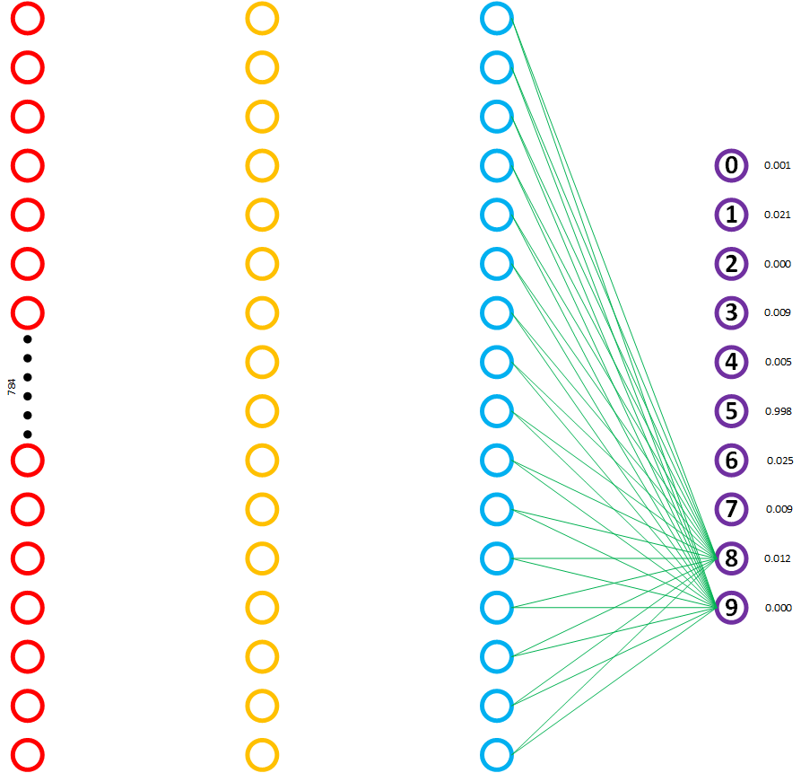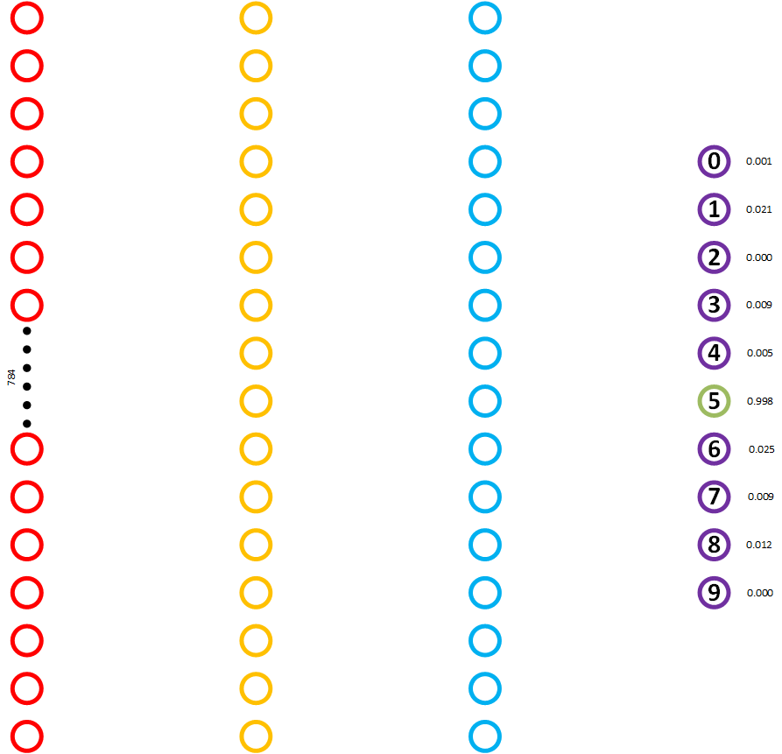

**FIGURE 6.49 Process of calculating output layer values**

1. **BRAM – INPUTS**

The process of loading Inputs inside MLP Network is done by AXI-Stream interface. Loading algorithm can be seen in Figure 6.50. A conclusion is that it’s needed 784 iterations for a first calculating layer, 16 for second and 16 for last layer.

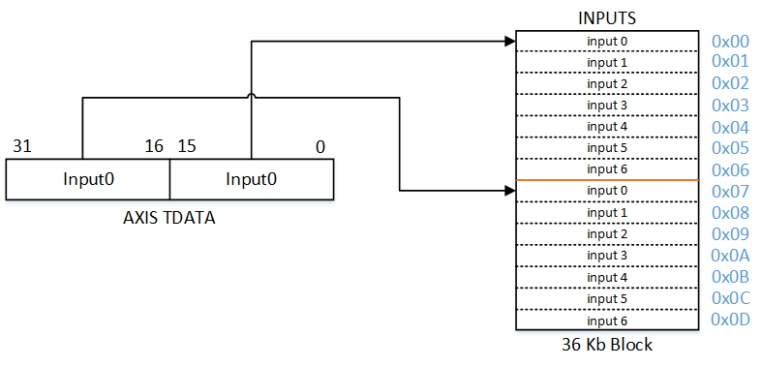

**FIGURE 6.50 Process of loading inputs**

1. **BRAM – BIASES**

The process of loading Biases inside MLP Network is also done by AXI-Stream interface. Loading algorithm can be seen in Figure 6.51. A conclusion is that it’s needed 784 / 2 = 392 iterations for a first calculating layer, 8 for second and 8 for last layer.

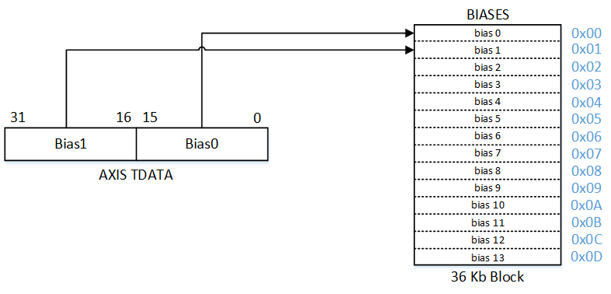

**FIGURE 6.51 Process of loading biases**

1. **BRAM – WEIGHTS**

Conclusion for loading weights is same as for loading biases. Needed number of iterations is (784 * 2) / 2 = 784.

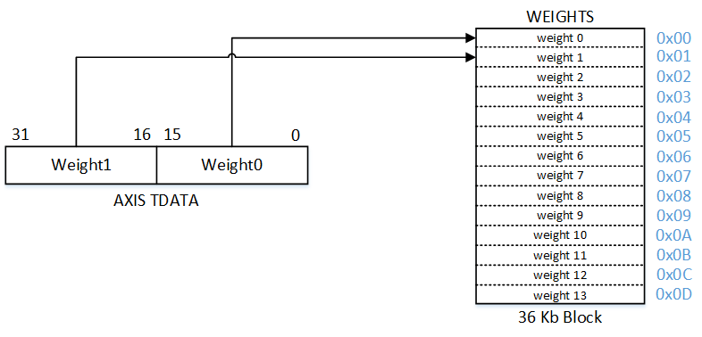

**FIGURE 6.52 Process of loading weights**

1. **BRAM - SIGMOID LUT**

In our project, we used sigmoid as the activation function. As consequence of 16bit architecture and BRAM limits, the sigmoid function is sampled with 10 bits. It basically means we have 1024 samples, as a result, minimal step is 0.03125, which is quite good. As an example in Figure 6.53 is shown a look of discrete sigmoid function in 100 steps.

Sigmoid BRAM is configured as dual port ROM.

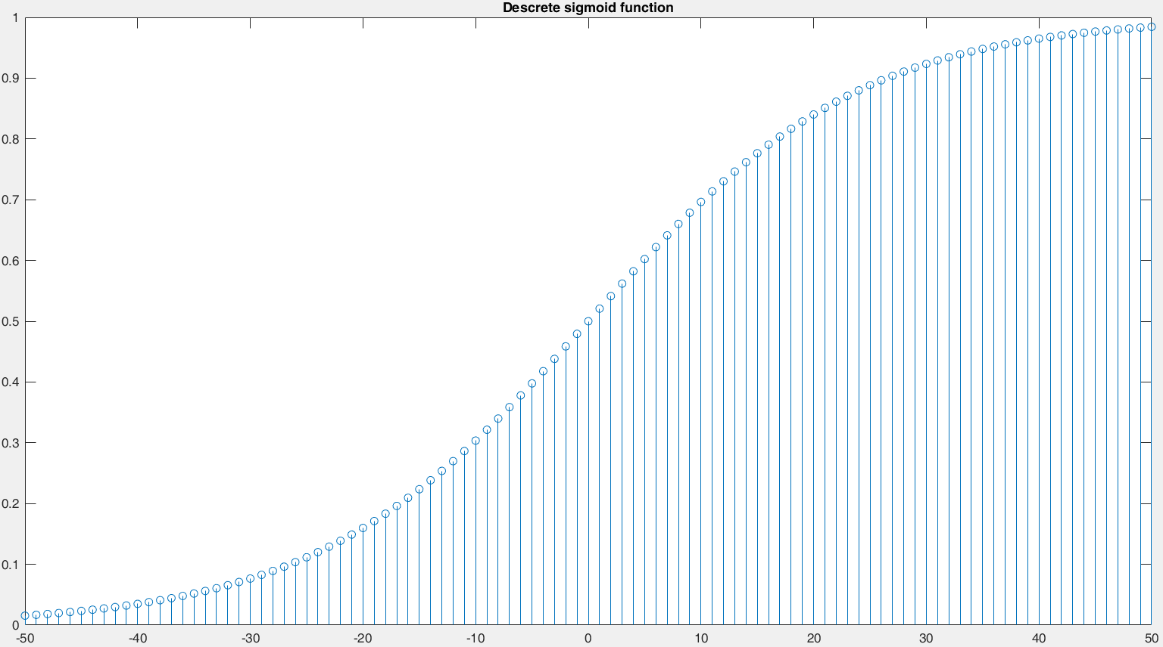

**FIGURE 6.51 Discrete sigmoid function**

1. **NEURONS**

Fixed Point Notation is a representation of our fractional number as it is stored in memory. In Fixed Point Notation, the number is stored as a signed integer in two’s complement format.

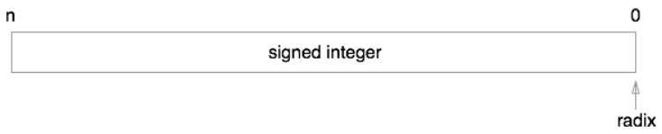

**FIGURE 6.52 Fixed Point without radix**

On top of this, we apply a notional split, locating the radix point (the separator between integer and fractional parts) a fixed number of bits to the left of its notational starting position to the right of the least significant bit. I’ve illustrated this in the diagram below.

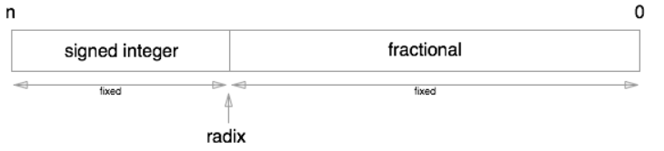

**FIGURE 6.53 Fixed Point with radix**

When we interpret the bits of the signed integer stored in memory we reposition the radix point by multiplying the stored integer by a fixed scaling factor. The scaling factor in binary is always 2 raised to a fixed exponent. As the scaling factor is a power of 2 it relocates the radix point some number of places to the left or right of its starting position.

During this conversion there are three directions that the radix point can be moved:

* **The radix point is moved to the right**: This is represented by a scaling factor whose exponent is 1 or more. In this case additional zeros are appended to the right of the least-significant bit and means that the actual number being represented is larger than the binary integer that was stored
* **The radix point remains where it is**: This is represented by a scaling factor whose exponent is 0 and means that the integer value stored is exactly the same as the integer value being represented.
* **The radix point is moved to the left**: This is represented by a scaling factor whose exponent is negative. This means that the number being represented is smaller than the integer number that was stored and means that the number being represented has a fractional component. Let’s take a look at a couple of examples.

**Examples of Fixed Point Numbers**

Let’s assume we have an 8-bit signed binary number 000110112 that is stored in memory using 8-bits of storage (hence the leading zeros).

In our first scenario, lets also assume this number was stored as a signed fixed-point representation with a scale factor of 22.

As our scale factor is greater than 1, when we translated the bits stored in memory into the number we are actually representing, we move the radix point two places to the right. This gives us the number: 11011002 (Note the additional zeros that are appended to the right of the least significant bit).

In our second scenario, let us assume that we start off with the same binary number in memory but this time we’ll assume that it is stored as a signed fixed-point representation with a scale factor of 2-3. As the exponent is negative we move the radix point three places to the left. This gives us the number 00011.0112

**Advantages and Disadvantages of Fixed Point Representation**

The major advantage of using a fixed-point representation is performance. As the value stored in memory is an integer the CPU can take advantage of many of the optimizations that modern computers have to perform integer arithmetic without having to rely on additional hardware or software logic. This in turn can lead to increases in performance and when writing your apps, can therefore lead to an improved experience for your users.

However, there is a downside! Fixed Point Representations have a relatively limited range of values that they can represent.

So how do we work out the maximum and minimum numbers that can be stored in a fixed-point representation and determine whether it is suitable for our needs? All we do is take the largest and smallest integer values that can be stored in the given number of bits and multiply that by the scale factor associated with our fixed-point representation. For a given signed binary number using b bits of storage with a scale factor of f the maximum and minimum values that can be stored are:

Minimum: −2b−1/2f

Maximum: (2b−1−1)/2f

If the number you want to represent fits into this range then things are great. If it doesn’t though, you have to look for an alternative! This is where Floating Point Notation comes in.

In our case we are using Sign.4.11 system. Which give us range from -16 to 15.9995117188.

Main neuron task is to multiply and accumulate the result. Before sending final calculation to

sigmoid BRAM neuron saturates result in case of overflow.

1. **BRAM - OUTPUT REGISTER**

As well as for the weight, the same thing goes for output reg BRAM.

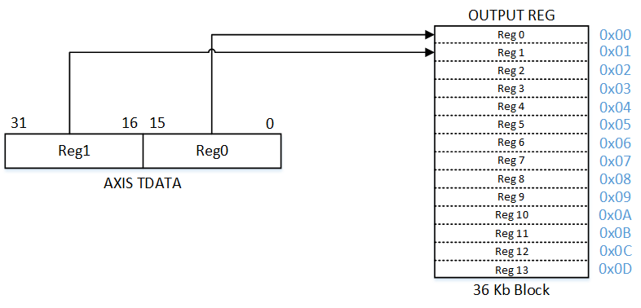

**FIGURE 6.54 Process of storing neuron values after activation (sigmoid) function**

1. **AXI-STREAM MASTER**

After finishing calculations for one whole layer MLP IP sends data to DDR via AXI-Stream Master interface and DataMover. Outputs of this layer are actually inputs for next layer, this does not apply to the last layer, as that layer is our wanted number.

## 6.4 8x8 MATRIX

During the project, we realize that we need somewhere to show results we got. So we decide to make LED 8x8 matrix by which we can show a number that neural network was recognized.

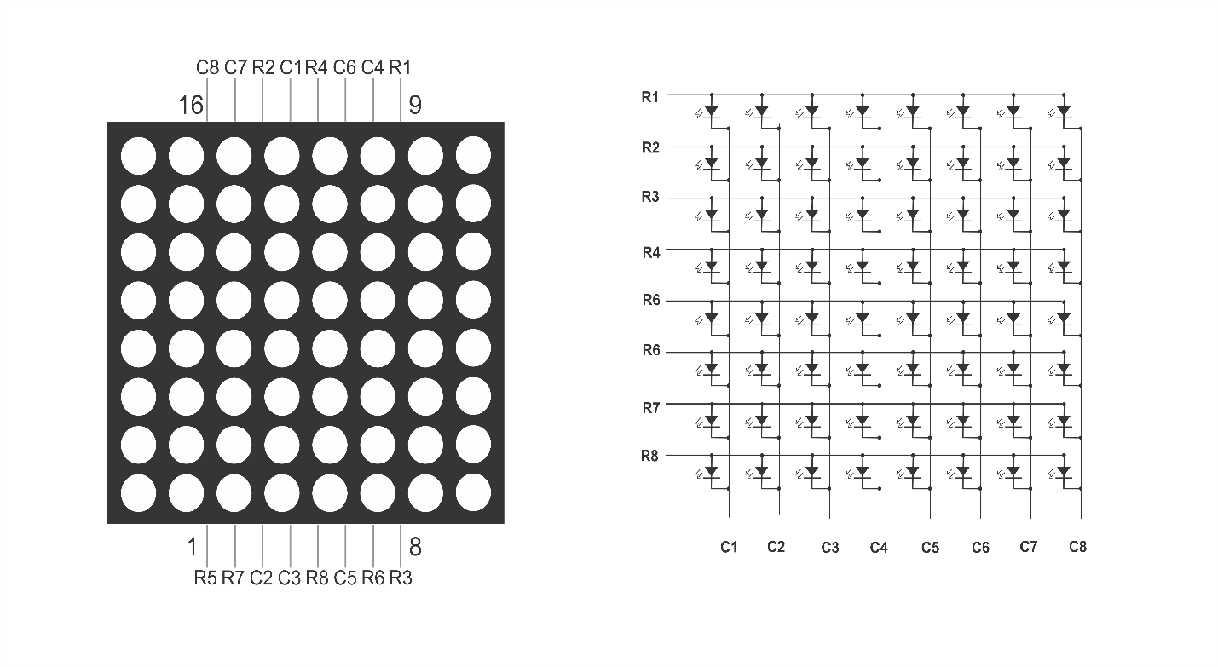

**FIGURE 6.55 LED matrix and LED matrix schematic**

### 6.4.1 Working principles of LED matrix

An **LED array** is a collection of LEDs, they can be arranged in many patterns, the most typical being a single line, or a matrix pattern. Here we use the matrix pattern. A matrix defines a rectangular or square consisting of intersecting rows and columns. The intersection of these rows and columns are important to how we talk to the matrix and address individual LEDs.

Let’s start by looking at an LED, there is a negative (cathode) terminal that goes towards ground, and a positive (anode) one that goes towards power. The power terminal gets connected to a ZYBO I/O pin, which will pump out voltage, turning it on and off based on the uploaded program. The anodes and cathodes are connected, forming the columns and rows. A LED matrix can either be *column anode* or *column cathode*(Figure 5.1 right image).

If we wanted to be able to control each LED individually, every LED in a matrix would need it’s own I/O pin. A 8x8 matrix would need 64 pins. That’s a lot! Luckily there is something called multiplexing which reduces the number of pins needed to 16 in order to control the matrix. The pins can then be referred by the row number or column number, for example, Row 1-8 (R1 - R8) or Column 1-8 (C1 - C8).

**Multiplexing** works by turning on LEDs in one row or column at a time, for simplicity’s sake, let’s say we are turning on rows. Each row is turned on and off right after one another at a rate quick enough that the **persistence of vision**causes us to see a static image.

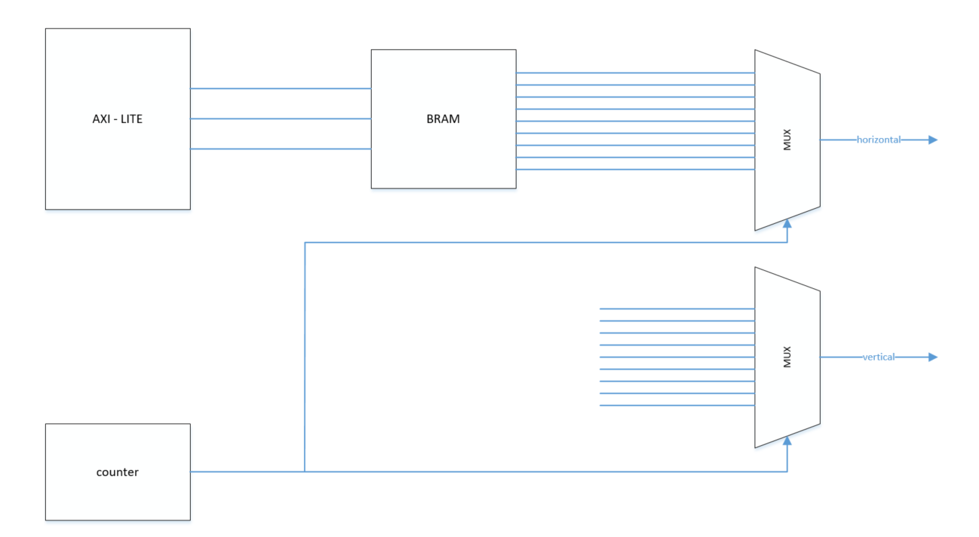

**FIGURE 6.56 LED matrix block diagram**

# **CHAPTER-7 REFERENCES**

* Machine Learning: An Algorithmic Perspective, Second Edition. Stephen Marsland
* [www.neuralnetworksanddeeplearning.com](http://www.neuralnetworksanddeeplearning.com)
* pg022_axi_datamover
* pg235-v-hdmi-tx-ss
* ug472_7Series_Clocking
* ug473_7Series_Memory_Resources
* ug585-Zynq-7000-TRM
* ug901-vivado-synthesis
* ug1037-vivado-axi-reference-guide
* ZYBO_RM_B_V6
* [uCAM-III Datasheet](https://www.4dsystems.com.au/productpages/uCAM-III/downloads/uCAM-III_datasheet_R_1_0.pdf)

**Note:** These manuals, books, and sites were used for writing documentation or for understanding and building project.

